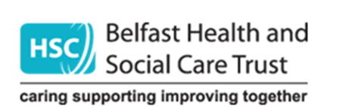 Rural Needs Impact Assessment
Section 1: Define activity subject to Section 1(1) of Rural Needs Act (NI) 2016
1A. Short title describing activity being undertaken that is subject to Section 1(1) of the Rural Needs Act (NI) 2016:
Resilience Plan: The Belfast Health and Social Care Trust (BHSCT) Resilience Plan brings together what we will need to do to respond to additional demand from the pressures of winter 2020/2021 alongside any subsequent waves of COVID-19

1B. Are you Developing, Adopting, Implementing or Revising a Policy a Strategy or a Plan? (Underline or Circle)
Or are you delivering or designing a public service? (Underline or Circle)
What is official title of this Policy, Strategy, Plan or Public service (if any)?
Resilience Plan
1C. Give details of the aims and/or objectives of the Policy, Strategy, Plan or Public Service:
We, as a provider of integrated health and social care, and an employer of over 20,000 staff, must remain agile, flexible and responsive to these pressures. Crucially, we need comprehensive surge plans in place for critical care, hospital beds and support to care homes. This Resilience Plan has been developed with staff focusing on the holistic pressures that will challenge our services for the next 3-6 months and so the impact and planning for any future COVID-19 surges and winter pressures has been considered in an integrated way.
1D. What definition of ‘rural’ is the Trust using in respect of the Policy, Strategy, Plan or Public Service:
Definition used is that provided by the Inter Departmental Urban Rural Definition Group (2015) which stated that ‘Rural meant

‘Settlements with fewer than 5,000 residents and open countryside’. In light of this, please see analysis below in terms of NI rural settlement profile.
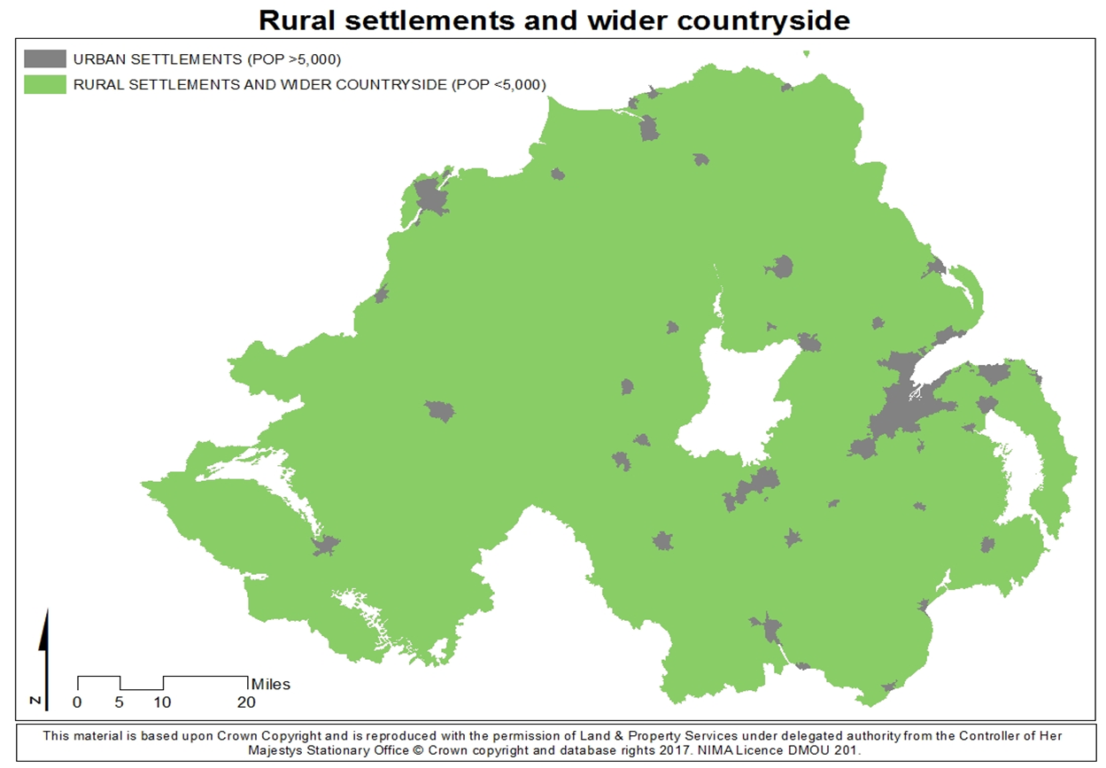

Section 2 - Understanding impact of Policy, Strategy, Plan or Public Service
2A. Is the Policy, Strategy, Plan or Public Service likely to impact on people in rural areas?
No If response is NO Go To Section 2E.
2B. How is it likely to impact on people in rural areas?

2D. Please indicate which of the following rural policy areas the Policy, Strategy, Plan or Public Service is likely to primarily impact on.
Jobs or Employment in Rural Areas |  | Community Safety or Rural Crime |  | Agriculture-Environment
Education or Training in Rural Areas |  | Health or Social Care Services in Rural Areas |  | Other, please state below;
Rural Development |  | Broadband/Mobile Communications in Rural Areas |  | Other, please state below;
Poverty or Deprivation in Rural Areas |  | Rural Business, Tourism or Housing |  | Other, please state below;

2E. Please explain why the Policy, Strategy, Plan or Public Service is NOT likely to impact on people in rural areas.

BHSCT is committed to its statutory duty to have due regard to rural needs when developing, adopting, implementing or revising policies, strategies and Plans, and when designing and delivering public services. In so doing we will strive to ensure that we pay due regard to the social and economic needs of people in rural areas when carrying out the aforementioned activities. The Trust is mindful that the level of ‘regard’ due will depend on the circumstances and, in particular, on the relevance of rural needs to the decision or function in question. The greater the relevance and potential impact for people in rural needs, the greater the regard required by the duty.

The Resilience Plan comprises two plans – one being the annual Winter Plan for the Trust to try to deal with increased demand due to seasonal pressures and the second is a Surge Plan to deal with a second wave of COVID-19. Every year Belfast Trust prepares a plan to explain how we will address the expected increase in demand for unscheduled secondary care services during winter. This year these pressures will be further compounded if we simultaneously experience another surge of COVID-19. We have recently seen increases in the number of COVID-19 cases across Northern Ireland and therefore are working on the basis that there will likely be a second COVID-19 surge later in the year albeit the timing and scale of the second wave is unpredictable.

Our Plan has been structured across 5 themes, as follows:

- Looking after our people: Patients, service users, carers and staff
- Maximising capacity in the community therefore avoiding an Emergency Department (ED) attendance or acute admission and supporting vulnerable people at home
- Maximising capacity in Hospitals to deal with managing service demand arising from COVID-19 and winter pressures
- Urgent and Emergency Care service readiness
- Enabling flow and facilitating timely discharge

Our Plan has been developed aligned to the following principles as outlined in the Regional Covid-19 Pandemic Surge Planning Strategic Framework 2020:
- Safety of our patients and service users remains the overriding priority.
- Safe staffing remains a key priority and Trusts will engage with Trade Union side on safe staffing matters in relation to relevant surge plans.
- Trusts should adopt a flexible approach to ensure that ‘business as usual’ services can be maintained as far as possible, in line with the Rebuilding HSC services Strategic Framework. This should allow Trusts to adapt swiftly to the prevailing COVID-19 context.
- It is recognised that there will be a fine balance between maintaining elective care services and managing service demand arising from COVID-19 and winter pressures. Addressing COVID-19 and winter pressures will take priority over elective care services, although the regional approaches announced such day case elective care centres and orthopaedic hubs will support continuation of elective activity in the event of further COVID-19 surges.
- The HSC system will consider thresholds of hospital COVID-19 care, which may require downturn of elective care services.
- Trusts Surge Plans, whilst focusing on potential further COVID-19 surges, should take account of likely winter pressures.
- Trusts should plan for further COVID-19 surges within the context of the regional initiatives
- Trusts should, as far as possible, manage COVID-19 pressures within their own capacity first. Should this not be possible, Trusts are required to make use of the regional Emergency Care facility at Belfast City Hospital or the regional ‘step down’ facility provided at Whiteabbey hospital, as appropriate. Trusts will also consider collectively how they will contribute staff resources to support Nightingale hospitals and care homes when necessary.
- The Department, HSCB, PHA and the Trusts will closely monitor COVID-19 infections, care home outbreaks, hospital admissions and ICU admissions to ensure a planned regional response to further COVID-19 surges. This will support continued service delivery.
- The Department will, if COVID-19 infection rates and other indicators give cause for action, recommend further tightening of social distancing measures to the Executive

On 11th March 2020, the World Health Organisation officially declared Covid-19 a pandemic due to the speed and scale of transmission. As a result the Health and Social Care sector faced unprecedented pressures in their primary aims to:
- Safeguard lives by reducing the further spread of the Covid-19 virus; and to
- Prevent the HSC system from becoming overwhelmed due to the Covid-19 pandemic and the demands this is placing on the whole HSC system.
During the pandemic measures were taken to try to best deal with the demands and consequences of Covid-19 and were undertaken with the utmost urgency to protect life and address urgent public health matters. Many services across Belfast Trust and beyond continued to operate throughout the pandemic, albeit on a reduced scale while other services had to be stood down because of clinical, patient or staff safety, as well as physical and workforce capacity constraints.

The Trust recognises that there are a number of policy leads/decision makers across HSC who likewise must comply with the Rural Needs Impact Assessment duties in the development, implementation and review of the Regional HSC surge plans. It is important that was as a Health and Social Care system work together. The Trust therefore commits to collaborate, as necessary, with all relevant HSC organisations in seeking to ensure the fulfilment of these statutory duties.

Please note the following factors considered when deciding that our policy is not likely to impact people in rural areas:

- This is an overarching rural screening to gauge the cumulative impact of the measures within our Resilience Plan to help address and build resilience in our HSC system to deal with Winter Pressures and the impact of a second Covid-19 Surge. The Trust is committed to monitoring those measures in the Plan over coming months in terms of the impact on people in rural areas and further stand-alone rural screenings will be undertaken as appropriate.

- Many of the measures within the Plan will constitute temporary changes to facilitate service delivery where it is most needed but also to facilitate an agile response to a further surge. The Trust remains wholly committed to engage, comprehensively impact assess and consult should we wish to make any of these changes permanent. We have engaged in a Trust wide ‘Learning from COVID-19’ initiative which includes listening to service users, patients and carers to and this has helped inform our plans

- It is noted that the majority of the Trust’s services are delivered to people not from a rural community as defined by the Inter Departmental Urban Rural Definition Group (2015). The services that come within the remit of this assessment therefore are restricted to services delivered regionally by the Trust. We are also mindful that a Rural Needs Impact Assessment is proportionate to the scale of the potential impact and relevance of the activity being undertaken
- When considering the impact on people from a rural community, the Trust is mindful that it is important to consider in full the potential impact on rural needs and that we are clear about what is a need and what is desirable. (In general, a need can be considered to be something that is essential to achieve a standard of living comparable with that of the population in general e.g. can the people in the rural area access key public services such as health and social care?)

- Our Plan (which involve some regional services) does not have a differential impact on people in rural areas because the proposals apply equally to people both in urban and rural areas

- Our Plan has been written designed to address the following principles stipulated by the Department of Health:
  - Ensure Equity of Access for the treatment of time-critical patients across Northern Ireland, as per regional prioritisation
  - Minimise the transmission of Covid-19 and
  - Protect the most urgent services.
- Due to continue social distancing and infection control requirements the Trust will continue to use telephone clinics and virtual IT solutions to triage and review patients which will enhance the accessibility of regional services for people who live beyond Belfast. Telephone and Virtual clinics means that patients and service users can access a service without the need to travel which certainly benefits those living in rural communities. However, the Trust is mindful of the need for good connectivity and so will continue to monitor this innovation through feedback from service users. The Trust will strive to provide a hybrid service delivery model and so face-to-face appointments for regional services may happen when it is clinically assessed and where social distancing and infection control guidance permits.
- To ensure optimal resource use, the Trust continues to work with colleagues in other Trusts across Northern Ireland. Regular regional meetings and communication have been enhanced during the Covid-19 surge and will continue
- Implementation of these measures and any associated impact are under daily review by the Trust’s Executive Team

If you completed 2E above GO TO Section 6
SECTION 3 - Identifying Social and Economic Needs of Persons in Rural Areas
3A. Has the Trust taken steps to identify the social and economic needs of people in rural areas, relevant to the Policy, Strategy, Plan or

Public Service? Yes No if the response is NO, GO TO Section 3D
3B. Which of following methods or information sources were used by the Trust to identify these needs?

Consultation with relevant stakeholders / Survey or Questionnaire / Research / Statistics / Publications / Other methods.
Please provide details:

3C. What social and economic needs of the people in rural areas have been identified?

3D Please explain why no steps were taken by the Trust to identify the social and economic needs of people in rural areas?

SECTION 4 - Considering Social and Economic Needs of Persons in Rural Areas
4A. What issues were considered in relation to the social and economic needs of people in rural areas?

SECTION 5 - Influencing the Policy, Strategy, Plan or Public Service
5A. Has the policy, strategy, plan or public service been changed by consideration of the rural needs identified?
Yes No if the response is NO, GO TO Section 5C

5B. If yes, how have rural needs influenced the policy, strategy plan or public service?

5C. If no, why have the rural needs identified not influenced the policy, strategy, plan or public service?

Section 6: Documentation:
6A. Please tick below to confirm that the RNIA Template will be retained by the Trust and relevant information on the Section 1 activity compiled in accordance with paragraph 6.7 of the guidance.
X
I confirm that the RNIA Template will be retained and relevant information compiled.
Rural Needs Impact Assessment undertaken by: | Orla Barron
Job Title/Directorate | Equality and Corporate Planning Lead
Signature: |  | Date: | 18/09/20
Approved by: | Charlene Stoops
Job Title/Directorate | Director of Performance, Planning and Informatics
Signature: | 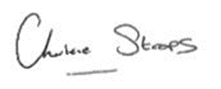 | Date: | 18/09/20

