
Equality, Good Relations and Human Rights SCREENING TEMPLATE with GUIDANCE

**Completed and Signed Screening Templates are public documents posted on the Trust’s website**
- All policies / proposals require an Equality Screening
- Policy authors are responsible for Equality Screenings

Section 1: Information about the Policy / Proposal
- Name of the policy/proposal | Proposal to amalgamate General Practitioner Out of Hours (OOH) provision onto one site (Beldoc ) during July and August 2021 at those times when there is limited GP cover i.e. weekend afternoons/early evenings, Bank Holiday afternoons/early evenings and between 12 midnight and 8am.
- Status of policy/proposal  (please underline) | New |  |  | Existing |  |  | Revised
- Department/Service Group:  (please underline) | Corporate Services Group  (Please specify) | Nursing and User Experience | Un-scheduled and Acute Care |  | Surgery & Specialist Services | Specialist Hospitals & Women’s Health |  | Children’s Community Services | Adult Social & Primary Care
- Description of the policy/ proposal? | Context  When Belfast Health and Social Care Trust was created from 6 Legacy Health and Social Services Trusts in 2007, it retained GP OOH provision at the existing at Beldoc on the Crumlin Road and Sebdoc on the Saintfield Road. Beldoc continued to support north and west Belfast whilst Sebdoc provided GP OOH service to south and east Belfast.  GP Out of Hours (OOH) aims to provide, for urgent conditions, a comprehensive, safe and efficient out of hours service to the Northern Ireland population, as well as to the non-resident transient population, who are also entitled to General Medical Services (GMS) services until the patient’s own GP surgery is next open.  GP OOH in Belfast is provided from the 2 legacy bases Beldoc and Sebdoc for a population of 354,706 people and the triage is provided by GPs – the outcome of which is onward referral, telephone advice, consultation at base or home visit.  From Monday – Friday, the Belfast service is provided from 6pm till midnight with 3 GPs at each base (Beldoc and Sebdoc) and 1 GP at each base from midnight till 8am At weekends, the service is provided between 8am and 6pm with a maximum of 5 GPs at Beldoc and a maximum of 6 GPs at Sebdoc. There are 9 x 6 hour shifts on each site which are staggered to meet peak periods of demand. From 6pm- midnight, with 3 GPs operating from each site and from midnight to 8am, the number of GPs reduced to one at each site. BHSCT GPOOH service is £1 million over budget.  Issue  The BHSCT GPOOH service has had ongoing issues trying to provide a full GPOOH service for both bases BELDOC and SEBDOC with particular issues in filling GP slots from the beginning of June. This has included having to close bases due to no GP cover for mainly the BELDOC site for Saturday and Sunday OOH services throughout June and has included 1 episode of closure during a week day. This meant that patients were redirected to the Urgent Care Centre at the Royal Victoria Hospital.  This is largely due to smaller pool of GPs in Belfast to recruit and retain. Whilst there is an official increase in the number of GPs, the workforce makeup is completely changing with more doctors working part-time. (Approximately 75% of the GP workforce between the ages 25 and 39 are female.) Working Out of Hours is not perceived as attractive option with risk and challenges of the GPOOH service. GPOOHs is already dependent on their semi- retired GPs to support the service This workforce shortage is further compounded by the requirement for GPs to work in Covid Centres. COVD 19 has also placed a significant strain on the GP workforce.  An RQIA review in April 2021 had already highlighted a number of challenges with the present GP Out-of-Hours Service model and “considered that this model may not be sustainable into the future. …they found that increasingly fewer GPs were contributing to the GP Out-of-Hours Service, a consequence of: increasing pressures facing daytime GP Services; increasing pressures in the out-of-hours service; limited flexible working arrangements; and financial implications associated with working in the out-of-hours service such as static pay and changes to pension arrangements. If no action is taken, the result is likely to be fewer locations able to provide GP Out-of-Hours Services, as well as increasing gaps in rotas and services in those locations that remain, with consequent delays and longer waiting times for patients”.  Rationale  The Trust is committed to providing a safe, effective and compassionate service for the greater Belfast area over the July/August period in 2021 and is therefore proposing that it will amalgamate provision for Belfast onto one site when there is limited GP cover i.e. weekend afternoons/early evenings, bank holiday afternoons/early evenings and the period between midnight and 8am. This will consolidate the scant resources and ensure that a Belfast wide GP OOH service will be able to safely assess and treat patients.  Figure 1: Map to show distance and time taken to travel between Beldoc and Sebdoc  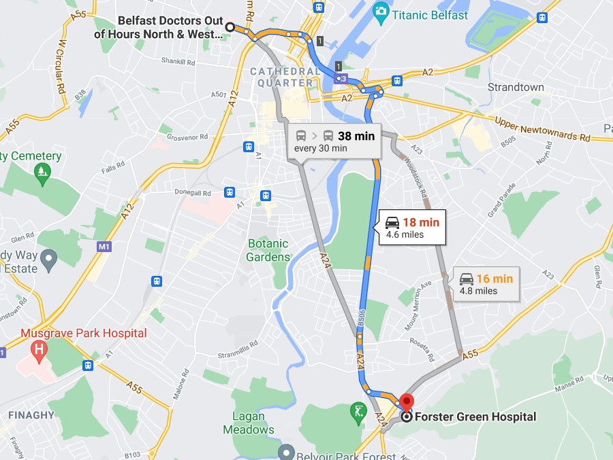  The tables below shows the GP OOH calls by type by hour May 2021 activity for GP OOH at Beldoc and then at Sebdoc. This illustrates the significant decrease in demand for the service between 12 midnight and 8am. It also shows the relatively low number of patients who are required to physically come to the base or who are deemed as requiring a home visit. Therefore the temporary and partial amalgamation of the current services into one base and the location will be of less import he Trust remains committed to the principle that "The purpose of GP Out-of-Hours Services in primary care should meet those urgent patient needs that cannot safely be deferred until the patient's own GP practice is next open”. This is a temporary reconfiguration for the months of July and August and should the Trust need to consider making this reconfiguration permanent, it would be subject to full engagement and public consultation in line with our statutory duties in terms of Personal and Public Involvement and Section 75: Equality duties of the Northern Ireland Act 1998. .  Table 1: GP OOH at Beldoc: Calls by type by hour May 2021  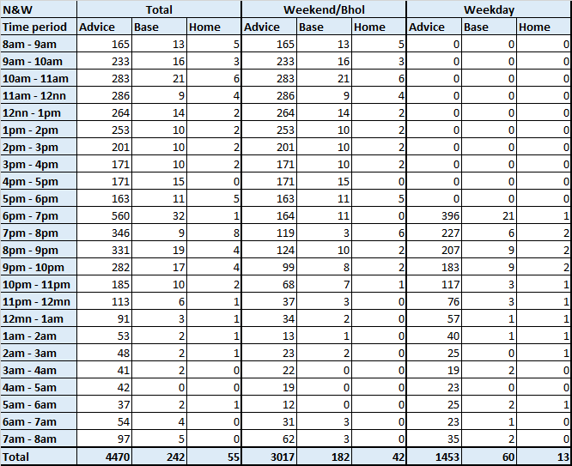  Table 2: GP OOH at SEBDOC; Call by type by hour May 2021  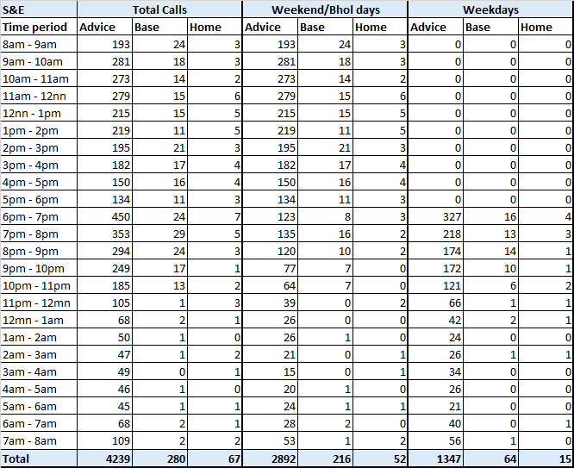  Table 3: Combined activity for Beldoc and Sebdoc May 2021  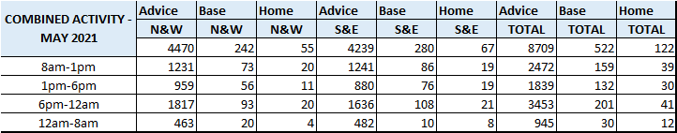  The tables above show that :  - In total and on average 6% of phone calls resulting in a need for a patient to come to the GP OOH base. And 1.4% of phone calls on average result in a need for the GP to undertake a home visit.  Figure 2: Average calls in May 2021  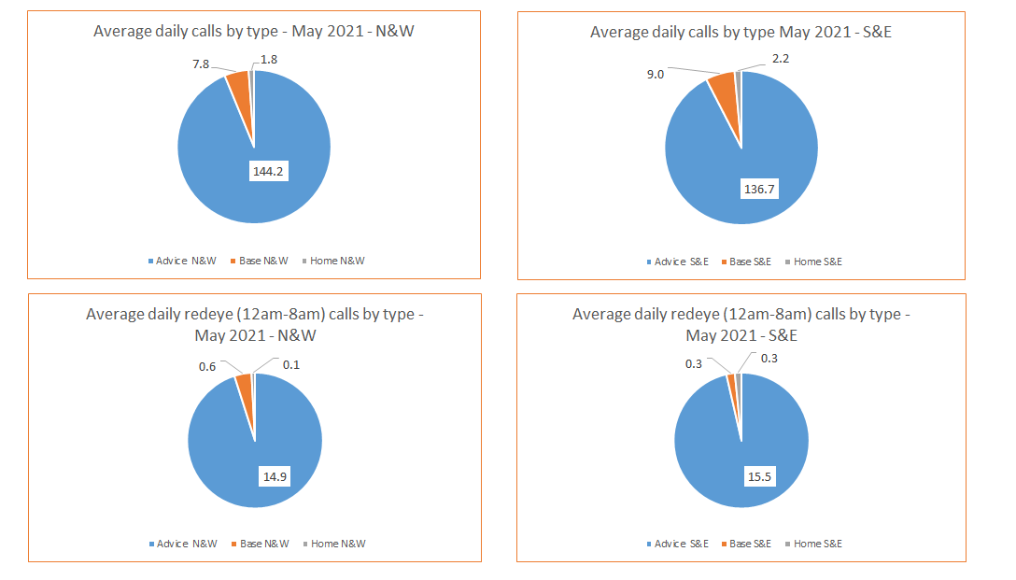  Further analysis of the May 2021 figures show that there is a marginally increased level of contacts made to Beldoc than Sebdoc during the 1-6pm shift – an average of 5 a day and during the same shift on a Bank Holiday, there are on average 4 more calls to Beldoc than Sebdoc. Overall in May during the 12 midnight to 8am shift, there was a very small differential of 0.5 contacts on a daily basis between Beldoc and Sebdoc.  Table 3: Analysis of May GP OOH activity  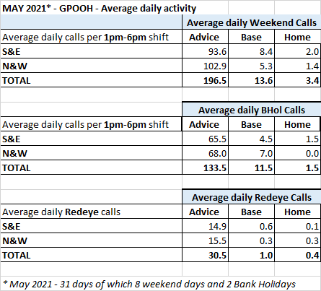  By way of illustration in terms of the scant available resources, projections for adequate staffing of the 2 GP OOH week commencing the 6th July show that there are significant shortfalls in terms of adequately and safely staffing both bases. This is in spite of ongoing efforts by the Administration Team to maximise rota coverage and it is fair to say that achieving this is becoming increasingly challenging.  Health Inequalities and Social Deprivation  Belfast Trust recognises that it provides services to the whole population of Belfast –some of whom experience high levels of deprivation and health inequalities. Some wards in North and West Belfast have the highest levels of deprivation in Northern Ireland and their communities experience some of the highest levels of chronic illnesses, poor mental health and those suffering from an addiction. The Annual Inequalities Report for 2021 found that large inequality gaps continue to exist for mental health indicators, with the death rate from intentional self-harm in the most deprived areas was double that in the least deprived areas. Life expectancy values for Northern Ireland as a whole are 76.8 years for males and 81.4 for females.1 Life expectancy is lowest in three Belfast constituencies (West, North and East). In Belfast West, the life expectancy of males (72.3 years) is four and one half years less than the Northern Ireland average (76.8), while the life expectancy of females (78.4) is three years lower than the regional average (81.4).  On the basis of the higher levels of uptake of GPOOH at Beldoc and some of the most deprived wards in Northern Ireland are within north and west Belfast, the Trust would propose that for the two month period that the contingency plan would be to amalgamate GP Out of Hours at the Beldoc site during those times when there is limited GP cover i.e. weekend afternoons/early evenings, Bank Holiday afternoons/early evenings and the Redeye period. (12 midnight to 8am).  The Trust remains committed to the principle that "The purpose of GP Out-of-Hours Services in primary care should meet those urgent patient needs that cannot safely be deferred until the patient's own GP practice is next open”. This is a temporary reconfiguration for the months of July and August and should the Trust need to consider making this reconfiguration permanent, it would be subject to full engagement and public consultation in line with our statutory duties in terms of Personal and Public Involvement and Section 75: Equality duties of the Northern Ireland Act 1998.  The Trust is also awaiting regional decision making in regard to the longer term future of Integrated Urgent Care which aims to have a more closely Integrated Urgent Care service in the out of hours period and is based on the need that the current system is not sustainable and that a more personalized and convenient service is available and responsive to people’s healthcare needs when  - they need urgent medical advice or assistance,  - they need to make an appointment with an urgent care service  - they require health information or reassurance about how care for themselves or what to do next
- Who owns the policy/proposal?  Where does it originate? | Belfast Trust and Primary Care Partners in conjunction with HSCB and DOH
- Who are the main stakeholders affected (Internal and External)? | Population of Belfast, General Practitioners, Belfast Trust Management and GP OOH Administrative Staff, Nursing, Drivers, Paramedics, Trade Unions
(1.7) Provide details of how you involved stakeholders, views of colleagues, service users, staff side or other stakeholders when screening this policy/proposal. | The recent RQIA review engaged with patients online and with postal surveys and the results showed a high level of patient satisfaction among those using the GP Out-of-Hours Service. The review found that expectation of a face to face care contact was high and that patients who received a home visit or consultation were more satisfied than patients who received telephone advice. The Review Team highlighted a concern that many patients perceived the GP Out-of-Hours Service as a continuation of daytime GP services rather than an urgent care service. This perception was important in relation to the service’s ability to respond to demand.
(1.8 ) Other policies/strategies with a bearing on this policy/proposal | - RQIA Review of GPOOH Services in Northern Ireland April 2021  - GP–Led Care Working Group report, DoH, March 2016 ‘building sustainable out of hours services.’  - Strategic framework of GP OOH, HSCB, Jan 2014  - Analysis of Survey Returns from General Practices reported by the then Department for Health, Social Services and Public Safety, in January 2015  - Estimating the Volume and Growth Strategic Framework for GP Out-of-Hours, HSC Board (June 2012).  - The case for change reported by the BMA in Northern Ireland in February 2015; and Understanding Pressures in General Practice reported by the King’s Fund in May 2016  - No More Silos - Urgent care review and implementation
- Are there any factors that could contribute to/detract from the intended aim/outcome of policy/proposal? | BHSCT is committed to the full implementation of this policy and through regular monitoring it is anticipated that the aims and objectives of the policy will be fully realised and any factors that could detract from those aims and objectives will be minimised/avoided. However influencing factors regarding the full implementation of the policy include: GP availability and general public awareness in terms of appropriately accessing the right level of care e.g. Emergency Department, GP regular hours and GP Out of Hours

Section 2: Classification of the Policy / Proposal: If it is clinical or technical in nature with no bearing on equality of opportunity or good relations, you will be able to screen the policy out. Please note these are the only circumstances that a policy can be screened out at this early stage.

- The purpose of this Section is to consider the policy/proposal in terms of its relevance and likely impact (actual/potential) on equality of opportunity, disability duties, good relations and human rights & to consider what Reasonable Adjustments may be needed for patients/service users/staff including any information e.g. leaflets / letters in accessible/alternative formats. Guidance on how to promote accessible services
- To determine the impact (actual and potential) of a policy/procedure on equality of opportunity, disability duties, good relations and human rights please complete the screening questions at 2.1 – 2.6.

Section 75 (‘S75’) equality categories include: Age, Dependent Status, Disability, Gender, Marital Status Ethnicity, Religion, Political Opinion and Sexual Orientation.
Screening Questions | Yes | No
(2.1) Is there an impact on Equality of Opportunity for those affected by this policy, for each of the S75* equality categories? I.e. is there a differential impact for one S75 group rather than the others? | √
(2.2) Are there better opportunities to promote equality of opportunity for people within the S75 categories? | √
(2.3) Does the policy impact upon Good Relations between people of a different religious belief, political opinion or racial group? |  | √
(2.4) Are there opportunities to better promote good relations between people of a different religious belief, political opinion or racial group? |  | √
(2.5) Are there opportunities to encourage disabled people to participate in public life and promote positive attitudes toward disabled people? (Disability Duties) |  | √
(2.6) Does the policy/proposal impact on human rights? |  | √

SCREENING DECISION

- If you have answered Yes to any of the above questions complete Sections 3 - 9. OR

- If you have answered No to all of the above questions the policy may be screened out - go to Screening Decision at 2.7.

- It should be noted that all policies are likely to have some impact on equality in how they are communicated to stakeholders (particularly in relation to disability or ethnic minority languages). You must ensure that you have considered this in line with the guidance document Making Communication Accessible for All.
- Ethnic minority interpreters are available from NIHSCIS in a range of 35 different languages and ISL/BSL interpreters can be accessed via RNID - National hearing loss charity Further guidance is available from the Planning & Equality Team.
N.B: All Staff must complete their mandatory equality, good relations and human rights training once every five years. This can be booked via HRPTS or completed online at www.hsclearning.com. The online programme is called ‘Making a Difference.’ Belfast Trust staff can also access a suite of equality and diversity training including: disability awareness, human rights and embracing diversity in HSC – please contact Lesley.Jamieson@belfasttrust.hscni.net for more information. An Equality, Good Relations and Human Rights training manual has also been produced for staff
(2.7) Screening Decision:

This policy / proposal is ‘screened out’ on the basis that:

IMPACT: | OUTCOME:
No Impact | Screened Out as it is purely clinical or technical nature and has no relevance or impact (actual / potential) in terms of equality of opportunity, disability duties, good relations and human rights.
(2.8) Any other reasons: Please detail

Approved Lead Officer:  Position:  Date: |  | Countersigned by*:  Equality Manager:  Date:
Please sign and date and forward to the Planning and Equality Team for consideration - equality.team@belfasttrust.hscni.net

*Equality screenings are completed with information provided by the policy author subject to advice and assistance provided by the Trust’s Equality Managers

Section 3: Consideration of Equality and Good Relations issues and evidence used
This section records the quantitative and qualitative data you have used to consider equality and good relations issues including:
- The assessment of impact on staff and service users

(3.1) Quantitative and Qualitative Data: Service Users
Your own information systems might contain qualitative data relating to patients/service users. If you only have some of the data, just complete what you have and use proxy indicators for other groups e.g. political opinion or sexual orientation. In the absence of data it may be useful to do a survey or a snapshot of who your service users are. For the qualitative data, consider using anecdotal or professional experience in this section.
Equality Category | Service Users | Quantitative Data  (2011 Census Data unless otherwise stated) |  |  | Qualitative Data  (Needs, Experiences, Priorities)
Equality Category | Service Users | Belfast / Castlereagh population |  | Service users affected % | Qualitative Data  (Needs, Experiences, Priorities)
1. Age | 0-15  16-24  25-34  35-44  45-54  55-64  65+ | 22%  11%  12%  14%  14%  12%  15% |  | GP OOH Provision is available for all people of all ages in Belfast and Castlereagh | The RQIA Review in 2021 found that calls to Out of Hours in relation to children (under 10 years of age) and older people (over 60 years of age) were the most frequent to the service; accounting for 53% of all contacts. (this was in regard to all of NI GP Out of Hours Provision) Anecdotally GP OOH providers recounted that they were receiving an increased volume of calls from residential and nursing homes.  There will be a differential impact on older people and those under 10.  For those requiring to visit the GP Out of Hours base, there is a travel distance of less than 5 miles between the two current bases Beldoc and Sebdoc (16-18 minutes by car or 38 minutes by public transport) (. It is important to note that due to the public transport infrastructure, it may require people in certain areas of Belfast who do not have their own private transport to either take one bus into the city centre and a further bus to either base in the north of Belfast or take a taxi.  The 2019/2020 NISRA Continuous Household Survey indicated that 68% of people in the Belfast Trust area had access to one or more cars/vans; 32% of people did not have access to a car/vans. Regionally, the figure was 83% of people with access to a car/or van and 17% without.  Given the statistics which show there is very little requirement to attend the GP OOH base during the specified times, this will impact on very few people.
2. Dependent Status | Caring for a child dependent older person/ person with a disability | 12% of usually resident population provide unpaid care - 36% of whom are male and 64% are female |  |  | As aforementioned, parents of children and carers for older people account for more than half the contacts made to Out of Hours. Therefore on this basis there will be a differential impact on those with caring responsibilities. For those requiring to visit the GP Out of Hours base, there is a travel distance of less than 5 miles between the two current bases Beldoc and Sebdoc. It is important to note that due to the public transport infrastructure, it may require people in certain areas of Belfast who do not have their own private transport to either take one bus into the city centre and a further bus to either base in the north of Belfast or take a taxi. (16-18 minutes by car or 38 minutes by public transport).  The 2019/2020 NISRA Continuous Household Survey indicated that 68% of people in the Belfast Trust area had access to one or more cars/vans; 32% of people did not have access to a car/vans. Regionally, the figure was 83% of people with access to a car/or van and 17% without.  Given the statistics which show there is very little requirement to attend the GP OOH base during the specified times, this will impact on very few people.
3. Disability | Yes  No | 21%  79% |  |  | The Trust recognises people with disabilities may access primary care services more – in and out of hours and given that the prevalence of disability increases with age, therefore this proposal will impact differentially on disabled people. For those requiring to visit the GP Out of Hours base, there is a travel distance of less than 5 miles between the two current bases Beldoc and Sebdoc. It is important to note that due to the public transport infrastructure, it may require people in certain areas of Belfast who do not have their own private transport to either take one bus into the city centre and a further bus to either base in the north of Belfast or take a taxi. (16-18 minutes by car or 38 minutes by public transport).  The 2019/2020 NISRA Continuous Household Survey indicated that 68% of people in the Belfast Trust area had access to one or more cars/vans; 32% of people did not have access to a car/vans. Regionally, the figure was 83% of people with access to a car/or van and 17% without.  Given the statistics which show there is very little requirement to attend the GP OOH base during the specified times, this will impact on very few people.
4. Gender | Female  Male | 49%  51% |  |  | According to the RQIA report in 2016/17, 42% (234,900) of contacts made with the GP Out-of-Hours Service across Northern Ireland (expressed as gender of patient) were male, and 58% (329,191) were female. Therefore proportionally there are more females accessing the service than males. For those requiring to visit the GP Out of Hours base, there is a travel distance of less than 5 miles between the two current bases Beldoc and Sebdoc. It is important to note that due to the public transport infrastructure, it may require people in certain areas of Belfast who do not have their own private transport to either take one bus into the city centre and a further bus to either base in the north of Belfast or take a taxi. (16-18 minutes by car or 38 minutes by public transport).  The 2019/2020 NISRA Continuous Household Survey indicated that 68% of people in the Belfast Trust area had access to one or more cars/vans; 32% of people did not have access to a car/vans. Regionally, the figure was 83% of people with access to a car/or van and 17% without.  Given the statistics which show there is very little requirement to attend the GP OOH base during the specified times, this will impact on very few people.
5. Marital Status | Married/Civil Partnership Single  Other/Not known | 34.21%  46.6%  19.19% |  |  | On the basis of the information available, there is nothing to suggest that this will impact on the basis of a person’s marital status.
6. Race  Ethnicity | White  Black/Minority Ethnic | 98%  2% |  |  | On the basis of the information available, there is nothing to suggest that this will impact on the basis of a person’s race or ethnicity.
7. Religion | Roman Catholic | 41% |  |  | On the basis of the information available, there is nothing to suggest that this will impact on the basis of a person’s religious belief.
7. Religion | Presbyterian  Church of Ireland  Methodist  Other Christian | 42%
7. Religion | Buddhist Hindu Jewish Muslim Sikh Other None | 17%
8. Political Opinion  Based on Council seats October 2017 | DUP  SF  SDLP  UUP  APNI  Green  PBP  IND  PUP | Belfast  13  19  4  6  8  1  1  5  3 | Lisburn & Castlereagh  4  1  1  2  4  1  0  0  0 |  | On the basis of the information available, there is nothing to suggest that this proposal will impact on the basis of a person’s political opinion.
9. Sexual Orientation | Opposite sex  Same sex  Same and Opposite sex  Do not wish to answer /Not known | Estimated 6-10% of persons identify as lesbian, gay, bisexual  Source: 2012 report by Disability Action & Rainbow Project |  |  | On the basis of the information available, there is nothing to suggest that this proposal will impact on the basis of a person’s sexual orientation.
Health inequalities |  |  |  |  | Overall it can be seen that Belfast Health and Social Care Trust area still suffers from significant deprivation, in comparison with NI –  Belfast Trust Population Health Outcomes  The Trust is mindful that it provides services for users from some of the most deprived areas in Northern Ireland:  - Belfast is the most deprived out of the 26 Local Government Districts (LGDs).  - Belfast has the highest concentration of disadvantage with 7 out of the worst 10 wards (3 North, 3 West, 1 Shankill) and 12 out of the worst 20 wards on the NI Multiple Deprivation Measure 2 (NIMDM) 2010 (also known as Noble Measure).  - Belfast has 9 of the 10 worst wards in the region in relation to health deprivation.  - The most widespread disadvantage and deprivation exists in north and west Belfast.  The Trust and Primary Care are aware of the direct correlation between levels of deprivation and poor health outcomes. Research shows that population health is affected to a greater extent by the economic, social and environmental conditions in which people are born, live, work and age, with overall health tending to improve with each step up the socioeconomic ladder. This is commonly known as the ‘social gradient of health’ and exists across the whole population with the greatest differences, or inequalities in health seen between the most and least disadvantaged in our society. This in turn will mean that people from more deprived areas will rely more heavily on health and social care services including GP Out of Hours, resulting in a differential impact on people from deprived communities. For those requiring to visit the GP Out of Hours base, there is a travel distance of less than 5 miles between the two current bases Beldoc and Sebdoc. It is important to note that due to the public transport infrastructure, it may require people in certain areas of Belfast who do not have their own private transport to either take one bus into the city centre and a further bus to either base in the north of Belfast or take a taxi. (16-18 minutes by car or 38 minutes by public transport).  The 2019/2020 NISRA Continuous Household Survey indicated that 68% of people in the Belfast Trust area had access to one or more cars/vans; 32% of people did not have access to a car/vans. Regionally, the figure was 83% of people with access to a car/or van and 17% without.  Given the statistics which show there is very little requirement to attend the GP OOH base during the specified times, this will impact on very few people.
  32 | Health outcomes were worse than the NI average ..most notably Drug Misuse/Related Mortality, Alcohol Specific Mortality and Alcohol Related Admissions
  8 | Health outcomes were similar to the NI average
  3 | Health outcomes were better than the NI average – most notably circulatory admissions

Some staff will be affected by this proposal who work within the Admin, Medical and Support Service Personnel Areas –The majority of the Medical staff are sessional and vary in the volume of shifts that they cover.
(3.2) Quantitative and Qualitative Data: Staff

This information will be provided together with analysis and advice by the Employment Equality Team in the Human Resources department.

Quantitative Data: For staff data please contact Martin McGrath on 028 95 048353 / martin.mcgrath@belfasttrust.hscni.net

Qualitative Data: Consideration will be given to the different needs, experiences and priorities of each of the categories in relation to the policy / proposal.
Should any equality/modernisation related issues arise, they will be managed through the Organisational Change Framework

When organisational/policy change is necessary, regardless of whether it is a permanent or temporary change, the Trust is committed to treating staff fairly and equitably. Staff can be assured that the change process will be properly managed. This includes consultation with staff and the opportunity for staff to discuss in one to one meetings any adverse equality impacts resulting in changes to their employment.

This Framework also works alongside other Human Resources policies including, for example, the Disability and Reasonable Adjustment Framework, the Work Life Balance Policy and Procedure, the Recruitment and Selection Policy and Procedure and Agenda for Change Terms and Conditions Handbook.

Equality Category |  |  | Groups |  |  |  |  | Quantitative Data |  |  |  |  |  |  | Qualitative Data
 |  |  |  |  |  |  |  | Belfast Trust workforce  (@January 2021) |  |  |  |  |  | Staff affected by the Policy/Proposal %
1.  Age |  |  | 16-24  25-34  35-44  45-54  55-64  65+ |  |  |  |  |  |  |  |  |  |  |  | The workforce profile is broadly in line with that of the Trust overall workforce profile with (51%) aged <45 compared to that of the Trust data (49%) aged >45+
  6%
  24%
  24%
  24%
  19%
  3%
  17%
  34%
  20%
  17%
  12%
2.  Dependant Status |  |  | Dependants  No Dependants Not known |  |  |  |  |  |  |  |  |  |  |  | A higher proportion of staff have declared dependant status +15% (33%) compared to that of the workplace profile (18%). However, it should be noted that 43% of staff have not declared.  A higher proportion of staff have declared no dependant status +5% (25%) compared to that of the workplace profile (20%).
  18%
  20%
  62%
  33%
  25%
  43%
3. Disability |  |  | Yes  No  Not known |  |  |  |  |  |  |  |  |  |  |  | Broadly in line with overall workforce profile
  2%
  63%
  35%
  3%
  62%
  35%
4. Gender |  |  | Female  Male |  |  |  |  |  |  |  |  |  |  |  | There is a higher proportion of male staff + 23% 473%) compared to that of the workplace profile (24%).
  76%
  24%
  53%
  47%
5. Marital Status |  |  | Married/ Civil P’ship  Single  Other/Not known |  |  |  |  |  |  |  |  |  |  |  | A lower proportion of staff have declared marital status as married -15% (33%) compared to that of the workplace profile (48%).  A lower rate of Single Status is also evident -18% (13%) compared to that of the workplace profile (31%).
  48%
  31%
  4%
  17%
  33%
  13%
  2%
  52%
6. Race  a) Ethnicity |  |  | BME White  Not Known |  |  |  |  |  |  |  |  |  |  |  | A lower proportion of staff Ethnicity status is ‘White’ -9% (62%) compared to that of the workplace profile (71%). However, it should be noted that 32% of staff have not declared.
  4%
  71%
  26%
  5%
  62%
  32%
b) Nationality |  |  | GB  Irish  Northern Irish  Other  Not known |  |  |  |  |  |  |  |  |  |  |  | A higher proportion of staff Nationality status is ‘GB’ +8% (29%) compared to that of the workplace profile (18%).  A higher proportion of staff Nationality status is ‘NI’ +6% (7%) compared to that of the workplace profile (1%).
  21%
  15%
  1%
  63%
  29%
  16%
  7%
  48%
7. Religion  a) Community Background |  |  | Protestant  Roman Catholic  Neither |  |  |  |  |  |  |  |  |  |  |  | There is a lower proportion of staff from the Roman Catholic community background -14% (31%) compared to that of the overall workforce profile (45%). However, it should be noted that 36% of staff have not declared.
  35%
  45%
  20%
  33%
  31%
  36%
b) Religious Belief |  |  | Christian  Other  No religious belief  Not known |  |  |  |  |  |  |  |  |  |  |  | A higher proportion of staff Religious Belief status is ‘Christian’ +10% (41%) compared to that of the workplace profile (31%). However, there is limited data available as 44% of staff have not declared.
  31%
  10%
  1%
  58%
  41%
  9%
  5%
  44%
8. Political Opinion  * 2011 Assembly election |  |  | Broadly Nationalist Broadly Unionist Other Do not wish to answer/Unknown  Not known |  |  |  |  |  |  |  |  |  |  |  | A lower proportion of staff Political Opinion status is ‘Not Known’ -14% (41%) compared to that of the workplace profile (55%).  However, there is limited data available, as 41% of staff have not declared.
  7%
  7%
  23%
  55%
  8%
  11%
  8%
  27%
  41%
  14%
9. Sexual Orientation |  |  | Opposite sex  Same sex or both sexes  Do not wish to answer |  |  |  |  |  |  |  |  |  |  |  | Limited data available.  A higher proportion of staff Political Opinion status is ‘Opposite Sex’ +7% (53%) compared to that of the workplace profile (44%).
  44%
  1%
  6%
  48%
  53%
  2%
  6%
  39%
Section 4: Consideration of Impacts, Mitigation, Alternative Policies / Proposals
This section details steps that can be taken to reduce/remove any adverse impact or opportunities to better promote equality of opportunity

Given the evidence gathered in Section 3, please identify for each of the nine equality categories the level of impact, mitigation measures and alternative policies / proposals that better promote equality of opportunity.
Is there an impact on Equality of Opportunity for those affected by this policy, for each of the S75 equality categories?
Are there better opportunities to promote equality of opportunity for people within the S75 categories?
Does the policy impact upon Good Relations between people of a different religious belief, political opinion or racial group?
Are there opportunities to better promote good relations between people of a different religious belief, political opinion or racial group?
Are there opportunities to encourage disabled people to participate in public life and promote positive attitudes toward disabled people?
Does the policy/proposal impact on human rights?
(4.1) SERVICE USERS
Equality Category |  |  |  |  | Level of Impact |  |  |  |  |  |  |  | Mitigation measures and alternative policies or actions that might lessen the severity of the equality impact. Also detail what measures can be taken to further promote equality of opportunity.  If Major impact identified for any category, an EQIA is necessary please contact the Planning and Equality Team directly.
 |  |  |  |  | Major |  |  |  | Minor |  |  | None
Age |  |  |  |  |  |  |  |  | √ |  |  |  | This is a temporary partial reconfiguration for 2 months to consolidate limited resources only at the specified times when there is a significant and evident decrease in demand for GP OOH provision. (weekend afternoons/early evenings, Bank Holiday afternoons/early evenings and between 12 midnight and 8am.)  For the majority of patients approx. (93%), this proposal will have no impact at all given that most of the advice is provided by telephone and only a very minor percentage of people need to come to the base.  The distance between the 2 bases is less than five miles.  The Trust is proposing to use the Beldoc site in light of the increased demand from communities in both north and west Belfast and because of the increased levels of health inequalities and social deprivation in some wards.  The Trust is currently working to enhance GP OOH provision with the following improvements implementing Nursing triage to commence in September /October and is also seeking funding for pharmacist input for weekends to help with repeat prescriptions. This is pending a regional review of GP Out of Hours provision.
Dependant Status |  |  |  |  |  |  |  |  | √
Disability |  |  |  |  |  |  |  |  | √
Gender |  |  |  |  |  |  |  |  | √
Marital Status |  |  |  |  |  |  |  |  |  |  |  | √
Race (Ethnicity) |  |  |  |  |  |  |  |  |  |  |  | √
Religion |  |  |  |  |  |  |  |  |  |  |  | √
Political Opinion |  |  |  |  |  |  |  |  |  |  |  | √
Sexual Orientation |  |  |  |  |  |  |  |  |  |  |  | √
Inequalities |  |  |  |  |  |  |  |  | √
(4.2) STAFF
Equality Category |  |  |  |  |  | Level of Impact |  |  |  |  |  |  | Mitigation measures and alternative policies or actions that might lessen the severity of the equality impact  Also detail what measures can be taken to further promote equality of opportunity (where Minor Impact identified).  If Major impact identified for any category, an EQIA is necessary please contact the Planning and Equality Team directly.
 |  |  |  |  |  | Major |  |  |  | Minor |  | None
Age |  |  |  |  |  |  |  |  |  |  |  |  | Compared to the overall Trust profile there is a higher proportion of male staff (53%) and with dependant status (33%). A higher proportion of staff have also declared has having a religious belief (50%) 41% of which are Christian.  Where limited data is available in Sexual Orientation, Political Opinion and Religious Belief, Community Background and Ethnicity it would be remiss to decide a firm level of impact.  The service will constructively engage with those affected and ensure that it adheres to the Organisations Management of Change Framework.  In line with this process, staff will be offered the opportunity to discuss in one to one meetings any adverse equality impacts resulting in changes to work location and/or working patterns.
Dependant Status
Disability
Gender
Marital Status
Race | Ethnicity
Race | Nationality
Religion | Community Background
Religion | Religious Belief
Political Opinion
Sexual Orientation
Multiple Identity e.g. female staff with caring responsibilities
Section 5: Good Relations

Based on the evidence collected in Section 3 & 4:
- To what extent is the policy/proposal likely to impact Good Relations i.e. between people of different religious belief, political opinion or racial group?
- Are there any additional measures that could be suggested to ensure the policy or proposal promotes Good Relations?
Good Relations category |  | Level of impact |  |  |  |  |  |  |  |  | Mitigation Measures and Alternative Policies or Actions that might lessen the severity of the equality impact. Are there opportunities to further promote good relations (where Minor Impact identified)?  If Major impact identified for any category, an EQIA is necessary please contact the Planning and Equality Team directly.
 |  | Major |  | Minor |  |  | None
Religious belief |  |  |  |  |  |  | X |  |  |  | All Trust staff attend mandatory Equality, Human Rights and Good Relations training which includes reference to the Good Relations duty.  The Trust has a clear and well defined Good Relations strategy ‘Healthy Relations for A Healthy Future 2’ whereby the corporate commitment to Good Relations is underlined.  The Trust will ensure that all services and all facilities are welcoming to all patients their carers and advocates regardless of their religious affiliation, political opinion and racial group.  Given the nature of the GP OOH service being predominantly over the telephone, it is not envisaged that the location of the GP OOH on the Crumlin Road would constitute a “chill factor” for people accessing the service.  Appropriate and inclusive means of communication will be used to contact and communicate with patients, their families and carers who do not speak English as their first language. An interpreter will be booked and/or letters translated using established protocols within the Trust as appropriate.
Political opinion |  |  |  |  |  |  | X
Racial group |  |  |  |  |  |  | X
Section 6: Disability Duties
How does the policy / proposal:  - encourage disabled people to participate in public life and  - promote positive attitudes towards disabled people?  Consider what other measures you could take to meet these duties. | Appropriate and inclusive means of communication will be used to communicate with patients and carers. Staff will be mindful of any reasonable adjustments required in the implementation of this policy for both patients and carers.  All Health and Social Care staff are required to undertake mandatory equality training which includes disability duties.  Disability Awareness Training is provided throughout the year, available on HRPTS. Bespoke Disability awareness training sessions can also be provided for staff teams on demand, when it is feasible to do so.  The Trust has produced a suite of guidance for increasing access to services and information. These are all available on the hub or on request from the Planning & Equality team.
Section 7: Human Rights
Belfast Health and Social Care Trust is committed to providing the highest attainable standard of physical and mental health within our available resources.

- Does the policy/proposal negatively impact on any of the following human rights?
Article | Yes | No
A2: Right to life |  | X
A3: Right to freedom from torture, inhuman or degrading treatment or punishment |  | X
A4: Right to freedom from slavery, servitude & forced or compulsory labour |  | X
A5: Right to liberty & security of person |  | X
A6: Right to a fair & public trial within a reasonable time |  | X
A7: Right to freedom from retrospective criminal law & no punishment without law |  | X
A8: Right to respect for private & family life, home and correspondence. |  | X
A9: Right to freedom of thought, conscience & religion |  | X
A10: Right to freedom of expression |  | X
A11: Right to freedom of assembly & association |  | X
A12: Right to marry & found a family |  | X
A14: Prohibition of discrimination in the enjoyment of the convention rights |  | X
1st protocol Article 1 – Right to a peaceful enjoyment of possessions & protection of property |  | X
1st protocol Article 2 – Right of access to education |  | X
(7.1) Outline any actions you will take to promote awareness of human rights and evidence that human rights have been taken into consideration in decision making processes:
The Trust is committed to promoting, protecting and respecting human rights in all aspects of its work and will ensure that human rights are considered as an integral part of its actions and decision-making processes. The Trust acknowledges the importance of taking a human rights based approach and will endeavor to ensure that the principles of human rights underpin all areas of work across the organisation. The Trust fully upholds the right to the highest attainable standard of physical and mental health and is proposing this temporary reconfiguration during July and August 2021 at limited times when demand is traditionally very low and to provide the service safely, equitably and effectively within available resources.

Section 8: Screening Decision
(8.1) Given the detail provided from sections 1-7 of this template, how would you categorise the impacts of this policy / proposal?
Tick ONE: | IMPACT: | OUTCOME:
 | Major Impact | Screened In for EQIA
√ | Minor Impact | Screened Out with Mitigation Required to better promote equality of opportunity, disability duties, good relations and human rights.
 | No Impact | Screened Out as it is purely clinical or technical nature and has no relevance or impact (actual / potential) in terms of equality of opportunity, disability duties, good relations and human rights.
(Please complete details required for one of the options below)
(8.2) Please give reasons for your decision and detail any mitigation you have considered.
As previously outlined, this is a temporary and partial reconfiguration during time periods when there is significantly less contact with GP OOH. This will be over the months of July and August and will only occur at Bank Holidays (of which there are two 13th July and 30th August) afternoons/early evenings, weekend afternoons/early evenings and between 12midnight to 8am.

The vast majority of contact between patients and GP OOH is over the telephone therefore where the GP OOH base is will be immaterial to a high proportion of the patients.
The Trust will commit to ensuring that use of e-technology and virtual consultations will help ensure equity of access to the GP Out of Hours so that prescriptions can be emailed to a local pharmacy so that people from south and east Belfast can pick up their prescription without having to travel to the Crumlin Road base and also that virtual consultations will facilitate the GP to interact with the patient and lay eyes on them to aid their assessment and enhance their advice. GPs can refer directly into the Urgent Care Centre, which is collocated with the Emergency Department at the Royal Victoria Hospital.

Section 9: Monitoring
Please detail how you will monitor the effect of the policy/proposal for impact in terms of equality of opportunity, good relations, disability duties and human rights?

The Trust will monitor uptake of the service and will closely triangulate the activity data with qualitative information from both patients and GPs and Trust staff over the two month period. This will help to ensure that the impact is not more adverse than initially anticipated.

Section 10: Sign Off

Please sign /date and forward to the Equality and Planning Team for consideration - Lesley.Jamieson@belfasttrust.hscni.net.

Equality screenings are completed with information provided by the policy / proposal author subject to advice and assistance from the Trust’s Equality Managers.

Please note that Completed and Signed Screening Templates are public documents and are posted on the Trust’s website.

Approved Lead Officer: | Brian Armstrong | Countersigned by:
Position | Director of Unscheduled and Acute Care | Equality Manager | Orla Barron
Date | 1st July 2021 | Employment Equality Manager | Martin McGrath

Public authorities have a positive obligation to protect life, and a negative obligation not to remove life
This is an absolute right that cannot be restricted or interfered with
This is an absolute right that cannot be restricted or interfered with
On Occasion minor impact can warrant an EQIA

