Genetics results letter: cancer panel testing through mainstream pathway

Please ensure that you insert the appropriate details into the bold [boxed off] text in the template letter below.

Result: PMS2 pathogenic gene change identified

Dear [patient name],

You previously had a blood test carried out to look for changes in several genes associated with breast and ovarian cancer, as well as other cancers. This letter is to inform you of your genetic test result, and provide you with written documentation of this.

The test has identified a pathogenic (cancer-causing) change in the PMS2 gene in your blood sample. This result may reveal further increased cancer risks, as well as those of your biological relatives. I have enclosed a sheet which provides some information about what your result means.

I have requested that an appointment is made for you with the Clinical Genetics service to discuss this in greater detail and answer any questions that you may have. They may send you a family history questionnaire to be completed prior to your appointment.

Yours sincerely,
[Mainstream clinician name]

Cc: Department of genetic medicine, Belfast City Hospital via EPIC referral
Enc: Patient information sheet for those who receive an PMS2 positive genetic test result

Information for those who receive a PMS2 positive genetic test result
What does my genetic testing result mean?
Our genes can be thought of as our ‘inherited set of instructions’. They tell our body how to grow, develop and function. The PMS2 positive result you have received means that a pathogenic (cancer-causing) change has been identified in 1 of your 2 PMS2 gene copies that affects how it works.
Individuals who carry a PMS2 pathogenic gene change have a condition called ‘Lynch Syndrome’, and primarily have increased risks of developing bowel and endometrial (womb) cancers. Your lifetime risks of developing further primary cancers is greater than the general population due to this result. You may be eligible for additional screening to detect early signs of cancer.
What does this result mean for my blood relatives?
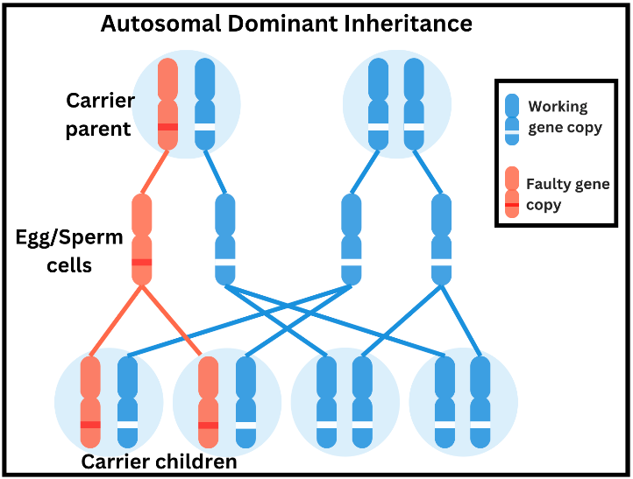
We receive half of our genetic information from each parent. If one parent carries an altered PMS2 gene copy, there is a 50% chance that this will be passed on to each child (regardless of their gender), and a 50% chance that the healthy copy is passed on. This is known as autosomal dominant inheritance. Because we share some of our genetic information with our blood relatives, there is a chance they may also carry the same gene change and therefore also have increased risks of developing certain cancers. These relatives may be eligible for genetic testing to determine whether they have also inherited it. This will be coordinated through clinical genetics and will be discussed at your follow-up appointment.
What are the next steps?
You will soon be offered an appointment with clinical genetics. During this, the genetics health professional will discuss in greater detail the specific risks associated with the gene change that has been identified in you, as well as screening and management options, and support available to yourself and your relatives. This is also a good opportunity to discuss any questions and concerns you may have. Prior to or during your appointment, you will be asked to provide information about your family history:
- To allow tailored risk information to be provided (associated genetic risks vary significantly when family history and individual circumstances are considered)
- To allow us to identify all of those at-risk who should be offered testing (note that we do not contact your family members)
The genetics team can also provide you with information and support to help share this information with the relevant relatives in a way that you feel most comfortable with.
Contact details for the clinical genetics service
In the meantime, if you have any urgent queries, please do not hesitate to contact us:
Email: genetic.medicine@belfasttrust.hscni.net Tel: 028 9504 8022

