Equality, Good Relations and Human Rights SCREENING TEMPLATE
Overview of Equality Screening Process

Section 1: Policy Scoping: This notes the background & context of the policy/proposal/decision being screened.
Section 2: Screening Classification: The purpose of this section is to consider the policy/proposal/decision in terms of its relevance and likely impact (actual/potential) on equality of opportunity, disability/good relations duties and human rights. Policies may be screened out at this stage provided they are clinical and/or technical and have no relevance whatsoever to equality, disability/good relations and human rights and have no bearing in terms of its likely impact on equality of opportunity or good relations for people within the equality and good relations categories.
Section 3: Evidence Used to Assess Impact: This section records the quantitative and qualitative data gathered and considered across the 9 protected groups (plus multiple identities) to assess the impact of the policy/proposal/decision on staff and service users.
Section 4: Consideration of Impact & Identification of Mitigation and/or Alternative Policies given the evidence.
Section 5: Good Relations Duties: Based on the evidence gathered the Good Relations duties are considered.
Section 6: Disability Duties: Based on the evidence gathered the Disability Duties are considered.
Section 7: Human Rights: Based on the evidence gathered Human Rights obligations are considered.
Section 8: Screening Decision: In this section, a decision is taken as to whether or not there is a need to carry out an equality impact assessment (EQIA), or to introduce (a) measures to mitigate the likely impact (b) an alternative policy to better promote the duties.
Section 9: Monitoring: identify the steps that will be taken to monitor the policy

Section 10: Approval and Authorisation: The screening decision is verified and approved by a senior manager responsible for the policy. Equality screenings are completed by a senior manager subject to advice/assistance from Trust Equality Managers.
Section 11: Statutory Rural Impact Assessments: Signposting
**Completed Screening Templates are public documents posted on the Trust Website**
Ref No: ES Jan 24 11 
Section 1: Policy Scoping: Information about the Policy / Proposal / Decision

- Name of the policy/proposal/decision |  |  |  | Relocation of the Sleep Service from City Hospital to Mater Hospital
- Status of policy/proposal/decision |  |  |  | New |  |  |  | Existing |  |  |  |  | Revised
- Trust Directorate / Division |  |  |  | Corporate Services Group (Please specify)  - Performance, Planning & Informatics  - Finance, Estates & Capital Development  - HR & Org Development  - Corporate Comms |  | Nursing and User Experience  Medical Directorate |  |  |  | Unscheduled Care and Older People's Acute Services |  | ACCTSS and Surgery  Anaesthetics, Critical Care, Theatres and Sterile Services (ACCTSS) |  |  | Trauma, Orthopaedics, Rehab Services, Maternity, ENT, Dental and Sexual Health
 |  |  |  | Mental Health and Intellectual Disability |  | Cancer and Specialist Services |  |  |  | Children's Community Services and Social Work |  | Child Health & NISTAR, Imaging, Medical Physics and Outpatients and Medical Illustration |  |  | Adult Community, Older Peoples' Services and Allied Health Professionals
- Description of the policy/ proposal/decision? |  |  |  | This is an equality screening of the relocation of the Sleep Service from City Hospital to Mater Hospital which occurred in August 2023.  Background  The Sleep Service provides a sleep diagnostic and treatment service for patients with obstructive sleep apnoea and other more complex sleep disorders. The service carries out approximately 2200 diagnostic tests per year and issues CPAP treatment to around 650 patients per year. The Sleep Service also look after 4000 existing CPAP patients who require an annual review of their equipment and new consumables.  Sleep medicine has grown massively over the last 10-15 years. This is reflected in recent stats that showed approximately 40% of all referrals directed to respiratory services in the Belfast Trust are sleep related.  The Sleep Clinic has 5 staff members:  - Sleep Physiology Manager  - Senior Chief Sleep Physiologist  - Senior Sleep Physiologist  - Sleep Physiologist  - Senior Support Sleep Physiologist  Decision Process/Rationale for change:  Since 2018 there has been discussion about relocating in order to centralise the service and create more space for an ever growing service. Part of the Sleep Service was already located at the Mater Hospital. Centralising the service means the multi-disciplinary team can work better together and more efficiently. In turn service users should experience more effective and efficient care.  Space became available in the Mater hospital in June 2023 and it was confirmed the service would move.  There was a team meeting to discuss the relocation to the Mater Hospital (MIH) once the move was confirmed. There was a meeting with the Sleep Physiology Manager, Sleep Service consultant leads, Clinical Respiratory Consultant Lead, MIH site manager and MIH outpatient manager in April/May 2023 to discuss the potential move.  The Sleep Service was fully operational on the MIH site from August 2023.  Impact of the relocation:  It is believed that overall, the move will be beneficial for both staff and service users. For staff it centralises all the skilled sleep physiologists in one area. For service users there is one department, one contact number and patients are receiving an equitable service.  The new location of the Sleep Clinic is the Mater Hospital.  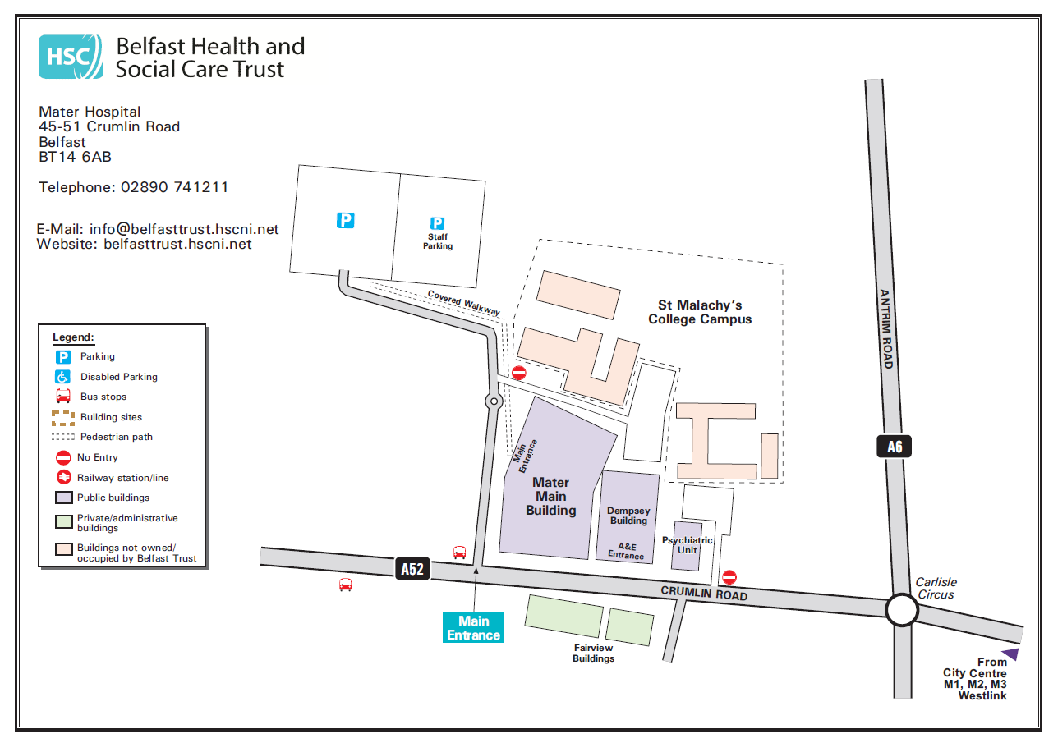  The Mater Hospital is approximately 2 miles from the previous location at the City Hospital. This is approximately a 45 minute walk, 14 minute drive and 32 minutes on public transport. It takes approximately 25 minutes to walk to the Mater Hospital from the city centre and 16 minutes on a bus. The new location is accessible by regular public transport. See images below:  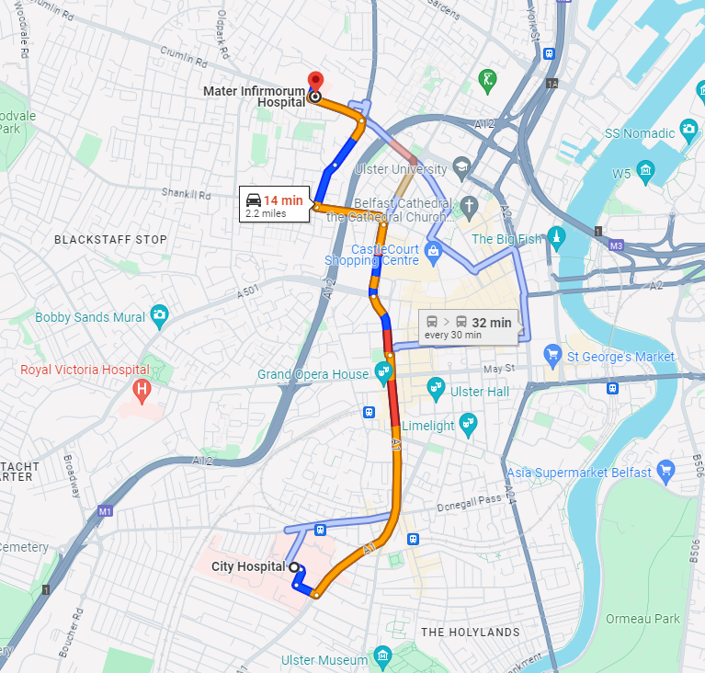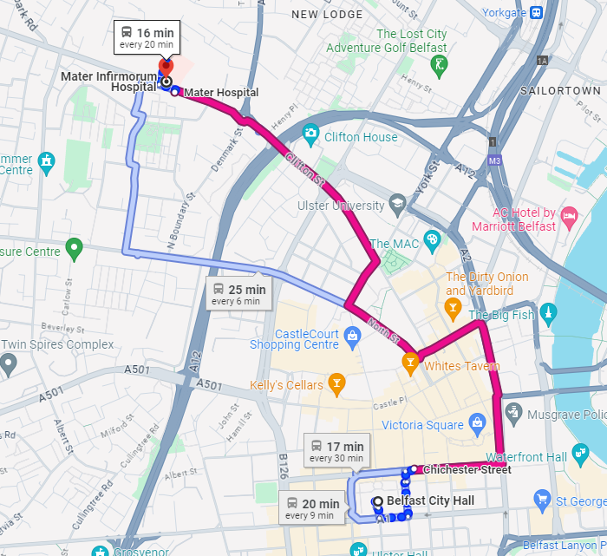  Shortly after the service had relocated there has issues raised regarding the lack of accessible parking spaces near to the service. Essential building works were being carried out resulting in the loss of spaces for blue badge holders in front of the Main Hospital Building and one on the road to the Public Car Park. They have since been returned for use.  Communication & Feedback:  - All Sleep Service staff were informed of the decision to relocate at a team meeting in May 2023 and all physiologist staff and managers were in support of the decision. Admin staff did not wish to travel to the MIH and remained on the Belfast City Hospital site.  - Service users were informed on all correspondence – letters, text messages and phone calls (the service has retained the same phone number)  - Services users were informed via the closed Facebook group  - Banners were put up in the City Hospital where the service was previously located, to inform people the service had moved to the Mater Hospital.  - To date the majority of feedback from staff and services users has been neutral  - The service has committed to doing some follow up on the new location – real time feedback with services users who attend the clinic, asking has the move affected them and what could be done to improve any adverse effects.
- Who owns the policy/proposal? |  |  |  | Director of Unscheduled and Acute Care
- Who are the main stakeholders affected? |  |  |  | - Actual or potential service users  - Carers  - All sleep clinic staff
- Provide details of how you involved stakeholders, views of colleagues, service users, staff side or other stakeholders when screening this policy/proposal. |  |  |  | - Service users were informed on all correspondence – letters, text messages and phone calls  - Services users were informed via the closed Facebook group  - The relocation was discussed at an operational meeting with the Sleep Physiology Manager, Sleep Service consultant leads, Clinical Respiratory Consultant Lead, MIH site manager and the MIH outpatient manager. All physiologist and admin staff were informed of the decision at the staff meeting.
- Other policies/strategies with a bearing on this policy/proposal |  |  |  | N/A
- Are there any factors that could contribute to/detract from the intended aim/outcome of the policy/proposal/decision? |  |  |  | Belfast Trust is committed to the full implementation of this policy and through regular monitoring it is anticipated that the aims and objectives of the policy will be fully realised and any factors that could detract from those aims and objectives will be minimised/avoided.
Section 2: Screening Classification of the Policy / Proposal /Decision

- The purpose of this Section is to consider the policy/proposal in terms of its relevance and likely impact (actual/potential) on equality of opportunity, disability duties, good relations and human rights.

- To determine the impact (actual and potential) of a policy/proposal on equality of opportunity, disability duties, good relations duties and human rights please complete the screening questions at 2.1 – 2.6.

Screening Questions |  |  |  |  |  |  |  |  |  |  |  |  |  | Yes |  | No
(2.1) Is there an impact on Equality of Opportunity for those affected by this policy, for each of the S75*
equality categories? I.e. is there a differential impact for one S75 group rather than the others?
(2.2) Are there better opportunities to promote equality of opportunity for people within the S75* categories?
(2.3) Does the policy impact upon Good Relations between people of a different religious belief, political opinion or racial group? (Good Relations Duties)
(2.4) Are there opportunities to better promote good relations between people of a different religious belief, political opinion or racial group? (Good Relations Duties)
(2.5) Are there opportunities to encourage disabled people to participate in public life and promote positive attitudes toward disabled people? (Disability Duties)
(2.6) Does the policy/proposal impact on human rights?

*S75 protected equality categories include: Age, Dependent Status, Disability, Men and Women generally, Marital Status Ethnicity, Religion, Political Opinion and Sexual Orientation.
Screening Statement

- If you have answered Yes to any of the above questions (2.1 – 2.6) please complete Sections 3 – 10

- If you have answered No to all of the above questions (2.1 – 2.6) please complete only 2.7, 2.8 and 2.9

(2.7) Screening Statement:
This policy is ‘screened out’ on the basis that - please tick all statements that are appropriate to the policy:

- It is purely clinical policy and/or is technical in nature and has no relevance or bearing in terms of its likely impact (actual / potential) on equality of opportunity, good relations and for people within these categories and in relation to disability duties, good relations and human rights.
- It is a purely clinical policy and/or is technical in nature and aims to standardise practice to achieve best practice based on current evidence.
- Other reason: Please provide details.
(2.8): Statutory Duties – Making Reasonable Adjustments and Accessible Information

To complete the equality screening please tick this box to indicate that you have considered and have made explicit reference in the policy to the need to make reasonable adjustments and information accessible.

- The Trust has a statutory duty to make reasonable adjustments in respect of disabled patients/service users/carers/visitors.

This includes making all communication (in person, by phone, via email) and any information provided (in writing, verbally) accessible using alternative formats as required. Accessible/ Alternative formats can include, for example, information translated into Easy Read format or into Audio format - when a patient/service user/carer/visitor has a learning disability or is visually impaired. For advice on making information accessible for a person with a disability please refer to the staff guidance
Making-Communication-Accessible-for-All-A-guide-for-HSC-Staff

- In addition, if a patient/service user/carer/visitor does not speak English as their first language or has poor English, the Trust has a statutory duty to provide an interpreter and to translate written information. This facilitates informed consent, better understanding and greater independence.

(2.9) Approval
Please sign / date and forward to the Equality and Planning Team for consideration equalityscreenings@belfasttrust.hscni.net
Lead Responsible Manager:  Name:  Position:  Date: |  |  |  |  |  |  |  |  | Countersigned by Equality Manager:  Name: Samantha Whann  Date: 31 October 2024
Section 3: Evidence used to Assess Impact on Service Users and Staff

This section records the quantitative and qualitative data you have used to consider equality and good relations issues to assess the impact on staff and service users across the 9 protected categories plus multiple identities.
Evidence to help inform the screening process may be quantitative and qualitative. Consideration needs to be given to the different needs, experiences and priorities of each of the categories in relation to the policy / proposal. For example: previous consultations and equality impact assessments (EQIAs), statistics, research, complaints, feedback, referrals, grievances, inspection reports, focus groups, user groups etc. Please also refer to the Equality Commissions’ publication: Section 75 - Using Evidence in Policy Making (A Signposting Guide) (equalityni.org)
(3.1) | Quantitative and Qualitative Data: Service Users
Equality Category |  | Service Users | Quantitative Data  (Using 2022 census data unless otherwise stated) |  |  |  |  |  |  |  | Qualitative Data  (Needs, Experiences, Priorities)
 |  | Service Users | Belfast  Population only |  | NI  Population |  | Service Users affected %
1.  Age |  | 0-14  15-24  25-34  35-44  45-54  55-64  65-74  75+ | 18.04%  14.57%  15.47%  13.35%  11.85%  12%  7.8%  6.92% |  | 19.19%  11.8%  12.74  13.11%  13.27  12.73  9.3%  7.86% |  |  |  |  |  | All service users who use the Sleep Service are adults, 18 or over. The Sleep Service was unable to retrieve more specific data, but anecdotally we are aware that most of the service users are between 40 and 65 years of ages. It is not expected there will be an adverse differential impact in terms of age.
2. Dependent Status |  | Caring for a child dependant, older person or a person with a disability |  |  | 12.42 %  are carers |  | Unknown |  |  |  | It is not expected there will be an adverse differential impact in terms of dependent status.  However, the relocation will impact on service users who have a disability. It is therefore reasonable to expect that these service user could have a carer.  Belfast Trust always work in collaboration with carers to deliver a compassionate and safe service. The impact of the guidance may be deemed positive for carers given the aim of the guidance is to enable the service user to maximise functional independence and minimise the impact of their disability upon their daily occupational performance.  Belfast Trust is aware of the vital roles that carers play in the lives of their loved ones and there are specific services in place to support carers.
3.  Disability |  | Yes*  No  *Type of disability:  - Deafness or partial hearing loss  - Blindness or partial sight loss  - Mobility or dexterity difficulty that requires the use of a wheelchair  - Intellectual or learning disability  - Learning difficulty  - Autism or Asperger Syndrome  - Emotional, psychological or mental health condition  - Frequent periods of confusion or memory loss  - Long term pain or discomfort  - Shortness of breath or difficulty breathing  - Other condition |  |  | 24.33%*  75.67%  5.75%  1.78%  1.48%  0.89%  3.15%  1.86%  8.68%  1.99%  11.58%  10.29%  8.81% |  | Unknown |  |  |  | The Disability Discrimination Act (DDA) 1995 defines a disabled person as a person with “physical or mental impairment which has a substantial and long-term adverse effect on his ability to carry out normal day-to-day activities.”  Given the nature of service, it is likely most of the service users would be consider disabled under the DDA. Therefore the relocation of the service has potential for a differential equality impact on disability.  Over all, the nature of this differential impact should be positive as the relocation is aimed at centralising the service and creating more space for an ever growing service. Centralising the service means the multi-disciplinary team can work better together and more efficiently. In turn service users should experience more effective, efficient and equitable care.  Shortly after the service had relocated there has issues raised regarding the lack of accessible parking spaces near to the service. Essential building works were being carried out resulting in the loss of spaces for blue badge holders in front of the Main Hospital Building and one on the road to the Public Car Park. They have since been returned for use. There were other, albeit limited, options for accessible parking available in the interim.  The limitations on accessible parking were unavoidable due to the nature of the Mater site and for health and safety reasons. New accessible spaces have been created in the main car park, however this is an uphill walk from the main entrance.  The Sleep Service were aware of the limited accessible spaces and ensured service users were aware of the options available. Admin informed patients via telephone and there was a Facebook post, which provided information on the matter.  Appropriate and inclusive means of communication will be used to communicate with current and new service users and their carers/families. Staff will be mindful of any reasonable adjustments required for new services users, whether in discussions, explanations or obtaining feedback to maximise the service users understanding of what is happening and to reduce any potential confusion. When information is provided reasonable alternative formats such as easy read or large print will be provided when required. If service users, their carers or families do not have English as a first language interpreters/ translations will be provided.
4.  Men and Women generally |  | Female  Male |  |  | 50.81%  49.19% |  | Unable to retrieve this data |  |  |  | The Sleep Service was unable to retrieve specific data, but anecdotally there are more men using the service than women. It is not expected there will be an adverse differential impact in terms of men and women generally.
5.  Marital Status |  | Single  Married  Civil P’ship Separated  Divorced  Widowed | 49.82%  32.94%  0.26%  4.73%  6.15%  6.1% |  | 38.07%  45.59%  0.18%  3.78%  6.02%  6.36% |  | Unknown |  |  |  | It is not expected there will be an adverse differential impact in terms of marital status.
6.  Race  Ethnicity |  | White BME | 92.95%  7.05% |  | 96.55%  3.45% |  | Unknown |  |  |  | There is no evidence that the policy would have an adverse impact in terms of race ethnicity.  Information and guidance provided either verbally or in writing will be accessible to ensure service users are aware of the responsibilities and in the event of a breach to optimise learning. Interpreters can be booked via the Regional Interpreting Service and translated through a range of Trust contracted providers.
7.  Religion |  | Roman Catholic  Presbyterian C.of Ireland  Methodist Other Christian  Other Religions  No Religion  Religion not stated | 43.46%  12.44%  8.49%  2.86%  5.95%  2.96%  21.67%  2.17% |  | 42.31%  16.61%  11.55%  2.35%  6.85%  1.34%  17.39%  1.6% |  | Unknown |  |  |  | There is no evidence that the policy would have an adverse impact in terms of religion.
8.  Political Opinion  Based on total elected candidates in the local government elections 2023  *Figures extracted from Lisburn and Castlereagh Council 2023. |  | DUP  SF  SDLP  UUP  APNI  Green  PBP  IND  Trad UP | Belfast  Council  14  22  5  2  11  3  1  1  2 |  | C’reagh*  3  2  1  1  5  0  0  0  0 |  | Unknown |  |  |  | There is no evidence that the policy would have an adverse impact in terms of political opinion.
9.  Sexual Orientation |  | Straight or heterosexual  Gay or lesbian  Bisexual  Other  Prefer not to say  Not stated | 87.1%  2.27%  1.48%  0.32%  5.2%  3.64% |  | 90.04%  1.17%  0.75%  0.17%  4.58%  3.30% |  | Unknown |  |  |  | There is no evidence that the policy would have an adverse impact in terms of sexual orientation.
Multiple Identities |  |  |  |  |  |  |  |  |  |  | There is no evidence that the policy would have an adverse impact in terms of multiple identities.

(3.2) Quantitative and Qualitative Data: Staff

When organisational / policy change is necessary, regardless of whether it is a permanent or temporary change, the Trust is committed to treating staff fairly and equitably. Staff can be assured that the change process will be managed. This includes consultation with staff and the opportunity for staff to discuss in one to one meetings, any adverse equality impacts resulting in changes to their employment.

Information will be provided together with analysis and advice by the Employment Equality Team in the Human Resources department.

Quantitative Data: Please contact: Samantha Whann / Tel: 028 96159615 Email : samantha.whann@belfasttrust.hscni.net
Qualitative Data: Consider the different needs, experiences and priorities of each of the categories in relation to the policy / proposal / decision.
Should any equality / modernisation related issues arise they will be managed through the Organisational Change Framework.
Click here for Framework

This framework also works alongside other Human Resources policies including for example the Disability and Reasonable Adjustment Framework, the Work Life Balance Policy and Procedure, the Recruitment and Selection Policy and Procedure and Agenda for Change Terms and Conditions Handbook.

Equality Category | Groups | Quantitative Data |  | Qualitative Data
Equality Category | Groups | Belfast Trust workforce  (@January 2023) | Staff affected by the Policy/Proposal  /Decision %
1.  Age | 16-24  25-34  35-44  45-54  55-64  65+ | 6%  23%  25%  23%  19%  3% |  | The aim of the relocation of the Sleep Clinic was to centralise the service and create more space for an ever-growing service. Centralising the service means the multi-disciplinary team can work better together and more efficiently. In turn, service users should experience more effective, efficient and equitable care.  All Sleep Service staff were informed of the decision to relocate at a team meeting in May 2023 and all physiologist staff and managers were in support of the decision. Admin staff did not wish to travel to the MIH and remained on the Belfast City Hospital site.  The relocation took place in accordance with the Organisational Management of Change Framework.  Due to the small numbers of staff relocating, a detailed breakdown of equality data will not be provided but has been considered to ensure any necessary steps are undertaken to mitigate any potential adverse impact.
2.  Dependant Status | Dependants No Dependants Not known | 18% 24% 58%
3.  Disability | Yes  No  Not known | 2% 65% 33%
4.  Men and Women generally | Female  Male | 76% 24%
5.  Marital Status | Married/ Civil P’ship  Single  Other/  Not known | 45% 28% 27%
6. Race  a) Ethnicity | BME White Not Known | 4% 68% 29%
b) Nationality | GB  Irish Northern Irish  Other  Not known | 20%  15% 2% 1% 62%
7. Religion  a) Community Background | Protestant Roman Catholic Neither | 35% 45% 20%
b) Religious Belief | Christian  Other No religious belief Not known | 30%  1% 10% 59%
8. Political Opinion  * 2011 Assembly election | Broadly  Nationalist Broadly Unionist Other Do not wish to answer/ Unknown  Not known | 7%  6% 8% 78%
9. Sexual Orientation | Opposite sex  Same sex or both sexes  Do not wish to answer | 43%  1%  56%
Multiple Identities |  |  |  | Generally speaking, people can fall into more than one Section 75 category. Taking this into consideration, are there any potential impacts of the policy/decision on people with multiple identities?  (For example; disabled minority ethnic people; disabled women; young Protestant men; and young lesbians, gay and bisexual people).

Section 4: Consideration of Impacts and Identification of Mitigations and/or Alternative Policies
Given the evidence gathered in Section 3, please identify for each of the nine equality categories the level of impact, mitigation measures and alternative policies / proposals that better promote equality of opportunity.
(4.1) SERVICE USERS
Equality Category | Level of Impact |  |  | Mitigation Measures and Alternative Policies or Actions that might lessen the severity of the equality impact  (where Major or Minor Impact identified)
Equality Category | Major | Minor | None
Age |  |  |  | The current and potential service users of the Sleep Service fall within the protected Section 75 Groups of disability. It is likely they will be differentially impacted by the relocation of the service to the Mater Hospital.  Over all, the nature of this differential impact should be positive as the relocation is aimed at centralising the service and creating more space for an ever growing service. Part of the Sleep Service was already located at the Mater Hospital. Centralising the service means the multi-disciplinary team can work better together and more efficiently. In turn service users should experience more effective, efficient and equitable care.  However, shortly after the relocation unavoidable building works was taking place at the Mater site and it impacted on the accessible parking spaces which were near the entrance to the building that service users use. There were other, albeit limited, options for accessible parking available in the interim. At that stage, during the building work it is likely the relocation of the Sleep Service to the Mater could have negatively impacted on service users who need an accessible parking space, given there were limited options and availability. The situation has since been resolved and the accessible parking spaces are now back in use.  Mitigation Measures  The relocation is expected to have an overall positive impact for the following reasons:  - Relocating and centralising service will in turn mean service users are receiving better, more effective care.  - There was a robust decision process which included several operational meetings with the Sleep Physiology Manager, Sleep Service consultant leads, Clinical Respiratory Consultant Lead, MIH site manager and MIH outpatient manager in April/May 2023 to discuss the potential move. There was several site visits to the MIH site to ensure the area was suitable for the sleep service.  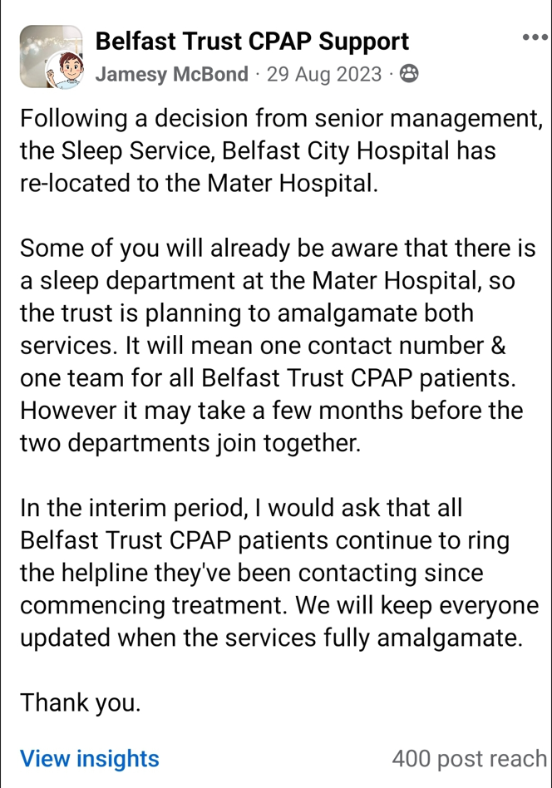  - All Sleep Service staff were informed of the decision to relocate at a team meeting in May 2023 and all physiologist staff and managers were in support of the decision. Admin staff did not wish to travel to the MIH and remained on the Belfast City Hospital site.  - Good communication with service users - service users were informed on all correspondence – letters, text messages and helpline (the service has retained the same phone number)  - Services users were informed via the closed Facebook group, see to the right:  - Banners were put up in the City Hospital where the service was previously located, to inform people the service had moved to the Mater Hospital.  - To date the majority of feedback from staff and services user has been neutral  - The service has committed to doing some follow up on the new locations – real time feedback with services users who attend the clinic, asking has the move affected them and what could be done to improve any adverse effect.  - Appropriate and inclusive means of communication will be used to communicate with current and new service users. Staff will be mindful of any reasonable adjustments required for services users whether that is relating to communication or physical accessibility.  With regard to the potential negative impact of limited accessible parking spaces for a period of time:  - This was time limited and all accessible spaces are now available for use  - The limitations on accessible parking were unavoidable due to the nature of Mater site and for health and safety reasons.  - The Sleep Service were aware of the limited accessible spaces and ensured service users were aware of the options available. Admin informed patients via telephone and there was a Facebook post, which provided this information.  - Staff at the Sleep Service offered assistance to anyone who needed support to and from the main car park.  - If needed, the Sleep Service were willing to offer an appointment online or at another location  - There were accessibility spaces available at the Fairview buildings and people could park on the main road  - New, additional accessible parking spaces have been created at the main car park.
Dependant Status
Disability
Men and Women generally
Marital Status
Race (Ethnicity)
Religion
Political Opinion
Sexual Orientation
Multiple Identities e.g. disabled ethnic minorities or young Protestant men.

(4.2) STAFF
Equality Category |  | Level of Impact |  |  | Mitigation Measures and consideration of alternative policies or actions that might lessen the severity of the equality impact  (where Major or Minor Impact identified)
 |  | Major | Minor | None
Age |  |  |  |  | Due to small number of staff relocating a breakdown will not be provided.  The service constructively engaged with those affected and ensured that it adhered to the Organisational Management of Change Framework.
Dependant Status
Disability
Men and Women generally
Marital Status
Race | Ethnicity
Race | Nationality
Religion | Community Background
Religion | Religious Belief
Political Opinion
Sexual Orientation
Multiple Identity e.g. female staff with caring responsibilities

Section 5: Good Relations

Based on the evidence collected in Sections 3 & 4:

- To what extent is the policy/proposal likely to impact Good Relations i.e. between people of different religious belief, political opinion or racial group?

- Are there any additional measures that could be suggested to ensure the policy or proposal promotes Good Relations?

Good Relations category | Level of impact |  |  | Mitigation Measures and Alternative Policies or Actions that might lessen the severity of the equality impact  (where Major or Minor Impact identified)
Good Relations category | Major | Minor | None
Religious belief |  |  |  | All Trust staff attend mandatory Equality, Human Rights and Good Relations training which includes reference to the Good Relations duty.  The Trust has a clear and well defined Good Relations strategy ‘Healthy Relations for A Healthy Future 3’ whereby the corporate commitment to Good Relations is underlined.  The Trust will ensure that all services and all facilities are welcoming to all patients their carers and advocates regardless of their religious affiliation, political opinion and racial group.  Appropriate and inclusive means of communication will be used to contact and communicate with patients, their families and carers who do not speak English as their first language. An interpreter will be booked and/or letters translated using established protocols within the Trust as appropriate.
Political opinion
Racial group

Section 6: Disability Duties

How does the policy / proposal:  - encourage disabled people to participate in public life and  - promote positive attitudes towards disabled people?  Consider what other measures you could take to meet these duties.  For example, have staff received disability equality training. | Appropriate and inclusive means of communication will be used to communicate with patients and carers. Staff will be mindful of any reasonable adjustments required in the implementation of this policy for both patients and carers.  All Health and Social Care staff are required to undertake mandatory equality training which includes disability duties.  Disability Awareness Training is provided throughout the year, available on HRPTS. Bespoke Disability awareness training sessions can also be provided for staff teams on demand, when it is feasible to do so.  The Trust has produced a suite of guidance for increasing access to services and information. These are all available on the hub or on request from the Planning & Equality team.

Section 7: Human Rights

Belfast Health and Social Care Trust is committed to providing the highest attainable standard of physical and mental health within our resources.

(7.1)

Does the policy/proposal/decision negatively impact on any of the following human rights?

The rights particularly relevant in the delivery of health and social care are emboldened below. Examples for these rights and further information can be found in the Equality Screening Toolkit.
Human Rights Articles | Yes | No
A2: Right to life
A3: Right to freedom from torture, inhuman or degrading treatment or punishment
A4: Right to freedom from slavery, servitude & forced or compulsory labour
A5: Right to liberty & security of person
A6: Right to a fair & public trial within a reasonable time
A7: Right to freedom from retrospective criminal law & no punishment without law
A8: Right to respect for private & family life, home and correspondence.
A9: Right to freedom of thought, conscience & religion
A10: Right to freedom of expression
A11: Right to freedom of assembly & association
A12: Right to marry & found a family
A14: Prohibition of discrimination in the enjoyment of the convention rights
1st protocol Article 1 – Right to a peaceful enjoyment of possessions & protection of property
1st protocol Article 2 – Right of access to education
If you answered YES to any of the above, please refer to the Human Rights Screening Tool below to check if the policy is likely to be human rights compliant.
If the flowchart indicates that the policy is unlikely to be human rights compliant, please contact the Planning and Equality team equalityscreenings@belfasttrust.hscni.net

If the flowchart indicates that the policy is likely to be human rights compliant, please continue to section 7.2.



(7.2)
Outline any actions you will take to promote awareness of human rights and evidence that human rights have been taken into consideration in decision making processes:
The Trust is committed to the safeguarding and promotion of Human Rights in all aspects of its work. The Human Rights Act 1998 gives effect in UK Law to the European Convention on Human Rights and requires legislation to be integrated so far as possible in a way that is compatible with the Convention rights. It also makes it unlawful for a public body to act incompatibly with the convention rights. Where a public authority has assumed responsibility for the welfare and safety of individuals, there is a particular duty to guarantee human rights.

The Trust is committed to the safeguarding and promotion of Human Rights in all aspects of its work. The Human Rights Act 1998 gives effect in UK Law to the European Convention on Human Rights and requires legislation to be integrated so far as possible in a way that is compatible with the Convention rights. It also makes it unlawful for a public body to act incompatibly with the convention rights. Where a public authority has assumed responsibility for the welfare and safety of individuals, there is a particular duty to guarantee human rights.

Belfast Trust is committed to carrying out its functions in line with the core principles and values that underline human rights legislation namely Freedom, Respect, Equality, Dignity and Autonomy (FREDA). Staff should use FREDA principles to red flag any behaviour that is not compatible with the Trust ethos of delivering safe, quality and compassionate care or which violates our equality and human rights statutory commitments.

Belfast Trust is committed to delivering safe, high quality and compassionate services. Employees are expected to deliver services and behave in a manner that is compatible with this commitment. Belfast Trust expects all employees to treat others with dignity and respect whether it be service users, carers, visitors or colleagues.

Human rights training is available throughout the year for any staff member who wishes to attend. Bespoke human rights training sessions can be delivered for staff groups on demand and a large number of resources relating to human rights in health and social care can be made available by the Planning and Equality team. The mandatory Equality training for staff and Managers also covers the area of human rights.

Section 8: Screening Decision  (8.1)  How would you categorise the impacts of this policy / proposal?  (Please underline one category) | Major  (Screened In for an Equality Impact Assessment) |  |  | Minor  (Screened Out with mitigation) | None  (Screened Out)
(8.2)  If you have identified any impact, what mitigation has  been considered to address this? | This is an equality screening of the relocation of the Sleep Clinic from the City Hospital to the Mater Hospital. The current and potential service users of the Sleep Service fall within the protected Section 75 Groups of disability. It is likely they will be differentially impacted by the relocation of the service to the Mater Hospital. Over all, the nature of this differential impact should be positive as the relocation is aimed at centralising the service and creating more space for an ever growing service. Part of the Sleep Service was already located at the Mater Hospital. Centralising the service means the multi-disciplinary team can work better together and more efficiently. In turn service users should experience more effective, efficient and equitable care. It is expected that any impact will be positive; the reasons are laid out in section 4.1.
(8.3)  Do you think the policy/proposal/decision should be subject to an Equality Impact Assessment (EQIA)?  NB: A full Equality Impact Assessment (EQIA) is usually confined to those policies or proposals considered to have major implications for equality of opportunity/good relations/human rights. | Yes | No | Reasons  A policy/proposal/decision is subject to an EQIA if one or more of the following criteria is met:  - The policy is significant in terms of its strategic importance.  - Potential equality impacts are unknown, because, for example, there is insufficient data upon which to make an assessment or because they are complex, and it would be appropriate to conduct an equality impact assessment in order to better assess them.  - Potential equality and/or good relations impacts are likely to be adverse or are likely to be experienced disproportionately by groups of people including those who are marginalised or disadvantaged.  - Further assessment offers a valuable way to examine the evidence and develop recommendations in respect of a policy about which there are concerns amongst affected individuals and representative groups, for example in respect of multiple identities.  - The policy is likely to be challenged by way of judicial review.  - The policy is significant in terms of expenditure.
Section 9: Monitoring  (9.1)  Please detail the steps you will take to monitor the effect of the policy/proposal/decision for impact in terms of equality of opportunity, good relations, disability duties and human rights? | Belfast Trust is committed to the effective monitoring of this policy so that we can identify any future adverse impact arising from the policy which may lead to conducting an equality impact assessment and with helping with future planning and policy development.  Monitoring will take place by undertaking the following steps:  - Service user feedback and complaints  - Governance meetings
Section 10: Approval and Authorisation

Please sign /date and forward to the Planning and Equality team equalityscreenings@belfasttrust.hscni.net
Equality screenings are completed with information provided by the senior responsible manager subject to advice and assistance from Belfast Trust Equality & Planning Managers.

**Completed Screening Templates are public documents posted on the Trust Website**
Lead Responsible Manager  Name: Niall Totten  Position: Sleep Clinic Manager  Date: 01/11/2024 | Countersigned by: Equality Manager/Employment Equality Manager  Name: Samantha Whann  Caroline McMenamin  Position: Assistant Service Manager, HR & OD  Planning & Equality Manager  Date : 31 October 2024
Section 11: Statutory Rural Impact Assessment Duties

The Trust is legally obliged to take due regard of the impact of any policy, proposal or decision on the social and economic needs of people who live in a rural community. This is particularly so when the policy/proposal/decision impacts service users/carers/patients across NI (eg regional service/policy).
Please tick the box to indicate that you have paid ‘due regard’ to the social and economic needs of the rural community

when developing, adopting, implementing or revising policies, strategies and plans and when designing and delivering
public services and that a rural impact assessment is not required.

OR
Please complete a Rural Needs Impact Assessment Template rural impact assessment if there is impact on the social and economic needs of people who live in a rural community.
Please go to the: Rural Impact Assessments Toolkit for HSC NI to find out how to undertake a rural impact assessment.
Contact Estella.Dorrian@belfasttrust.hscni.net for further advice.

