
NOTES
- This information should normally be contained in section 1B of the RNIA Template completed in respect of the activity.
- This information should normally be contained in section 2D of the RNIA Template completed in respect of the activity.
- The information contained in sections 3D, 4A & 5B of the RNIA Template should be considered when completing this section.

A Guide to the Rural Needs Act (NI) 2016 for Public Authorities
(Revised) April 2018
Information to be compiled by Public Authorities under Section 3(1)(a) of the Rural Needs Act (NI) 2016.

Name of Public Authority: | Belfast Health and Social Care Trust

Reporting Period: | April | 20 | 22 | to | March | 20 | 23

Belfast Trust is committed to promoting and upholding its duties in relation to the Rural Needs Act (NI) 2016 and will have ‘due regard’ to rural needs when developing, adopting, implementing or revising policies, strategies and plans, and when designing and delivering public services. The Trust acknowledges that the duty of ‘due regard’ means that it will consciously consider the social and economic needs of persons in rural areas when a policy, strategy, plan, or service design and delivery is under consideration. In addition, the Trust monitors this activity.

The Trust’s Executive Team and Trust Board considered this Annual Monitoring Report before submission to DAERA

- Activity Overview

To comply with our statutory duties and to mainstream our commitment to these duties the Trust has carried out the following activities:

- The Trust’s Senior Management Team are briefed to ensure ownership of and compliance to the rural statutory duties at a strategic level.

- It is the Trust’s responsibility for recording, co-ordination and monitoring its rural needs assessment activity and for satisfying itself that it is meeting its obligations. These duties are clearly outlined in the regional HSC publication Guidance for Board Members 2020.developed by HSC Trusts and disseminated to Belfast Trust Executive Team and Trust Board members.

- The Directorate of Planning, Performance and Informatics is responsible for the central co-ordination of the monitoring report on behalf of the Trust.

- Governance arrangements and reporting structure for ensuring compliance is through the Trust Involvement Group. This group reports directly to the Trust’s Assurance and Improvement Group, then through to Trust Board.

- Policy/Project leads across the Trust are responsible for completing rural needs impact assessments using a regionally agreed template (Appendix A) alongside the S75 equality screening template when appropriate during policy development/review including during the development of business cases, strategies and reform projects

- The Trust’s Planning and Equality Team provides support to colleagues across the Trust in relation to complying with and understanding of statutory obligations. One to one clinics are provided as required.

- In addition, rural champions have been trained to facilitate local decision making and ensure compliance with legislative requirements in regard to rural needs assessments. Support resources are available for policy/project leads

- To ensure effective mainstreaming and monitoring of the “due regard” within the Rural Needs Act the Trust’s mandatory policy development template includes a section relating to the Rural Needs Act as a requirement for staff to consider the social and economic needs of persons in rural areas when drafting a policy/proposal/plan or strategy.

By doing so, an explicit aid memoir is provided to staff to ensure that they consciously consider the social and economic needs of persons in rural areas when drafting a policy/proposal/plan or strategy.

- The Trust staff intranet site ‘The Loop’ has a section dedicated to ‘Writing a Policy’. Resources are available within a distinct Rural Needs section to raise awareness of the need to undertake a rural impact assessment if the policy impacts on the social and economic needs of people in rural areas.

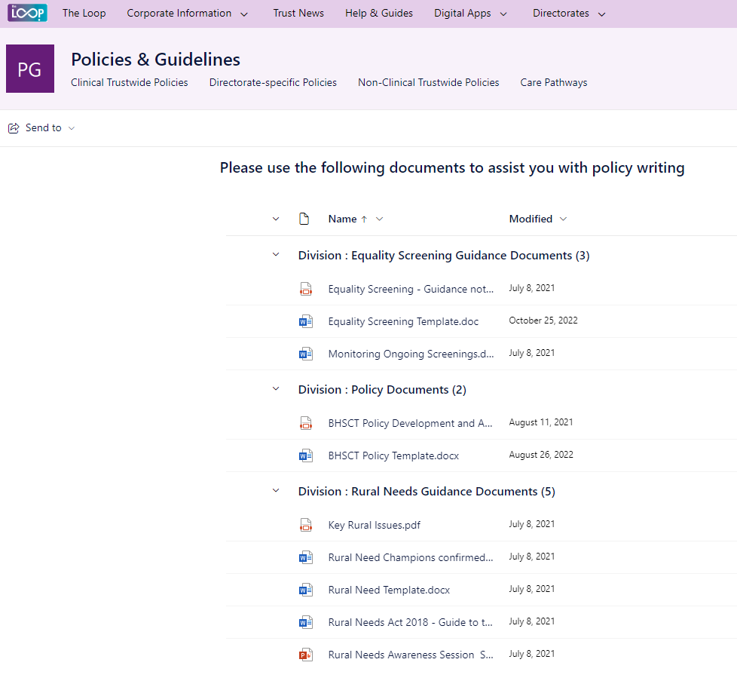

- HSC Rural Needs Toolkit Launched

During this reporting period, HSC Trust Rural Needs Leads regionally launched the Rural Proofing Toolkit. Minister for Health, Robin Swann launched the toolkit whilst the Department of Agriculture Environment and Rural Affairs Minister Edwin Poots endorsed the toolkit at an online event in October 2022.

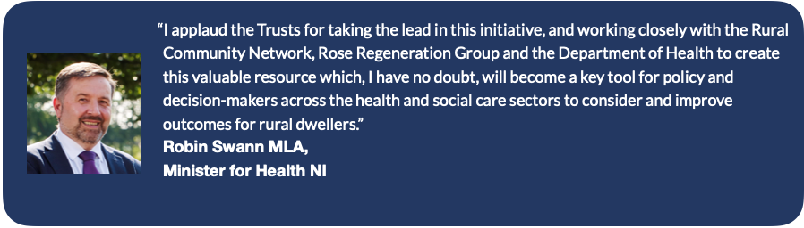
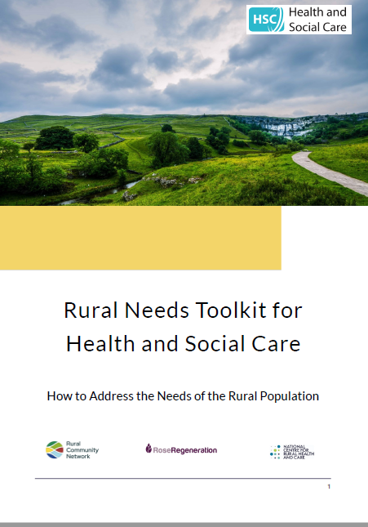

The toolkit was developed by all NI HSC Trusts in partnership with the National Centre for Rural Health and Care, the NI Rural Community Network, the Nuffield Trust and Rose Regeneration Limited to help those in the health and care sectors address the needs of their rural populations when developing strategies, initiatives and service delivery plans.

- ‘Rural’ Definition

Belfast Trust uses a working definition of ‘Rural’ in terms of Policy, Strategy, Plan or Public Service to mean those settlements with populations of less than 5,000 together with the open countryside as per DAERA guidance for public authorities.

Recognizing our Trust boundaries, where appropriate, our Community Development Teams and Health Promotion Teams continue to reach out to rural groups such as Killynure Residents Association.

- Rural Needs Assessments

Belfast Trust is committed to promoting and upholding its duties in relation to the Rural Needs Act (NI) 2016 and will have due regard to rural needs in the development of all our policy and public service delivery decisions.

The Trust is mindful that the level of ‘due regard’ expected will depend on the circumstances and, in particular, on the relevance of rural needs to the decision or function in question. The greater the relevance and potential impact for people in rural needs, the greater the due regard required by the duty.

Belfast Trust is the largest integrated health and social care provider in the UK delivering a service to over 360,000 people each year across Belfast and Castlereagh and the region.

When considering the impact of a policy, strategy or plan on the rural community, a fundamental consideration is ‘what constitutes a rural community?’. As noted previously Belfast Trust similar to all other HSC Trusts use the default definition of “rural” as developed by the Inter-Departmental Urban-Rural Definition Group i.e. that “ rural is classified by those settlements with populations of less than 5,000 together with the open countryside”.

Whilst it is acknowledged that approximately 670,000 people live in rural areas in Northern Ireland (36% of the population ) for Belfast Trust the geographical area for which it provides a service to in terms of local services is largely urban. Indeed, from NISRA’s Agricultural Census for 2022 the number of farms in Belfast is noted as 92 and some of these may only be temporary addresses or correspondence addresses.

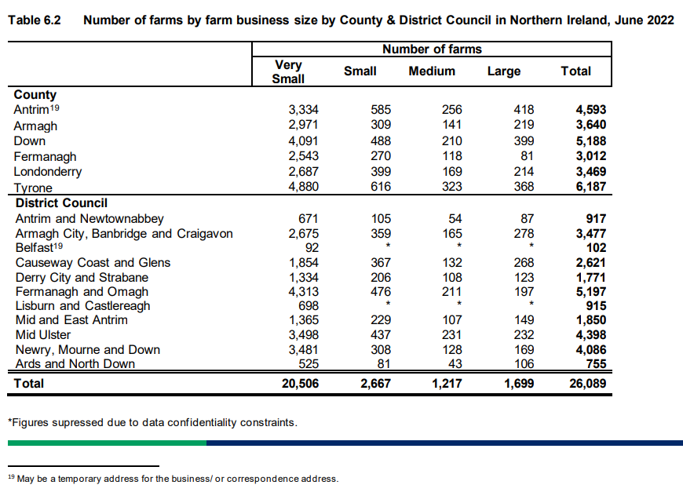

However, the Trust is mindful of those smaller pockets of rural areas within the Trust area and notably the need to consider rural impact in the delivery of our regional services.

In preparing this monitoring return the Trust considered policies in respect of the social and economic needs of persons in rural areas and for all, no rural needs were identified. In the interests of openness and transparency, the Trust has provided the following hyperlinks to our S75 equality screenings of Trust policies for the period under review:

- outcome-report-apr-june-2022
- outcome-report-july-sept-2022
- outcome-report-oct-dec-2022.docx
- Outcome-report-Jan-Mar 23

Many of the Trust policies are clinical, internal or technical in nature and so have had no bearing on rural needs. As such, no rural impact assessments were undertaken in the period under consideration.

To provide further context, the rural impact assessment activity over the last four years is noted as:
18/19 = 4, 19/20 = 2, 20/21 = 5, 21/22 = 5. Going forward Belfast Trust plan to proactively undertake awareness raising activities with senior managers regarding the rural needs duties.

In the interests of openness and transparency, Belfast Trust provides detail of those policies which were considered as having a bearing on rural needs and therefore subject to a rural needs assessment together with our monitoring reports on our website at: Rural Impact Assessments

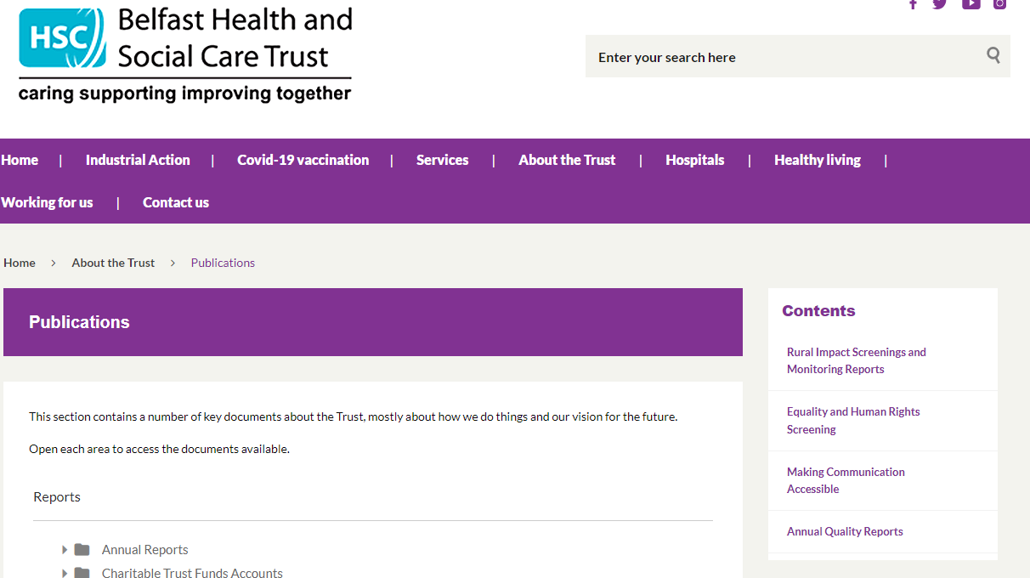
Rural Needs Impact Assessment Template APPENDIX A
Section 1: Define activity subject to Section 1(1) of Rural Needs Act (NI) 2016
1A. Short title describing activity being undertaken that is subject to Section 1(1) of the Rural Needs Act (NI) 2016:
1B. Are you Developing, Adopting, Implementing or Revising a Policy a Strategy or a Plan? (Underline or Circle)
Or are you delivering or designing a public service? (Underline or Circle)
What is official title of this Policy, Strategy, Plan or Public service (if any)?
1C. Give details of the aims and/or objectives of the Policy, Strategy, Plan or Public Service:
1D. What definition of ‘rural’ is the Trust using in respect of the Policy, Strategy, Plan or Public Service:
Section 2 - Understanding impact of Policy, Strategy, Plan or Public Service
2A. Is the Policy, Strategy, Plan or Public Service likely to impact on people in rural areas?
Yes No If response is NO Go To Section 2E.
2B. How is it likely to impact on people in rural areas?
2C. If the Policy, Strategy, Plan or Public Service is likely to impact on people in rural areas differently from people in urban areas, please explain how it is likely to impact on people in rural areas differently?
2D. Please indicate which of the following rural policy areas the Policy, Strategy, Plan or Public Service is likely to primarily impact on.
Jobs or Employment in Rural Areas |  | Community Safety or Rural Crime |  | Agriculture-Environment
Education or Training in Rural Areas |  | Health or Social Care Services in Rural Areas |  | Other, please state below;
Rural Development |  | Broadband/Mobile Communications in Rural Areas |  | Other, please state below;
Poverty or Deprivation in Rural Areas |  | Rural Business, Tourism or Housing |  | Other, please state below;

2E. Please explain why the Policy, Strategy, Plan or Public Service is NOT likely to impact on people in rural areas.

If you completed 2E above GO TO Section 6
SECTION 3 - Identifying Social and Economic Needs of Persons in Rural Areas
3A. Has the Trust taken steps to identify the social and economic needs of people in rural areas, relevant to the Policy, Strategy, Plan or

Public Service? Yes No if the response is NO, GO TO Section 3D
3B. Which of following methods or information sources were used by the Trust to identify these needs?

Consultation with relevant stakeholders / Survey or Questionnaire / Research / Statistics / Publications / Other methods.
Please provide details:
3C. What social and economic needs of the people in rural areas have been identified?
3D Please explain why no steps were taken by the Trust to identify the social and economic needs of people in rural areas?
SECTION 4 - Considering Social and Economic Needs of Persons in Rural Areas
4A. What issues were considered in relation to the social and economic needs of people in rural areas?
SECTION 5 - Influencing the Policy, Strategy, Plan or Public Service
5A. Has the policy, strategy, plan or public service been changed by consideration of the rural needs identified?
Yes No if the response is NO, GO TO Section 5C
5B. If yes, how have rural needs influenced the policy, strategy plan or public service?
5C. If no, why have the rural needs identified not influenced the policy, strategy, plan or public service?
Section 6: Documentation:
6A. Please tick below to confirm that the RNIA Template will be retained by the Trust and relevant information on the Section 1 activity compiled in accordance with paragraph 6.7 of the guidance.
I confirm that the RNIA Template will be retained and relevant information compiled.
Rural Needs Impact Assessment undertaken by:

Census 2021

