
NOTES
- This information should normally be contained in section 1B of the RNIA Template completed in respect of the activity.
- This information should normally be contained in section 2D of the RNIA Template completed in respect of the activity.
- The information contained in sections 3D, 4A & 5B of the RNIA Template should be considered when completing this section.

A Guide to the Rural Needs Act (NI) 2016 for Public Authorities
(Revised) April 2018
Information to be compiled by Public Authorities under Section 3(1)(a) of the Rural Needs Act (NI) 2016.

Name of Public Authority: | Belfast Health and Social Care Trust

Reporting Period: | April | 20 | 23 | to | March | 20 | 24

Belfast Trust is committed to promoting and upholding its duties in relation to the Rural Needs Act (NI) 2016 and will have ‘due regard’ to rural needs when developing, adopting, implementing or revising policies, strategies and plans, and when designing and delivering public services.

The Trust acknowledges that the duty of ‘due regard’ means that it will consciously consider the social and economic needs of persons in rural areas when a policy, strategy, plan, or service design and delivery is under consideration. In addition, the Trust monitors this activity.

Our HSC Rural Proofing Toolkit. launched in October 2022 was designed to help us address the needs of people in rural areas when designing and delivering our services. We recognise that people in rural areas can face particular challenges - the combination of geographical isolation, poor public transport links and low population density often impact on the ability of people in rural areas to access services which means that service delivery in rural areas often has to be different to that in urban areas. We are committed to ensuring where our services are delivered to people in rural areas that due regard is taken of the challenges that can exist.

The Trust’s Executive Team and Trust Board considered this Annual Monitoring Report before submission to DAERA

- Trust Governance and Assurance Framework : Commitment to the ‘due regard’ duty

To comply with our statutory duties and to mainstream our commitment to these duties the Trust has carried out the following activities:

- Robust accountability structures within the Trust ensure that the work relating to the fulfilment of Rural Needs Act (NI) 2016 is known across the Strategic Leadership Team in the Trust. The Involvement Steering Group which considers equality screening and rural assessments is part of the Trust Assurance and Accountability Framework which provides Strategic Leadership, holds to account, unblocks and assists with problem solving, seeks assurance, provides challenge and leadership and escalates risks to appropriate Trust Board Committees.

- It is the Trust’s responsibility to record, co-ordinate and monitor its rural needs assessment activity and for satisfying itself that it is meeting its obligations. These duties are clearly outlined in the regional HSC publication Guidance for Board Members 2020.developed by HSC Trusts and disseminated to the Belfast Trust Executive Team and Trust Board members.

- The Directorate of Planning, Performance and Informatics is responsible for the central co-ordination of the monitoring report on behalf of the Trust.

- The Trust Planning and Equality Team provides support to colleagues across the Trust in relation to complying with and understanding the statutory obligations. One to one support are provided as well as a dedicated on line resource within the Trust staff intranet – The LOOP (see figure 1)

Figure 1: Information about Rural Needs within the Planning & Equality Team’s Section: Staff Intranet: The LOOP

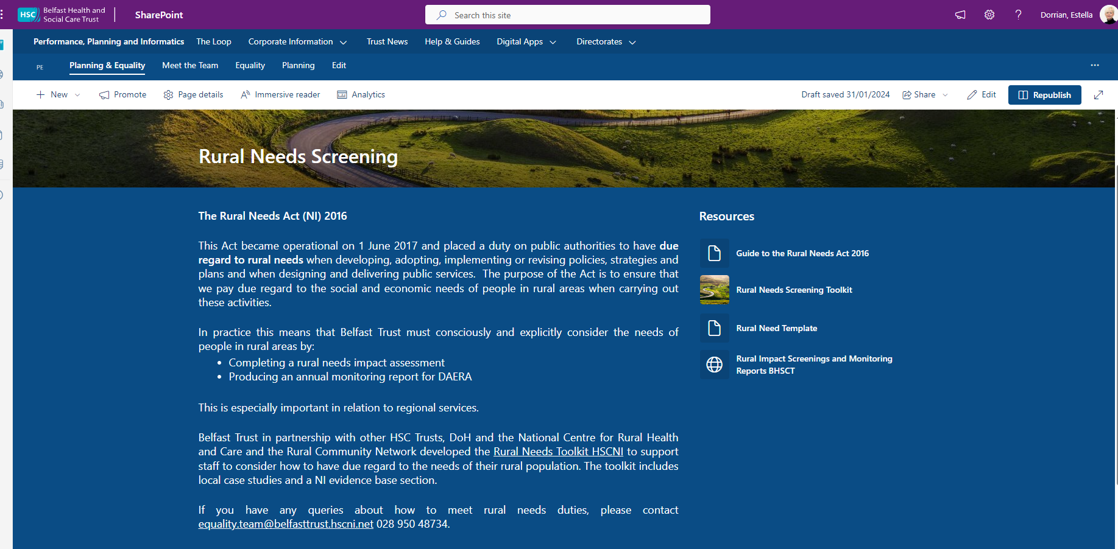

  - Policy/Project leads across the Trust are responsible for completing rural needs impact assessments using a regionally agreed template (Appendix A) alongside the S75 equality screening template when appropriate during policy development/review including during the development of business cases, strategies and reform projects

- In addition, rural champions have been trained to facilitate local decision making and ensure compliance with legislative requirements in regard to rural needs assessments.

- The Trust staff intranet site ‘The Loop’ has a section dedicated to ‘Writing a Policy’. This is available to all staff. Resources are available within a distinct Rural Needs section to raise awareness of the need to undertake a rural impact assessment when writing a policy.

Figure2: Rural Needs within the Writing A Policy Section of the staff intranet The LOOP
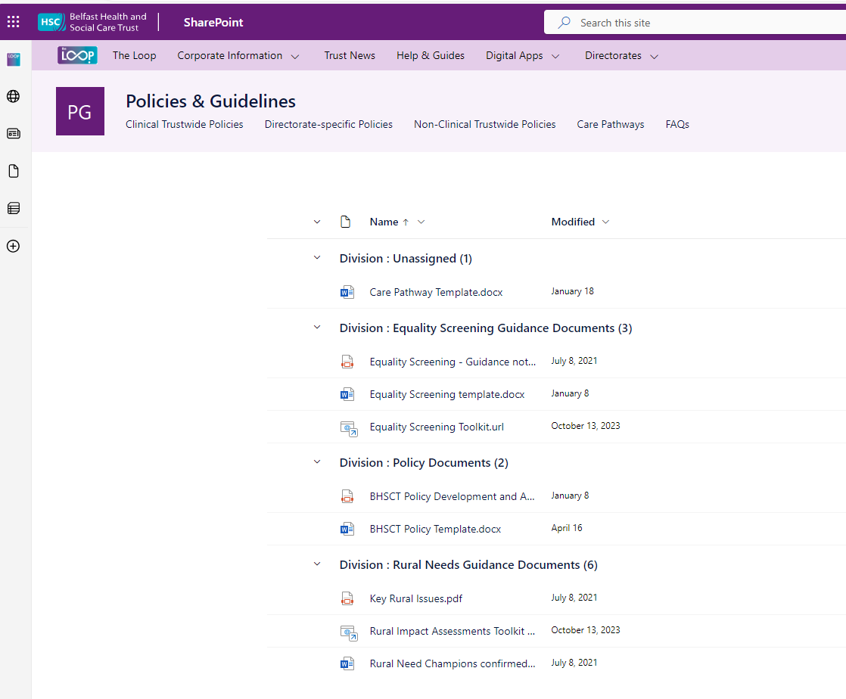

- To ensure the effective mainstreaming and monitoring of the “due regard” duty the Trust’s equality screening template now has a new section relating to rural impact assessments. This is an aide memoir to staff when undertaking an equality screening when drafting a policy, redesigning/modernising a service or planning to introduce a new service or way of working.

Figure 3: Rural Needs Assessment section within the Equality Screening Template

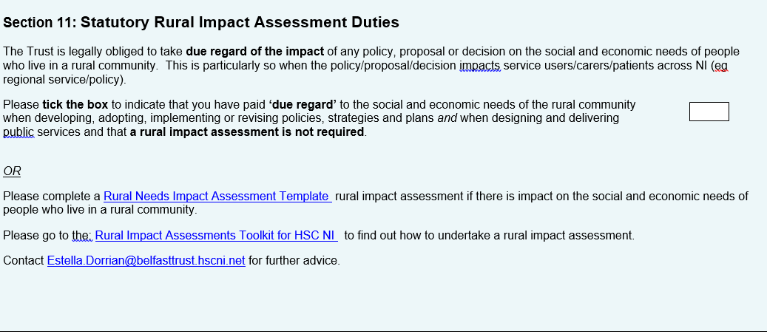

- Belfast Trust have designed a mandatory policy development template to ensure consistency across the Trust in terms of the key elements of a policy draft. The template includes a section relating to the legislative rural duties. This reminds staff of the need to have ‘due regard’ of the social and economic needs of persons in rural areas when drafting a policy/proposal/plan or strategy. By doing so, an explicit aid memoir is provided to staff to ensure that they consciously consider the social /economic needs of persons in rural areas when drafting a policy/proposal or strategy.

Figure 4: Policy Drafting template with explicit reference to rural needs duties in Section 12

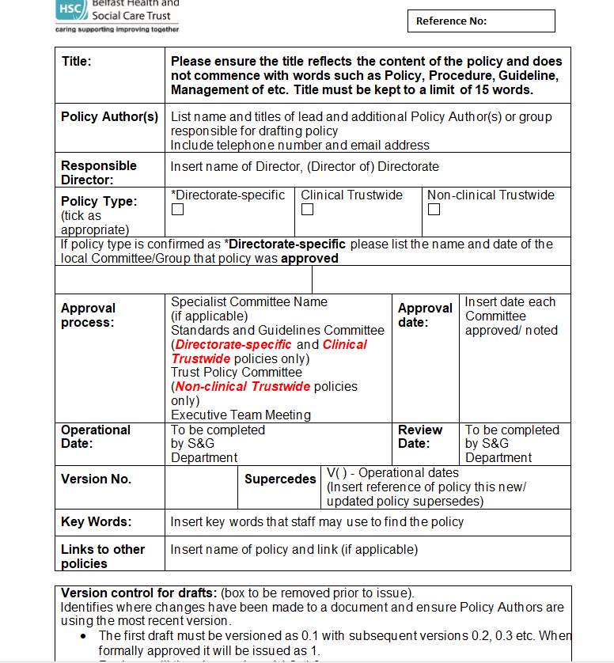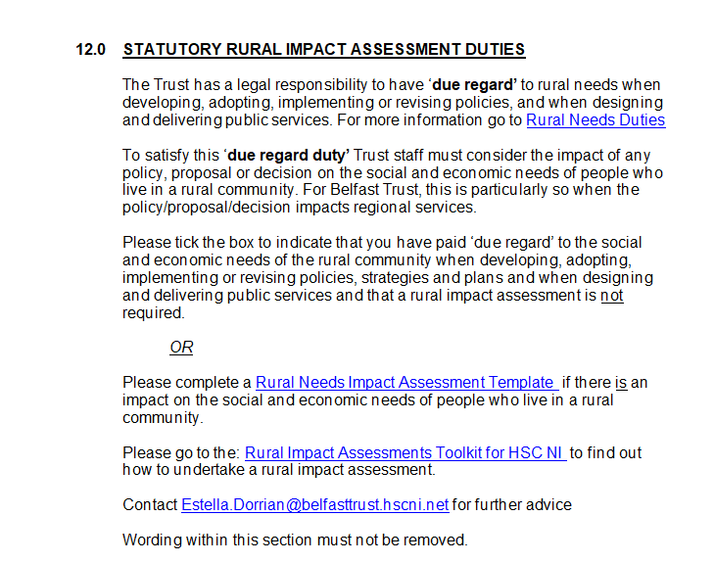

  - In the interests of openness and transparency, Belfast Trust provides detail of those policies which were considered as having a bearing on rural needs and therefore are subject to a full rural needs assessment together with our monitoring reports on our website at: Rural Impact Assessments

Figure 5: Belfast Trust Website: Rural Needs Section

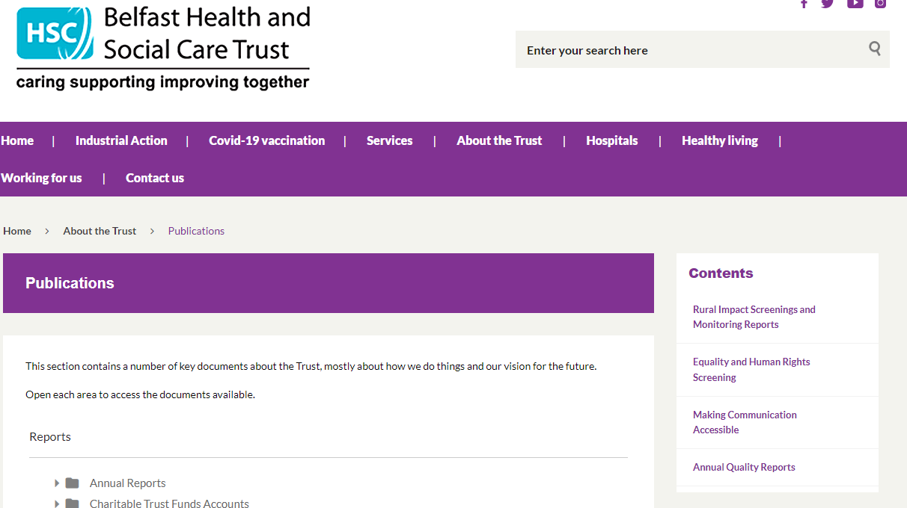

- ‘Rural’ Definition

Belfast Trust uses a working definition of ‘Rural’ in terms of Policy, Strategy, Plan or Public Service to mean those settlements with populations of less than 5,000 together with the open countryside as per DAERA guidance for public authorities.

Recognizing our Trust boundaries, where appropriate, our Community Development Teams and Health Promotion Teams continue to reach out to rural groups such as Killynure Residents Association.

- Rural Needs Assessments

Belfast Trust is committed to promoting and upholding its duties in relation to the Rural Needs Act (NI) 2016 and does have due regard to rural needs in the development of all our policy and public service delivery decisions.

The Trust is mindful that the level of ‘due regard’ expected will depend on the circumstances and, in particular, on the relevance of rural needs to the decision or function in question. The greater the relevance and potential impact for people in rural needs, the greater the due regard required by the duty.

Belfast Trust is the largest integrated health and social care provider in the UK delivering a service to over 360,000 people each year across Belfast and Castlereagh and the region.

When considering the impact of a policy, strategy or plan on the rural community, a fundamental consideration is ‘what constitutes a rural community?’. As noted previously Belfast Trust similar to all other HSC Trusts use the default definition of “rural” as developed by the Inter-Departmental Urban-Rural Definition Group i.e. that “ rural is classified by those settlements with populations of less than 5,000 together with the open countryside”.

Whilst it is acknowledged that approximately 670,000 people live in rural areas in Northern Ireland (36% of the population ) for Belfast Trust the geographical area for which it provides a service to in terms of local services is largely urban. Indeed, from NISRA’s Agricultural Census for 2022 the number of farms in Belfast is noted as 92 and some of these may only be temporary addresses or correspondence addresses. However there are small pockets of rural areas - the rural population of Belfast (2016 mid-year population estimates, NISRA) is approximately 1,484, including the small settlements of Edenderry, Hannahstown and Loughview.

In carrying out its statutory rural duties the Trust will remain mindful of those smaller pockets of rural areas within the Trust area and notably the need to consider rural impact in the delivery of our regional services.

In identifying the social and economic needs of people in rural areas the Trust will consider the NISRA data on the three relevant rural settlements and when considering the delivery of regional services alongside the information presented in the DAERA Rural Policy Framework for Northern Ireland. This provided further details of the social and economic needs generally for those who live in rural areas across Northern Ireland primarily in terms of transport, connectivity, broadband and access to services. Our HSC Rural Proofing Toolkit. Also supports us to address the needs of people in rural areas when designing and delivering our services.

In preparing this monitoring return Trust staff considered policies in respect of the social and economic needs of persons in rural areas and for all there were two rural needs assessments carried out in the reporting period.

In the interests of openness and transparency, the Trust has provided the following hyperlinks to our S75 equality screenings of Trust policies for the period under review:

- Outcome Report April - June 2023.docx

- Outcome Report July - Sept 2023.docx

- Outcome Report Oct - Dec 2023.docx

- Outcome Report Jan - Mar 2024.docx

74 equality screening were undertaken in the reporting period April 23 to March 24. The majority of these were clinical and technical screenings. This represents a reduction from previous years of between 30-40% however this is to b expected as the Trust has prioritised the rollout of a new IT system ‘Encompass’ across the whole Trust (replacing 100+ separate IT platforms) and as part of the Department of Health regional IT Transformation Programme of Work.

The Trust is reassured that where a policy was drafted or screened the duty to give ‘due regard’ to the social and economic neds of people in rural areas this was undertaken given the governance and assurance framework in sit described in section 1 above.

The following table includes information on policies where a Rural Needs Impact Assessment has been completed
escription of the activity undertaken by the public authority which is subject to section 1(1) of the Rural Needs Act (NI) 20161 | The rural policy area(s) which the activity relates to2. | Describe how the public authority has had due regard to rural needs when developing, adopting, implementing or revising the policy, strategy or plan or when designing or delivering the public service3.
Implemention of the decision to close Muckamore Abbey Hospital | Health
Re-location of Hematology Services to Western Trust | Health

Rural Needs Impact Assessment Template APPENDIX A
Section 1: Define activity subject to Section 1(1) of Rural Needs Act (NI) 2016
1A. Short title describing activity being undertaken that is subject to Section 1(1) of the Rural Needs Act (NI) 2016:
1B. Are you Developing, Adopting, Implementing or Revising a Policy a Strategy or a Plan? (Underline or Circle)
Or are you delivering or designing a public service? (Underline or Circle)
What is official title of this Policy, Strategy, Plan or Public service (if any)?
1C. Give details of the aims and/or objectives of the Policy, Strategy, Plan or Public Service:
1D. What definition of ‘rural’ is the Trust using in respect of the Policy, Strategy, Plan or Public Service:
Section 2 - Understanding impact of Policy, Strategy, Plan or Public Service
2A. Is the Policy, Strategy, Plan or Public Service likely to impact on people in rural areas?
Yes No If response is NO Go To Section 2E.
2B. How is it likely to impact on people in rural areas?
2C. If the Policy, Strategy, Plan or Public Service is likely to impact on people in rural areas differently from people in urban areas, please explain how it is likely to impact on people in rural areas differently?
2D. Please indicate which of the following rural policy areas the Policy, Strategy, Plan or Public Service is likely to primarily impact on.
Jobs or Employment in Rural Areas |  | Community Safety or Rural Crime |  | Agriculture-Environment
Education or Training in Rural Areas |  | Health or Social Care Services in Rural Areas |  | Other, please state below;
Rural Development |  | Broadband/Mobile Communications in Rural Areas |  | Other, please state below;
Poverty or Deprivation in Rural Areas |  | Rural Business, Tourism or Housing |  | Other, please state below;

2E. Please explain why the Policy, Strategy, Plan or Public Service is NOT likely to impact on people in rural areas.

If you completed 2E above GO TO Section 6
SECTION 3 - Identifying Social and Economic Needs of Persons in Rural Areas
3A. Has the Trust taken steps to identify the social and economic needs of people in rural areas, relevant to the Policy, Strategy, Plan or

Public Service? Yes No if the response is NO, GO TO Section 3D
3B. Which of following methods or information sources were used by the Trust to identify these needs?

Consultation with relevant stakeholders / Survey or Questionnaire / Research / Statistics / Publications / Other methods.
Please provide details:
3C. What social and economic needs of the people in rural areas have been identified?
3D Please explain why no steps were taken by the Trust to identify the social and economic needs of people in rural areas?
SECTION 4 - Considering Social and Economic Needs of Persons in Rural Areas
4A. What issues were considered in relation to the social and economic needs of people in rural areas?
SECTION 5 - Influencing the Policy, Strategy, Plan or Public Service
5A. Has the policy, strategy, plan or public service been changed by consideration of the rural needs identified?
Yes No if the response is NO, GO TO Section 5C
5B. If yes, how have rural needs influenced the policy, strategy plan or public service?
5C. If no, why have the rural needs identified not influenced the policy, strategy, plan or public service?
Section 6: Documentation:
6A. Please tick below to confirm that the RNIA Template will be retained by the Trust and relevant information on the Section 1 activity compiled in accordance with paragraph 6.7 of the guidance.
I confirm that the RNIA Template will be retained and relevant information compiled.
Rural Needs Impact Assessment undertaken by:

Census 2021

