
NOTES
- This information should normally be contained in section 1B of the RNIA Template completed in respect of the activity.
- This information should normally be contained in section 2D of the RNIA Template completed in respect of the activity.
- The information contained in sections 3D, 4A & 5B of the RNIA Template should be considered when completing this section.

A Guide to the Rural Needs Act (NI) 2016 for Public Authorities
(Revised) April 2018
Information to be compiled by Public Authorities under Section 3(1)(a) of the Rural Needs Act (NI) 2016.

Name of Public Authority: | Belfast Health and Social Care Trust

Reporting Period: | April | 20 | 24 | to | March | 20 | 25

Belfast Trust is committed to promoting and upholding its duties in relation to the Rural Needs Act (NI) 2016 and will have ‘due regard’ to rural needs when developing, adopting, implementing or revising policies, strategies and plans, and when designing and delivering public services.

The Trust acknowledges that the duty of ‘due regard’ means that it will consciously consider the social and economic needs of persons in rural areas when a policy, strategy, plan, or service design and delivery is under consideration. In addition, the Trust acknowledges the need to compile information on the exercise of this duty. The duty to rural proof means that we have a duty to identify the potential impact that a policy or strategy would have on a rural area, to make a proper assessment of those impacts if they are deemed to be significant and, where appropriate, to make adjustments to the policy or strategy to take account of rural circumstances.

Our HSC Rural Proofing Toolkit, launched in October 2022, was designed to help us address the needs of people in rural areas when designing and delivering our services. In addition, Belfast Trust is aware of and refers to DAERA’s revised guidance: Guide to the Rural Needs Act NI

We recognise that people in rural areas can face particular challenges - the combination of geographical isolation, poor public infrastructure and low population density often impact on the ability of people in rural areas to access services, meaning that service delivery in rural areas often has to be different to that in urban areas. We are committed to ensuring where our services are delivered to people in rural areas that due regard is taken of the potential challenges that can exist. Given our geographical profile, Belfast Trust is particularly mindful of our rural needs responsibilities when linked to the delivery of regional services.

The Trust’s Involvement Committee, Executive Team and Trust Board considered this Annual Monitoring Report .

- Trust Governance and Assurance Framework : Commitment to the ‘due regard’ duty

Robust governance and accountability structures have been established within the Trust to ensure that our responsibilities relating to the Rural Needs Act (NI) 2016 are met. To comply with our statutory duties and to mainstream our commitment to the fulfilment of these duties Belfast Trust has proactively carried out the following activities:

- The Trust’s Involvement Steering Group, which has oversight of our Section 75 Equality work and Rural obligations is part of the Trust Integrated Governance and Assurance Framework. The Framework provides strategic leadership, holds to account, unblocks and assists with problem solving, seeks assurance, provides challenge and escalates risks to appropriate Trust Board Committees.

- It is the Trust’s responsibility to record, co-ordinate and monitor its rural needs assessment activity and for satisfying itself that it is meeting its ‘due consideration’ obligations. These duties are clearly outlined in the regional HSC publication Guidance for Board Members 2020.developed by HSC Trusts and which has been proactively disseminated to the Belfast Trust Executive Team and Trust Board members.

- The Director of Planning, Performance and Informatics (PPI) is responsible for the central co-ordination of the Annual Rural Needs Monitoring Report on behalf of the Trust.

- The Trust’s Planning and Equality Team within PPI provides support to colleagues across the Trust in relation to complying with and understanding the statutory obligations. A Senior Planning and Equality Manager within the team is the rural needs co-ordinator for Belfast Trust. Rural champions have also been trained to facilitate local decision making and ensure compliance with legislative requirements in regard to rural needs assessments.

- To ensure the effective mainstreaming and monitoring of the “due regard” duty the Trust’s equality screening template now has a new section relating to rural impact assessments. This provides an aide memoir to staff when undertaking an equality screening when drafting a policy, redesigning/modernising a service or planning to introduce a new service or way of working.

Figure 1: Rural Needs Assessment Aide Memoire within the Equality Screening Template

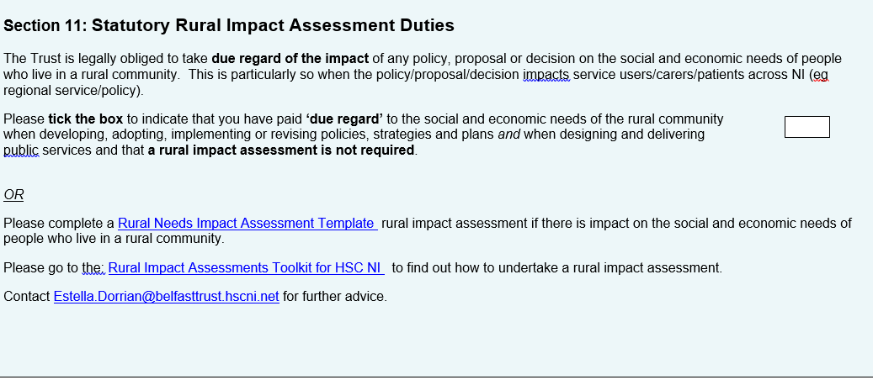

- Belfast Trust have designed a mandatory ‘Policy Drafting’ template to ensure consistency across the Trust in terms of the key elements of a policy . The template includes a section relating to the legislative rural duties. This reminds staff of the need to have ‘due regard’ of the social and economic needs of persons in rural areas when drafting a policy/proposal/plan or strategy. By doing so, an explicit aide memoir is again provided to staff to ensure that they consciously consider the social /economic needs of persons in rural areas when drafting a policy/proposal or strategy.

Figure 2: Policy Drafting template with explicit reference to rural needs duties in Section 12

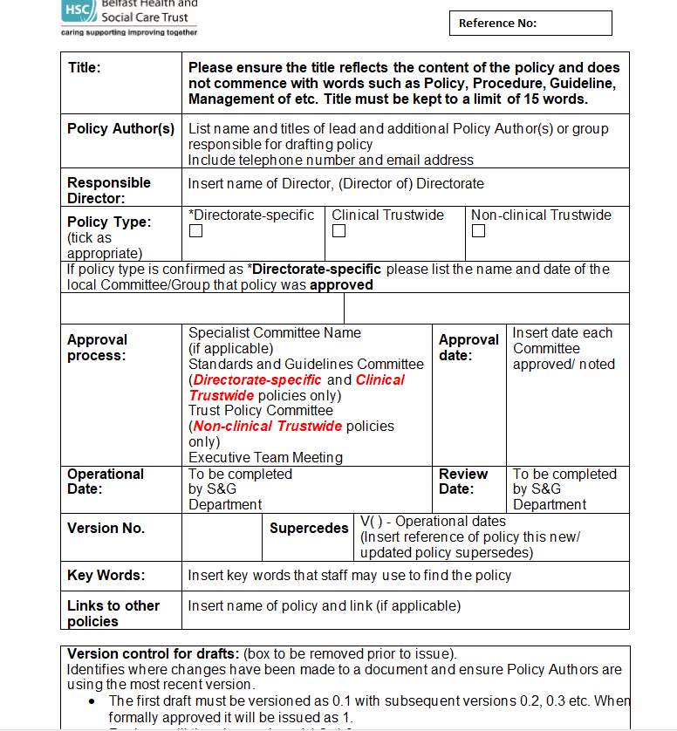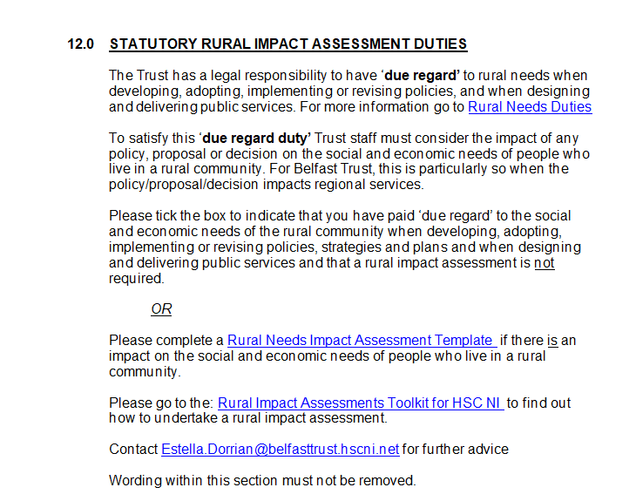

- Staff Awareness

Information about the statutory ‘due regard’ duty in relation to the social and economic needs of people in rural areas is provided to staff through a variety of channels and mechanisms as follows:

- The Planning & Equality Trust Staff Intranet site (The Loop) has a quick link to the HSC Rural Needs Toolkit. (Fig 3). In addition, dedicated online resources related to Rural Needs is contained within the Planning & Equality staff site (Fig 4 & 5).


Figure 3: Information about Rural Needs within the Planning & Equality Team’s Section: Staff Intranet: The LOOP

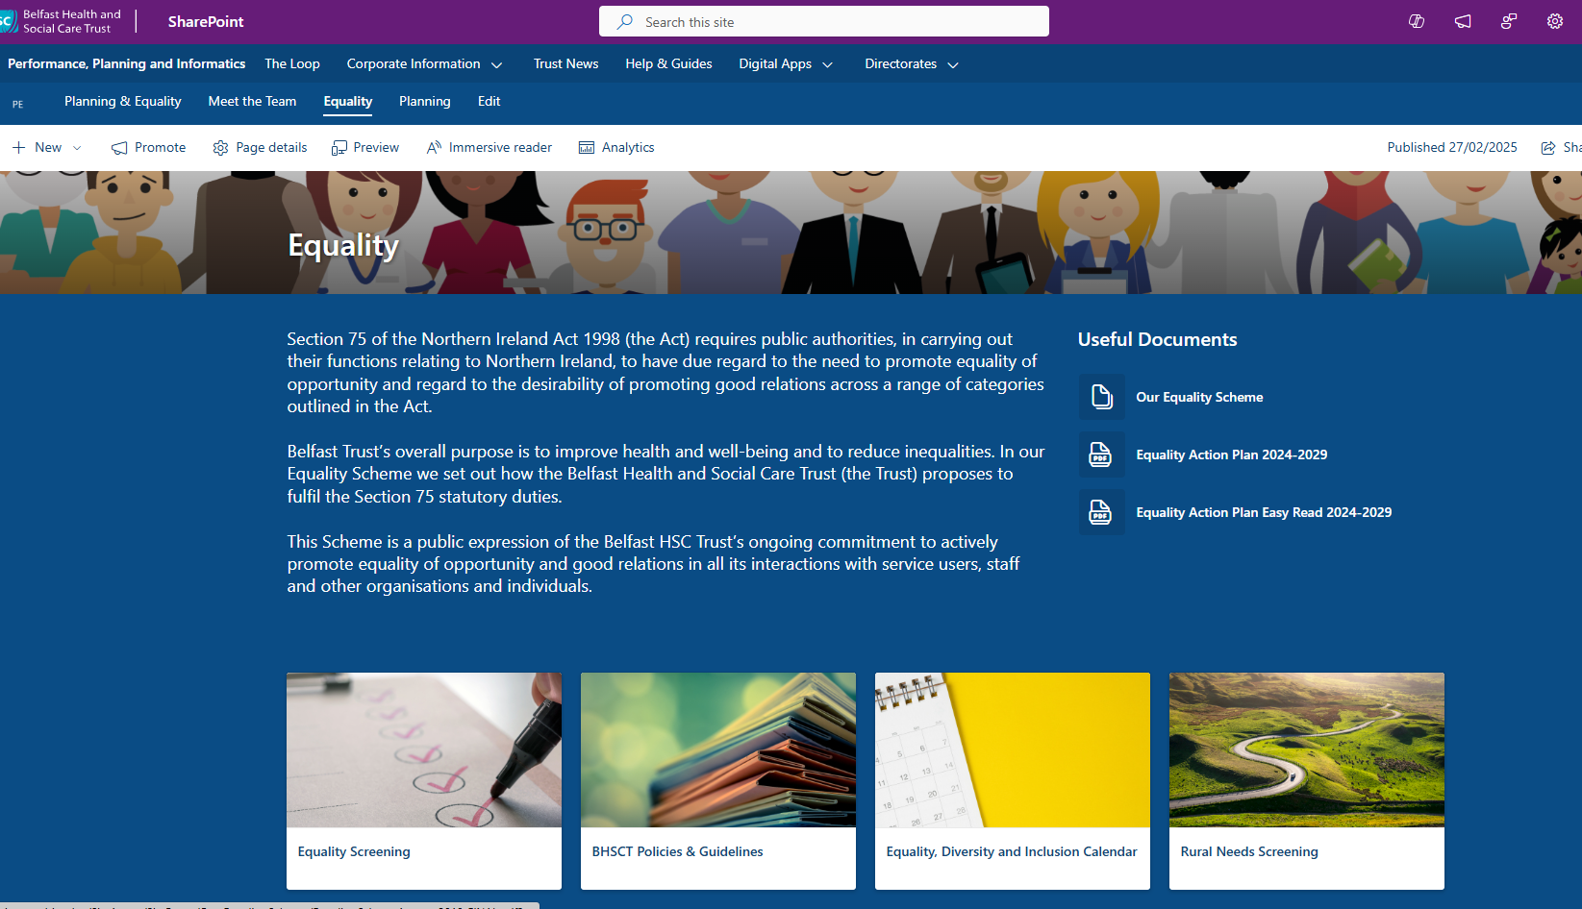
Figure 4/5: Information about Rural Needs within the Planning & Equality Team’s Section: Staff Intranet: The LOOP

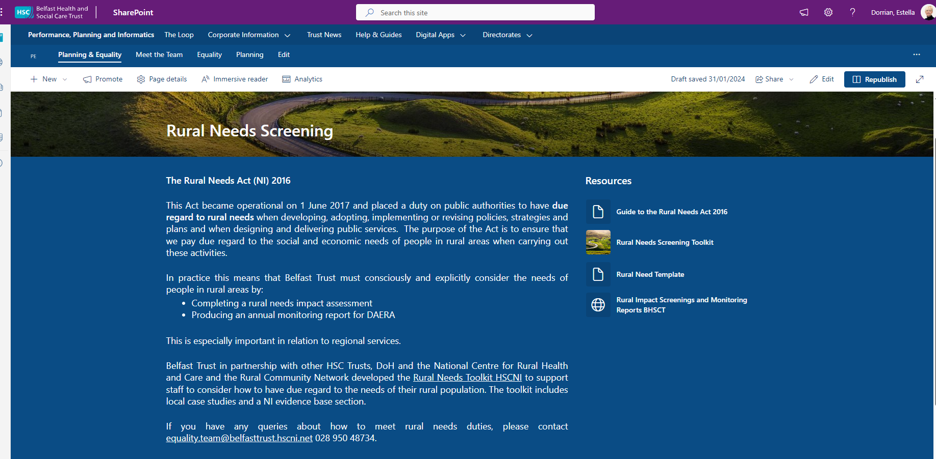

- The Trust staff intranet site ‘The Loop’ has a section dedicated to ‘Writing a Policy’. This is available to all staff. Resources are available within a distinct Rural Needs section to raise awareness of the need to undertake a rural impact assessment when writing a policy.

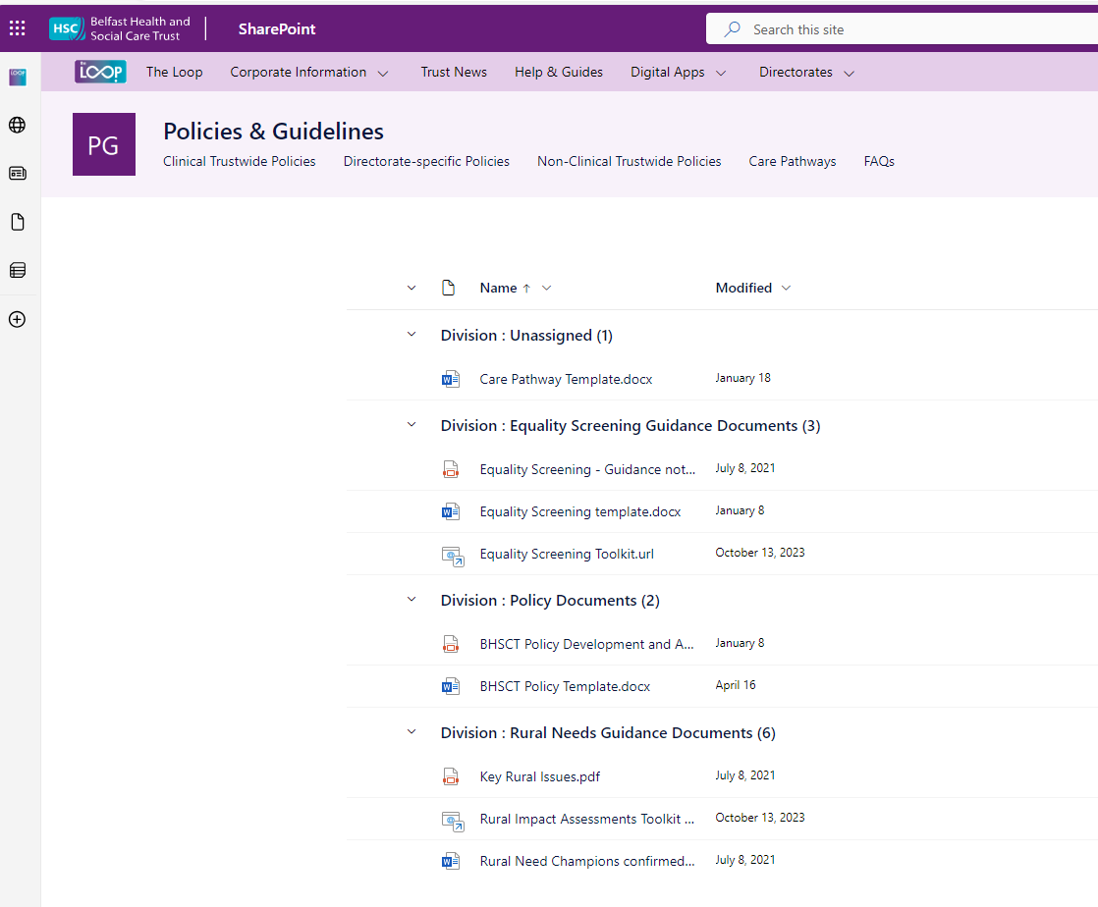
Figure 6: Rural Needs within the ‘Writing A Policy’ Section of the staff intranet The LOOP

- ‘Rural’ Definition

Belfast Trust uses a working definition of ‘Rural’ in terms of Policy, Strategy, Plan or Public Service to mean those settlements with populations of less than 5,000 together with the open countryside as per DAERA guidance for public authorities.

More than a third (36%) of Northern Ireland’s (NI) population lives in a rural area but given the urban population
that Belfast Trust serves in terms of District General Hospital services, there will be very few instances when a
rural impact assessment is appropriate or proportionate. As such, only the delivery of regional specialist services by
Belfast Trust are likely to require a rural assessment.

- Rural Needs Assessments

Belfast Trust is committed to promoting and upholding its duties in relation to the Rural Needs Act (NI) 2016 and to having due regard to rural needs in the development of our policy and public service delivery decisions.

Policy/Project leads across the Trust are responsible for completing rural needs impact assessments using a regionally agreed template (Appendix A) alongside the S75 equality screening template when appropriate during policy development/review including during the development of business cases, strategies and reform projects

In the interests of openness and transparency, Belfast Trust provides detail of those policies which were considered as having a bearing on rural needs and therefore are subject to a full rural needs assessment together with our monitoring reports on our website at: Rural Impact Assessments

Figure 7: Belfast Trust Website: Rural Needs Section

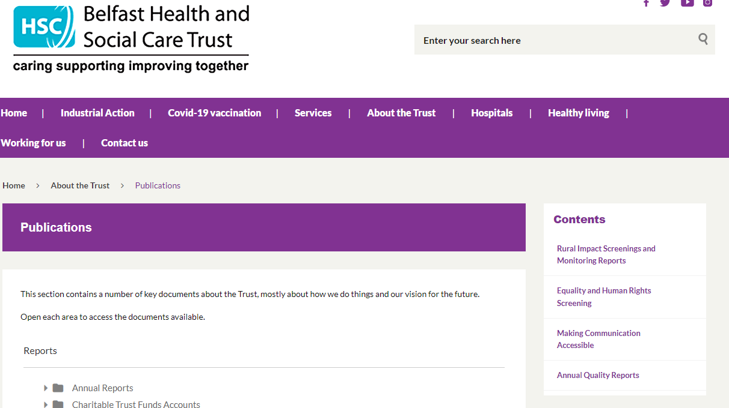

The Trust is mindful that the level of ‘due regard’ expected will depend on the circumstances and, in particular, on the relevance of rural needs to the decision or function in question. The greater the relevance and potential impact for people in rural needs, the greater the due regard required by the duty.

Belfast Trust is the largest integrated health and social care provider in the UK delivering a service to over 360,000 people each year across Belfast and Castlereagh and the region.

When considering the impact of a policy, strategy or plan on the rural community, a fundamental consideration is ‘what constitutes a rural community?’. As noted previously Belfast Trust similar to all other HSC Trusts use the default definition of “rural” as developed by the Inter-Departmental Urban-Rural Definition Group i.e. that “ rural is classified by those settlements with populations of less than 5,000 together with the open countryside”.

Whilst it is acknowledged that approximately 670,000 people live in rural areas in Northern Ireland (36% of the population ) for Belfast Trust the geographical area for which it provides a service to in terms of local services is largely urban. Indeed, from NISRA’s Agricultural Census for 2022 the number of farms in Belfast is noted as 92 and some of these may only be temporary addresses or correspondence addresses. However there are small pockets of rural areas - the rural population of Belfast (2016 mid-year population estimates, NISRA) is approximately 1,484, including the small settlements of Edenderry, Hannahstown and Loughview.

In carrying out its statutory rural duties the Trust will remain mindful of those smaller pockets of rural areas within the Trust area and notably the need to consider rural impact in delivery of our regional services.
In identifying the social and economic needs of people in rural areas the Trust will consider the NISRA data on the three relevant rural settlements and when considering the delivery of regional services alongside the information presented in the DAERA Rural Policy Framework for Northern Ireland. This provides further details of the social and economic needs generally for those who live in rural areas across Northern Ireland primarily in terms of transport, connectivity, broadband and access to services. Our HSC Rural Proofing Toolkit. also supports us to address the needs of people in rural areas when designing and delivering our services.

In preparing this monitoring return Belfast Trust staff considered policies in respect of the social and economic needs of persons in rural areas and for all there were three rural needs assessments were carried out in the reporting period.

In the interests of openness and transparency, the Trust has provided the following hyperlinks to our S75 equality screenings of Trust policies for the period under review:

      - Equality and Human Rights Screening - Apr to Jun 24
      - Equality and Human Rights Screening - July to Sept 24
      - Equality and Human Rights Screening- Oct to Dec 24
      - Equality and Human Rights Screening - Jan to Mar 25

94 equality screenings were undertaken in the reporting period April 24 to March 25. The majority of these were clinical and technical screenings (approx. 80%) which means they had no relevance to equality eg Wound Management Principles of Caring for Patients with an open wound.

The Trust is assured that where a policy was drafted or screened the duty to give ‘due regard’ to the social and economic neds of people in rural areas this was undertaken given the governance and assurance framework described in section 1 above.

The following table includes information on policies where a Rural Needs Impact Assessments have been completed

Description of the activity undertaken by the public authority which is subject to section 1(1) of the Rural Needs Act (NI) 2016 | Policy Area | Describe how the public authority has had due regard to rural needs when developing, adopting, implementing or revising the policy, strategy or plan or when designing or delivering the public service
BHSCT implementation of encompass system for electronic health care records. | Health | Implementation of encompass is expected to reduce unnecessary appointments for assessment, review and reduce repeated interventions, reducing need for travel and associated costs.  Encompass’ ability to collect and report on data, may make it easier to analyse health inequality data, and be useable for service development, re-design or improvements. Health inequalities between urban and rural populations will be better evidenced.  The ‘MyCare App will be available to all BHSCT service users regardless of where they live. This means that patients and service users and carers who use regional services delivered by BHSCT can access their medical records and are more informed.  The MyCare app will allow people to access information like medications, appointments and some test results. It is free to use, and it is optional.  The Department of the Economy is leading on the delivery of Project Gigabit in Northern Ireland. This is part of the UK Governments £5 billion programme to enable hard- to reach communities to access lightening-fast gigabit capable broadband. Policy and implementation takes this into consideration.
Emotional Wellbeing Teams in School (EWTS) service delivered by BHSCT to children and young people in schools within both Belfast Health & Social Care Trust. (BHSCT) & South Eastern Health & Social Care Trust (SEHSCT). | Health | Impact deemed positive.  The programme is part of the implementation of the DoE & DoH’s 2021 Framework: Children and Young People’s Emotional Health and Wellbeing in Education.  To implement the Framework the BHSCT programme will integrate support from the voluntary & community sector in local educational settings to enable effective, local early interventions. The goal is that children and young person’s problems can be prevented and where they do happen the right care/support is provided at the right time in the right place – locally
Implementation of the Closure of Muckamore Abbey Hospital | Health | Impact is deemed positive.  An integral aspect of the implementation of the DoH decision to close Muckamore Abbey Hospital is the resettlement of existing residents to their own local area. This means that the provision of care and support to Service Users and Patients will be based around their own home Trust locality which will ensure there is greater community integration and closer links to family, carers and other established local community supports.  The plan is for Belfast Trust to work in partnership with other Trusts across the region to resettle service users currently delayed in MAH into the community however as explained in 2B above, the impact will be a positive impact on people living in these rural areas.  Each Trust’s multidisciplinary team will be able to coordinate care and take ownership of the services provided to each of service users living within their Trust area. It is anticipated that services locally owned and operated will be better able to proactively deliver and react to the changing needs of this cohort of service users across Northern Ireland.  In addition, the provision of local support provides additional benefits to the families of the current cohort of patients/service users in MAH as families / carers no longer will have to travel across Northern Ireland to Hospital to visit and support their loved ones.

Rural Needs Impact Assessment Template APPENDIX A
Section 1: Define activity subject to Section 1(1) of Rural Needs Act (NI) 2016
1A. Short title describing activity being undertaken that is subject to Section 1(1) of the Rural Needs Act (NI) 2016:
1B. Are you Developing, Adopting, Implementing or Revising a Policy a Strategy or a Plan? (Underline or Circle)
Or are you delivering or designing a public service? (Underline or Circle)
What is official title of this Policy, Strategy, Plan or Public service (if any)?
1C. Give details of the aims and/or objectives of the Policy, Strategy, Plan or Public Service:
1D. What definition of ‘rural’ is the Trust using in respect of the Policy, Strategy, Plan or Public Service:
Section 2 - Understanding impact of Policy, Strategy, Plan or Public Service
2A. Is the Policy, Strategy, Plan or Public Service likely to impact on people in rural areas?
Yes No If response is NO Go To Section 2E.
2B. How is it likely to impact on people in rural areas?
2C. If the Policy, Strategy, Plan or Public Service is likely to impact on people in rural areas differently from people in urban areas, please explain how it is likely to impact on people in rural areas differently?
2D. Please indicate which of the following rural policy areas the Policy, Strategy, Plan or Public Service is likely to primarily impact on.
Jobs or Employment in Rural Areas |  | Community Safety or Rural Crime |  | Agriculture-Environment
Education or Training in Rural Areas |  | Health or Social Care Services in Rural Areas |  | Other, please state below;
Rural Development |  | Broadband/Mobile Communications in Rural Areas |  | Other, please state below;
Poverty or Deprivation in Rural Areas |  | Rural Business, Tourism or Housing |  | Other, please state below;

2E. Please explain why the Policy, Strategy, Plan or Public Service is NOT likely to impact on people in rural areas.

If you completed 2E above GO TO Section 6
SECTION 3 - Identifying Social and Economic Needs of Persons in Rural Areas
3A. Has the Trust taken steps to identify the social and economic needs of people in rural areas, relevant to the Policy, Strategy, Plan or

Public Service? Yes No if the response is NO, GO TO Section 3D
3B. Which of following methods or information sources were used by the Trust to identify these needs?

Consultation with relevant stakeholders / Survey or Questionnaire / Research / Statistics / Publications / Other methods.
Please provide details:
3C. What social and economic needs of the people in rural areas have been identified?
3D Please explain why no steps were taken by the Trust to identify the social and economic needs of people in rural areas?
SECTION 4 - Considering Social and Economic Needs of Persons in Rural Areas
4A. What issues were considered in relation to the social and economic needs of people in rural areas?
SECTION 5 - Influencing the Policy, Strategy, Plan or Public Service
5A. Has the policy, strategy, plan or public service been changed by consideration of the rural needs identified?
Yes No if the response is NO, GO TO Section 5C
5B. If yes, how have rural needs influenced the policy, strategy plan or public service?
5C. If no, why have the rural needs identified not influenced the policy, strategy, plan or public service?
Section 6: Documentation:
6A. Please tick below to confirm that the RNIA Template will be retained by the Trust and relevant information on the Section 1 activity compiled in accordance with paragraph 6.7 of the guidance.
I confirm that the RNIA Template will be retained and relevant information compiled.
Rural Needs Impact Assessment undertaken by:

Census 2021

