

Screening Outcome Report

1st April – 30th June 2024

Introduction

Section 75 of the Northern Ireland Act 1998 requires the Trust, when carrying out its functions in relation to Northern Ireland, to have due regard to the need to promote equality of opportunity between nine categories of persons, namely:

- between persons of different religious belief, political opinion, racial group, age, marital status or sexual orientation;
- between men and women generally;
- between persons with a disability and persons without; and
- between persons with dependants and persons without.

Without prejudice to its obligations above, the Trust must also have regard to the desirability of promoting good relations between persons of different religious belief, political opinion or racial group.

Belfast Trust’s Revised Equality Scheme was formally approved by the Equality Commission in September 2011. The revised Scheme outlines how we propose to fulfil our statutory duties under Section 75. Within the Scheme, the Trust gave a commitment to apply the screening methodology below to all new and revised policies and where necessary and appropriate to subject new policies to further equality impact assessment.

- What is the likely impact of equality of opportunity for those affected by this policy/proposal, for each of the Section 75 equality categories?
- Are there opportunities to better promote equality of opportunity for people within Section 75 equality categories?
- To what extent is the policy/proposal likely to impact on good relations between people of different religious belief, political opinion or racial group?
- Are there opportunities to better promote good relations between people of different religious belief, political opinion or racial group?

In keeping with the Trust’s commitments in its Equality Scheme the Trust has applied the above screening criteria to new policies and proposals. Screening identifies policies that are likely to have an impact on equality of opportunity and or good relations.

Screening identifies the impact of the policy/proposal as major, minor or none.
- If major – an Equality Impact Assessment may be carried out.
- If minor – consider mitigation or alternative policy and screen out.
- If none – screen out and give reasons.
- Ongoing screening – for strategies/policies that are to be put in place through a series of stages – screen at various stages during implementation.

Figure 1 provides a flowchart of how screening is conducted in Belfast Trust.
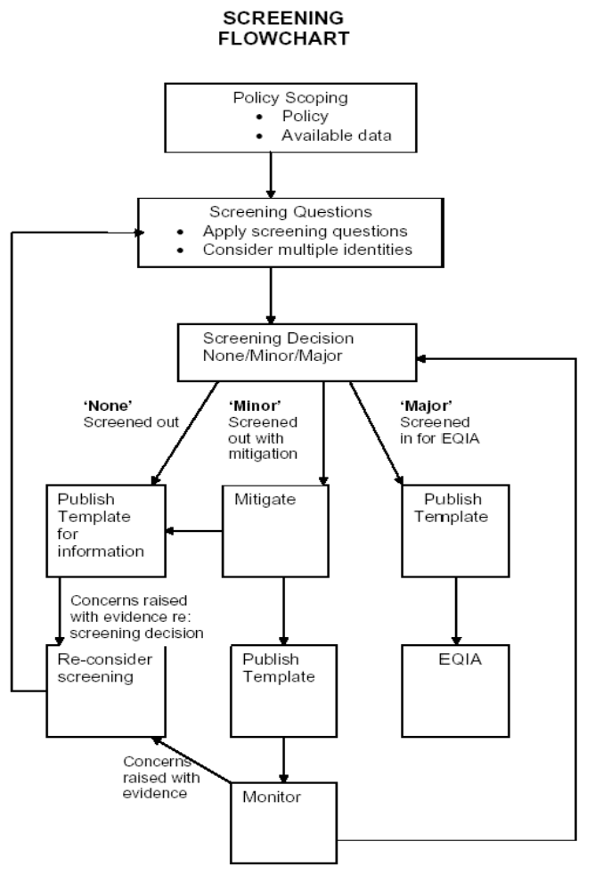

Belfast Trust also committed within its Revised Equality Scheme to prepare and publish for information regular reports on its screening exercises. Belfast HSC Trust has provided detail on all screenings undertaken since 1 September 2011 when the Trust received Equality Commission approval for their revised Equality Scheme. To further promote openness and transparency, there is a link to each completed screening template on the Belfast Trust’s website. www.belfasttrust.hscni.net.

The quarterly screening report shall detail all policies screened over a three month period and includes decisions reached.

This screening report outlines the screening outcomes from 1st April – 30th June 2024.

Communication and Engagement

Belfast Trust recognises the importance of stakeholder involvement – one of the 5 key strategic objectives that Belfast Trust devised at the outset was that of Partnership – we are committed to improving health and well-being through existing and new partnerships with a range of individuals, representative groups and voluntary and community organisations. The Trust is committed to providing people led services, drawing on the years of experience and listening to the needs and feedback that meaningful consultation can yield. There is a need to continue to effectively engage and work collaboratively with a wide range of stakeholders including Trust staff, Trade Unions, service users, carers, commissioners, primary care, public representatives and independent providers.

The Trust is committed to promoting personal and public involvement in all its activities. The development of new policies and proposals will be supported by effective engagement processes to ensure that staff, service users and all interested parties are fully involved. Planning for, and delivering safe, clinically effective and cost-effective services requires close collaboration at many levels.

If you have any queries about this document, and its availability in alternative formats (including Braille, disk and audio cassette, and in minority languages to meet the needs of those who are not fluent in English) then please contact:

Orla Barron
Equality Lead
Belfast Health and Social Care Trust
First Floor, Administration Building
Knockbracken Healthcare Park
Saintfield Road
Belfast
BT8 8BH

Telephone: 028 95046567
Textphone: 028 90637406
orla.barron@belfasttrust.hscni.net

This report details each proposal and the screening outcome – for ease of reference, readers can access the full completed screening template via a link to the Trust website. Should you have concerns which are based on supporting evidence regarding the screening decision, please contact the Health and Social Inequalities Manager as above and outline your concern along with the supporting evidence. Belfast Trust will duly consider rescreening the proposal.

Outcome of Screening

The screening outcomes are outlined below. Four possible outcomes are recorded:

- The policy has been ‘screened in’ for equality impact assessment;

- The policy has been „screened out’ with mitigation or an alternative policy proposed to be adopted;

- The policy has been ‘screened out’ without mitigation or an alternative policy proposed to be adopted.

- The policy will be subjected to ongoing screening. For more detailed strategies or policies that are to be put in place through a series of stages, screening should be considered at various times during implementation.
Description of Policy or Proposal | Screening Outcome
25/07/2023  Acute Mental Health Inpatient Centre (AMHIC) Operational Policy  Purpose:  The purpose of the operational policy is to set out daily arrangements within the AMHIC and should be used in conjunction with other relevant Trust clinical polices, Standard Operating procedures and regional guidance.  The AMHIC aims to provide a model of care based upon a whole team approach to address the biopsychosocial needs of its patients with a clear focus on recovery. | Screened Out - minor impact with mitigation
18/08/2023  Policy On the Data Protection and Protection of Personal Information  Purpose:  Belfast Health And Social Care Trust is required to collect and hold certain types of personal data including information about people with whom it deals with in order to operate. The legal requirement for the Trust and its staff to treat personal information confidentially and hold it securely is set out in the UK General Data Protection Regulation (GDPR) and the Data Protection Act 2018. | Screened Out
07/08/2023  Screening and vaccination of staff against infectious diseases in the workplace  Purpose:  This policy outlines the processes to be followed in the Trust to ensure that staff have appropriate screening for, and vaccination against, infectious diseases in the workplace. The general guidelines in the main policy should be used in conjunction with the more detailed information contained in the Occupational Health Standard Operating Procedures and in the Written  Instructions for vaccinations | Screened out – clinical in nature
11/07/2023  Guidance on the Perioperative Administration of Medications for Adult Patients Undergoing Surgery  Purpose:  This guideline is for healthcare professionals involved in managing patients’ medicines in the peri-operative period. Its purpose is to promote a standardised and consistent approach to practice across BHSCT for adult patients requiring surgery based on the best available evidence and expert opinion. The overall aim is to ensure patients administer only the appropriate medication prior to admission and on day of surgery for elective procedures, as well as equipping staff to manage medications safely in the perioperative period for patients undergoing unplanned or emergency surgery. | Screened out – clinical in nature

21/07/2023  Patient controlled analgesia (PCA) for adult patients over 16 years of age  Purpose:  Promote safe and effective pain management for adult patients using PCA. · Provide guidance on recognition and management of adverse effects, such as respiratory depression | Screened out – clinical in nature
22/08/2023  Adjudication of New Medicines (and Treatments)  Purpose:  The purpose of this policy is to outline the robust and transparent decision making process regarding new medicines within the trust. This policy covers the governance arrangements for management of new medicines and treatments within Belfast H&SC Trust. | Screened out – clinical in nature
16/08/2023  Belfast Health and Social Care Trust Policy and Procedural Arrangements relating to The Control of Noise at Work  Purpose:  This policy & procedural arrangement is designed to provide managers and staff with clear guidelines and outline their responsibilities to manage the risk associated with the control of noise at work | Screened out – clinical in nature
16/08/2023  Belfast Health and Social Care Trust Policy and Procedural Arrangements relating to Control of Vibration at Work  Purpose:  This policy & procedural arrangement is designed to provide managers and staff with clear guidelines and outline their responsibilities to manage the risk associated with vibration | Screened out – clinical in nature
21/07/2023  Clinical Recommendations for the Management of Malignant Bowel Obstruction (MBO)  Purpose:  Clinical guidelines on the conservative (non-surgical) management of malignant bowel obstruction in adults. Replaces clinical recommendations (1) and updates NICAN guidelines (2) with up to date changes on clinical management. | Screened out – clinical in nature
24/08/2023  Standard Operating Procedure for the Management of Complex Lower Limb Extremity Trauma (Adults).  Purpose:  This standard operating procedure outlines recommended practice for the management of adults with complex lower limb extremity trauma. It is based on international guidance, ongoing clinical audit, and published literature. It is aimed at specifically reducing the risk of amputation and also identifying the importance of considering primary amputation | Screened out
27/09/2023  Employers Procedures required under IR(ME)R (NI) 2018 for the protection of patients undergoing Medical Exposure to Ionising Radiation as part of Screening, Family History, Symptomatic and Surveillance Breast Screening Services  Purpose:  These Employer Procedures lay down basic measures for the health protection of individuals against the dangers of ionising radiation in relation to medical exposure as part of Screening, Family History, Symptomatic and Surveillance Breast Screening Services. The procedures have been developed to standardise practice and achieve best practice. The procedures explicitly reference the need for making reasonable adjustments and making communication accessible and inclusive in terms of disabled patients or patients whose first language is not English | Screened out – clinical in nature
03/08/2023  Guidelines for the administration of Tuberculin PPD RT 23 SSI by Registered Nurses working in the occupational Health service.  Purpose:  This policy has been developed to provide guidelines for registered nurses within the occupational health service .  The policy provides clear procedures to carry out mantoux testing as part of the occupational health screening and vaccination programme for health care workers employed by the Belfast Trust. It also applies to others who contract our services who are in clinical contact with patients in high risk areas who are at risk of exposure to TB .  This policy should be used in conjunction with trust wide medicines management policies and codes of practice for administration of medicines including Occupational standard operating procedures for the prevention and screening of Tuberculosis. | Screened out – No Impact
08/08/2023  Proposed relocation of Intellectual Disability (ID) Service’s South and East Community Teams and Allied Health Professional colleagues from Finaghy Health Centre/Mount Oriel to Graham House, in Knockbracken Healthcare Park (KBHCP)  Purpose:  The rationale for this move is to provide the necessary supporting infrastructure for the General Practitioners (GP’s) in Finaghy Health Centre to support the continued provision of core General Medical services and training facilities. It will also help to accommodate the additional services which will roll out in the near future, including Advance Nurse Practitioner (ANP), General Practice Nurse (GPN), and Multi-Disciplinary Teams to enhance patient experience within primary care | Screened Out - Minor Impact with Mitigation
24/08/2023  Relocation of Dunluce Health Visiting Staff  Purpose:  It is proposed that staff are relocated to other HV teams to ensure appropriate staffing levels, cover arrangements and access to suitable peer support. | Screened out – No Impact
25/01/2021  Relocation of Senior Executive Team and Admin support to RVH Site  Purpose:  Relocation of Senior Executive Team and Support Staff from BCH Site to RVH Site. Rationale For Change: Current issues facing the service: Demand for Clinical space is always increasing and it is becoming more challenging to identify suitable accommodation. | Screened out – No Impact
07/09/2023  Prescription Safety Spectacles Policy and Procedure  Purpose:  The Trust, as per the Personal Protective Equipment (PPE) at Work Regulations (NI) 1993 is required to ensure that suitable PPE is provided for employees who may be exposed to a risk to their health and safety while at work. | Screened out - technical nature
07/09/2023  First Aid at Work  Purpose:  This policy & procedural arrangements is designed to provide managers and staff with clear guidelines and outline their responsibilities regarding the provision of first aid at work. | Screened out - technical nature
Purpose:

Purpose:

Purpose:

Purpose:

Purpose:

Purpose:

Purpose:

