

Screening Outcome Report

1st July – 30th September 2025

Introduction

Section 75 of the Northern Ireland Act 1998 requires the Trust, when carrying out its functions in relation to Northern Ireland, to have due regard to the need to promote equality of opportunity between nine categories of persons, namely:

- between persons of different religious belief, political opinion, racial group, age, marital status or sexual orientation;
- between men and women generally;
- between persons with a disability and persons without; and
- between persons with dependants and persons without.

Without prejudice to its obligations above, the Trust must also have regard to the desirability of promoting good relations between persons of different religious belief, political opinion or racial group.

Belfast Trust’s Revised Equality Scheme was formally approved by the Equality Commission in September 2011. The revised Scheme outlines how we propose to fulfil our statutory duties under Section 75. Within the Scheme, the Trust gave a commitment to apply the screening methodology below to all new and revised policies and where necessary and appropriate to subject new policies to further equality impact assessment.

- What is the likely impact of equality of opportunity for those affected by this policy/proposal, for each of the Section 75 equality categories?
- Are there opportunities to better promote equality of opportunity for people within Section 75 equality categories?
- To what extent is the policy/proposal likely to impact on good relations between people of different religious belief, political opinion or racial group?
- Are there opportunities to better promote good relations between people of different religious belief, political opinion or racial group?

In keeping with the Trust’s commitments in its Equality Scheme the Trust has applied the above screening criteria to new policies and proposals. Screening identifies policies that are likely to have an impact on equality of opportunity and or good relations.

Screening identifies the impact of the policy/proposal as major, minor or none.
- If major – an Equality Impact Assessment may be carried out.
- If minor – consider mitigation or alternative policy and screen out.
- If none – screen out and give reasons.
- Ongoing screening – for strategies/policies that are to be put in place through a series of stages – screen at various stages during implementation.

Figure 1 provides a flowchart of how screening is conducted in Belfast Trust.
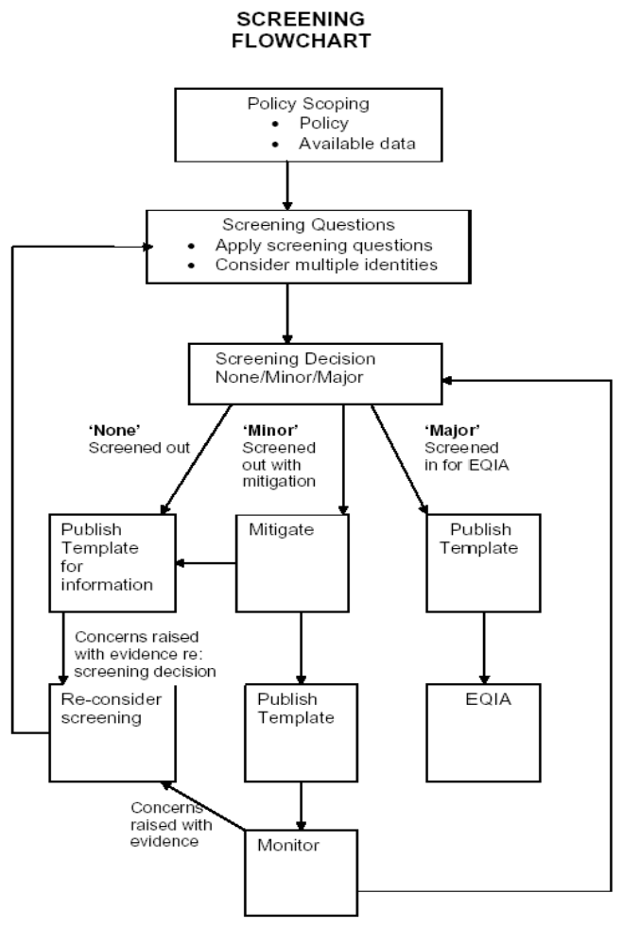

Belfast Trust also committed within its Revised Equality Scheme to prepare and publish for information regular reports on its screening exercises. Belfast HSC Trust has provided detail on all screenings undertaken since 1 September 2011 when the Trust received Equality Commission approval for their revised Equality Scheme. To further promote openness and transparency, there is a link to each completed screening template on the Belfast Trust’s website. www.belfasttrust.hscni.net.

The quarterly screening report shall detail all policies screened over a three month period and includes decisions reached.

This screening report outlines the screening outcomes from 1st July – 30th September 2025.

Communication and Engagement

Belfast Trust recognises the importance of stakeholder involvement – one of the 5 key strategic objectives that Belfast Trust devised at the outset was that of Partnership – we are committed to improving health and well-being through existing and new partnerships with a range of individuals, representative groups and voluntary and community organisations. The Trust is committed to providing people led services, drawing on the years of experience and listening to the needs and feedback that meaningful consultation can yield. There is a need to continue to effectively engage and work collaboratively with a wide range of stakeholders including Trust staff, Trade Unions, service users, carers, commissioners, primary care, public representatives and independent providers.

The Trust is committed to promoting personal and public involvement in all its activities. The development of new policies and proposals will be supported by effective engagement processes to ensure that staff, service users and all interested parties are fully involved. Planning for, and delivering safe, clinically effective and cost-effective services requires close collaboration at many levels.

If you have any queries about this document, and its availability in alternative formats (including Braille, disk and audio cassette, and in minority languages to meet the needs of those who are not fluent in English) then please contact:

Orla Barron
Equality Lead
Belfast Health and Social Care Trust
First Floor, Administration Building
Knockbracken Healthcare Park
Saintfield Road
Belfast
BT8 8BH

Telephone: 028 95046567
Textphone: 028 90637406
orla.barron@belfasttrust.hscni.net

This report details each proposal and the screening outcome – for ease of reference, readers can access the full completed screening template via a link to the Trust website. Should you have concerns which are based on supporting evidence regarding the screening decision, please contact the Health and Social Inequalities Manager as above and outline your concern along with the supporting evidence. Belfast Trust will duly consider rescreening the proposal.

Outcome of Screening

The screening outcomes are outlined below. Four possible outcomes are recorded:

- The policy has been ‘screened out’ because it has No relevance or bearing in terms of its likely impact (actual/potential) on equality of opportunity, good relations & in relation to disability duties & human rights.

- The policy has been ‘screened out’ with mitigation or an alternative policy has been adopted.

- The policy has been ‘screened in’ for an Equality Assessment.

Description of Policy or Proposal | Screening Outcome
08/05/2025  Bariatric Policy  Purpose  To reduce the risk of injury to patients/clients and staff, whilst maintaining patient dignity as it relates to bariatric patients by providing adequate space, equipment, environment and staff. | Screened out with mitigation
18/06/2025  Nurse or radiographer led head and neck new patient clinic  Purpose  Outlines the guiding principles for specialist led head and neck cancer new patient clinic, with the aim of setting a maximum standard for specialist led new patient clinic for head and neck cancer patients. | Screened out
02/07/2025  Radiological Examination for Haematology and Outlying Patients at Specialist Clinics, Bridgewater Suite, BCH – Policy for named Nurses Requesting (DB 850)  Purpose  To enable Named Nurses(s) to request chest x-rays, abdominal x-rays, and x-rays of areas of suspected bony disease for follow-up and review purposes on behalf of Consultants listed. To ensure appropriate initial and continuing education must underpin all role development and training programmes. | Screened out
09/07/2025  Use of topical beads with antibiotics in wound management  Purpose  To provide guidance on the topical use of STIMULAN beads (calcium sulphate powder and aqueous mixing solution supplied in pre-measured quantities) with antibiotics for wound management. | Screened out
18/07/2025  Voluntary Social Work Band 6 Transfer Policy  Purpose  Enable Social Workers to gain wider experience of Social Work services across the Trust, which may enable further career opportunities, and facilitate the retention of experienced staff. | Screened out
22/07/2025  Reporting and investigation of IR(ME)R related incidents in areas using X-rays and Radioisotopes for diagnostic and interventional procedures  Purpose  To detail how to correctly investigate an Ionising Radiation (Medical Exposure) Regulations (Northern Ireland) 2018, IR(ME)R related incidents within Belfast Health & Social Care Trust. It will ensure staff have access to a comprehensive, clear and user-friendly radiation incident reporting system that will encourage the reporting of radiation incidents. | Screened out
22/07/2025  Non-medical Non-research Imaging within the MRI SIM  Purpose  To document the management of volunteers in the optimisation and validation of imaging protocols and workflows prior to clinical implementation and commencing the routine clinical service within the Radiotherapy department. | Screened out
23/07/2025  Guidelines for inpatient assessment and management of hyperglycaemia in adults taking steroids  Purpose  To provide clinical guidance on the assessment and management of hyperglycaemic in adult inpatients taking glucocorticoid treatments. | Screened out
30/07/2025  Policy and procedure for the urinary catheterisation of a child in RBHSC  Purpose  To clarify best practice to ensure that urethral catheterisation is undertaken safely, effectively, and in the patient’s best interests. | Screened out
31/07/2025  Nurse led/Provision of free period products in Belfast Health & Social Care Trust – in line with The Period Products (Free Provision) Act (Northern Ireland) 2022  Purpose  To ensure period products are provided free of charge to all persons who need them in Belfast Health & Social Care Trust locations. | Screened out with mitigation
01/08/2025  Guideline for the Management of Systemic Anti-Cancer Therapy (SACT) Extravasation  Purpose  To help Health Care Professionals (HCPs) in Belfast Health & Social Care Trust who are involved in the administration of intravenous (IV) Systemic Anti-Cancer Therapy (SACT) to minimise the risks involved to avoid, recognise and manage extravasation. | Screened out
04/08/2025  Relocation of Fairholme  Purpose  To provide an effectively under-used scheme with a modern self-contained accommodation in South Belfast, providing increased space for tenants, privacy and dignity, in an environment that promotes mental health recovery. | Screened out with mitigation
12/08/2025  Haemodialysis via Arterio-Venous Fistula – Procedure to Commence and Discontinue Haemodialysis  Purpose  To provide a standard approach adopting an aseptic non-touch technique for dialysis commenced via Arterio/venous fistula. | Screened out
13/08/2025  Dexmedetomadine as a pre-med for children aged 0-18 years who are undergoing a general anaesthetic  Purpose  To provide an alternative anxiolytic for patients with a history of poor response or paradoxical reaction to midazolam, and to provide guidance in the Belfast Health & Social Care Trust on safe prescribing and administration of dexmedetomidine as premedication. | Screened out
14/08/2025  Referral to an Obstetric Consultant for Assessment in Pregnancy  Purpose  To be used by midwives and doctors to make a decision on when and why a woman needs referred during pregnancy to a Consultant Obstetrician. It will devise the best possible care pathway to be followed during pregnancy in the Belfast Health & Social Care Trust Antenatal Service in line with recommendations from National Institute for Health and Care Excellence (NICE) Antenatal Care Guideline (NG201) and Northern Ireland Health and Social Care Maternity Services Core Pathway for Antenatal Care, Public Health Agency 2016. | Screened out with mitigation
14/08/2025  Investigation and care of a Small-for-Gestational-Age Fetus (SGA) and in Fetal Growth Restriction (FGR)  Purpose  To provide recommendations for all healthcare providers in Belfast Trust, based on the best evidence available, to guide clinicians regarding the investigation and management of the small-for-gestational-age (SGA) fetuses and growth-restricted fetuses (FGR). | Screened out
14/08/2025  Prevention, Diagnosis and Management of Hyponatraemia in Labour and the Immediate Postpartum Period  Purpose  To reduce the risk of hyponatraemia through the expedients of increased awareness, accurate fluid balance monitoring and earlier detection. | Screened out
15/09/2025  BHSCT Security Policy  Purpose  To highlight the responsibilities of all Trust staff in relation to security to provide a safe and secure environment for Staff, patients and visitors and to maintain the security of Belfast Trust premises and assets. | Screened out with mitigation
16/09/2025  Dialysis Unit Fridge Alarm Response  Purpose  To ensure rapid response, outside of opening hours, in event of a maximum or minimum alarm being generated by the DU drug fridge thereby preventing significant financial waste. | Screened out
19/09/2025  Managers guidance on Temporary Recruitment Exercises  Purpose  To support Trust hiring managers to recognise when it is appropriate to advertise an internal vacancy via an ‘Expression of Interest’ or ‘Internal Trawl’ recruitment procedure and to ensure consistency in approach and practice. | Screened out
22/09/2025  Guidelines on PAVA Spray Contamination  Purpose  To provide staff with the safest methods of managing PAVA spray contamination of people, environment or clothing and ensure compliance with Legislative requirements as defined in the Health & Safety at Work (NI) Order 1978, as amended by the Management of Health and Safety at Work (NI) Regulations 2000 and Control of Substances Hazardous to Health Regulations (NI) 2003. | Screened out with mitigation
23/09/2025  Implementation of the Regional Guidance for the Patient/Carer Self-Administration of Subcutaneous (SC) Systemic Anti-Cancer Therapy (SACT) in the Community / Home setting  Purpose  To provide haematology and oncology patients with a choice about where their subcutaneous SACT is administered whilst maintaining safe practice. This may be either in the hospital setting, or at home, hereby improving the quality of life for patients by reducing the need for multiple hospital attendances. | Screened out
23/09/2025  Implementation of the NICaN Regional Guidelines for Confirming Pregnancy Status Before Commencing or Administering Systemic Anti-Cancer Therapy in Adults  Purpose  To prevent unknowingly treating a person with potentially harmful Systemic Anti-Cancer Therapy (SACT), by clearly establishing the pregnancy status of all persons of childbearing potential before they receive SACT; ensuring all persons who have started menstruating are given suitable information advising of the need to avoid pregnancy whilst receiving SACT treatment and are adequately counselled and consented for treatment; and to ensure that the outcome of any pregnancy test is checked and recorded in the appropriate documentation. | Screened out
24/09/2025  Administration of Blended Diet via Gastrostomy: Standard Operating Procedure (SOP) in the Acute Setting for Inpatients in RBHSC  Purpose  To ensure the safe provision of blended diets administered via appropriate gastrostomy tubes for children/young people (CYP) admitted to RBHSC who are already established on blended diets in the community. | Screened out
24/09/2025  Care and Management of Haemodialysis Catheters (Tunnelled and Non-Tunnelled)  Purpose  Provide a template for nursing and medical staff to ensure the effective and safe use and management of HDC. It will provide guidance in order to prevent and manage any potential complications associated with the use and care of HDC. | Screened out
10/10/2025  Implementation of Regional Policy Management of Heart Failure at End of Life  Purpose  For healthcare professionals managing heart failure symptoms when end of life is expected within weeks to days. The Regional Guidance covers symptom management and other helpful information for healthcare professionals in both acute and community settings including medical, nursing and pharmacy professionals, AHPs and healthcare assistants. | Screened out
10/10/2025  Management of diabetes at the end of life  Purpose  Provides guidance to any healthcare professional in acute and community settings on managing patients with diabetes in the last days of life including medical, nursing and pharmacy professionals, AHPs and healthcare assistants. | Screened out

