

Screening Outcome Report

1 October 2021 – 31 December 2021

Introduction

Section 75 of the Northern Ireland Act 1998 requires the Trust, when carrying out its functions in relation to Northern Ireland, to have due regard to the need to promote equality of opportunity between nine categories of persons, namely:

- between persons of different religious belief, political opinion, racial group, age, marital status or sexual orientation;
- between men and women generally;
- between persons with a disability and persons without; and
- between persons with dependants and persons without.

Without prejudice to its obligations above, the Trust must also have regard to the desirability of promoting good relations between persons of different religious belief, political opinion or racial group.

Belfast Trust’s Revised Equality Scheme was formally approved by the Equality Commission in September 2011. The revised Scheme outlines how we propose to fulfil our statutory duties under Section 75. Within the Scheme, the Trust gave a commitment to apply the screening methodology below to all new and revised policies and where necessary and appropriate to subject new policies to further equality impact assessment.

- What is the likely impact of equality of opportunity for those affected by this policy/proposal, for each of the Section 75 equality categories?
- Are there opportunities to better promote equality of opportunity for people within Section 75 equality categories?
- To what extent is the policy/proposal likely to impact on good relations between people of different religious belief, political opinion or racial group?
- Are there opportunities to better promote good relations between people of different religious belief, political opinion or racial group?

In keeping with the Trust’s commitments in its Equality Scheme the Trust has applied the above screening criteria to new policies and proposals. Screening identifies policies that are likely to have an impact on equality of opportunity and or good relations.

Screening identifies the impact of the policy/proposal as major, minor or none.
- If major – an Equality Impact Assessment may be carried out.
- If minor – consider mitigation or alternative policy and screen out.
- If none – screen out and give reasons.
- Ongoing screening – for strategies/policies that are to be put in place through a series of stages – screen at various stages during implementation.

Figure 1 provides a flowchart of how screening is conducted in Belfast Trust.
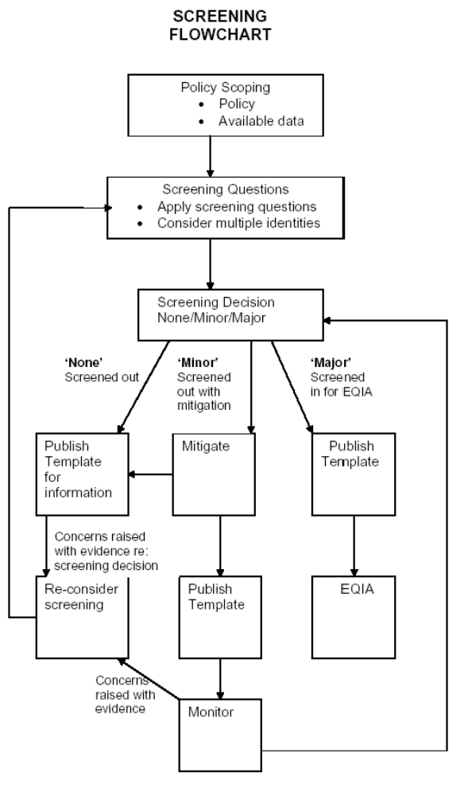

Belfast Trust also committed within its Revised Equality Scheme to prepare and publish for information regular reports on its screening exercises. Belfast HSC Trust has provided detail on all screenings undertaken since 1 September 2011 when the Trust received Equality Commission approval for their revised Equality Scheme. To further promote openness and transparency, there is a link to each completed screening template on the Belfast Trust’s website. www.belfasttrust.hscni.net.

The quarterly screening report shall detail all policies screened over a three month period and includes decisions reached.

This screening report outlines the screening outcomes from 1 October– 31 December 2021.

Communication and Engagement

Belfast Trust recognises the importance of stakeholder involvement – one of the 5 key strategic objectives that Belfast Trust devised at the outset was that of Partnership – we are committed to improving health and well-being through existing and new partnerships with a range of individuals, representative groups and voluntary and community organisations. The Trust is committed to providing people led services, drawing on the years of experience and listening to the needs and feedback that meaningful consultation can yield. There is a need to continue to effectively engage and work collaboratively with a wide range of stakeholders including Trust staff, Trade Unions, service users, carers, commissioners, primary care, public representatives and independent providers.

The Trust is committed to promoting personal and public involvement in all its activities. The development of new policies and proposals will be supported by effective engagement processes to ensure that staff, service users and all interested parties are fully involved. Planning for, and delivering safe, clinically effective and cost effective services requires close collaboration at many levels.

If you have any queries about this document, and its availability in alternative formats (including Braille, disk and audio cassette, and in minority languages to meet the needs of those who are not fluent in English) then please contact:

Orla Barron
Equality Lead
Belfast Health and Social Care Trust
First Floor, Administration Building
Knockbracken Healthcare Park
Saintfield Road
Belfast
BT8 8BH

Telephone: 028 95046567
Textphone: 028 90637406
orla.barron@belfasttrust.hscni.net

This report details each proposal and the screening outcome – for ease of reference, readers can access the full completed screening template via a link to the Trust website. Should you have concerns which are based on supporting evidence regarding the screening decision, please contact the Health and Social Inequalities Manager as above and outline your concern along with the supporting evidence. Belfast Trust will duly consider rescreening the proposal.

Outcome of Screening

The screening outcomes are outlined below. Four possible outcomes are recorded:

- The policy has been ‘screened in’ for equality impact assessment;

- The policy has been „screened out’ with mitigation or an alternative policy proposed to be adopted;

- The policy has been ‘screened out’ without mitigation or an alternative policy proposed to be adopted.

- The policy will be subjected to ongoing screening. For more detailed strategies or policies that are to be put in place through a series of stages, screening should be considered at various times during implementation.
Description of Policy or Proposal | Screening Outcome
4/10/21  Accessing and Retention of Previous Maternity Records which are Required for the First Antenatal Clinic Appointment  Purpose: The overall purpose of this policy is:  ● To ensure that women with previous relevant history will have their previous maternity records made available for their antenatal clinic appointment (ANC).  ● To ensure the medical team can review previous deliveries and note any potential risks that could impact on the current pregnancy/delivery.  ● To assist discussion between a woman and the consultant obstetrician.  ● To plan appropriate care management.  ● To assist midwifery and medical staff in their role. | Screened out without mitigation as is clinical/technical in nature.
23/10/21  Guidance for Prescribing and Monitoring of High Dose Antipsychotics in Mental Health Services  This Guidance is to ensure that the BNF advice based on the Royal College of Psychiatrists on the prescribing and monitoring of doses above the BNF upper limit is followed when high doses of antipsychotic medications are prescribed. | Screened out without mitigation as is clinical/technical in nature.
25/10/21  Restrictive Practices Policy  The Policy details specific roles and responsibilities for the Trust Board – Chief Executive, Directors and Co-Directors, Managers and Training Providers. The Policy also notes the following:  All Staff  - Have individual responsibility to ensure they work within the legal and ethical framework that pertains to practice and interventions that would be defined as restrictive with a pro-active response to poor practice  - Must ensure they comply with the Trust policy relating to restrictive practice and contribute to activities designed to support a reduction or elimination of restrictive practices  - Must ensure they are competent within their role and within the setting in which they are employed in order to meet the needs of the service user being cared for  - Must ensure that any gaps in knowledge, skills or practice in the area of restrictive practices and/or restrictive interventions are raised swiftly to their manage  - Must ensure they attend the appropriate training in relation to this policy  - Must take reasonable care of their own health and safety and that of others  - Must ensure they report all incidences of restrictive practices and/or interventions | Screened out with mitigation
2/11/21  Employers Procedures for External Beam Radiotherapy and Sealed Source Brachytherapy  Purpose: These employer’s procedures have been revised in line with IR(ME)R to ensure that the Belfast Health & Social Care Trust, hereafter referred to as the BHSCT, complies with the regulations. To meet legislative requirements of IR(ME)R. | Screened out without mitigation as is clinical/technical in nature.
9/11/21  Guidelines for empirical antibiotic prescribing in hospitalised adults  Purpose: The purpose of this guideline is to provide consistent Trust-wide guidance for the empirical antibiotic management of hospitalised patients with the commonly encountered bacterial infections. This will not change how services are delivered or current practice.  Objectives: To improve the quality of antibiotic prescribing and standardise the use of antibiotics across the Trust. | Screened out without mitigation as is clinical/technical in nature.
9/11/21  Policy for the administration of intra-venous(IV) and oral iodinated contrast media to adult patients by Radiographers  Purpose: The purpose to this policy is to provide guidance to Radiographers for the safe and effective administration of contrast agents and direction on how to manage patients should an adverse event occur. This policy merges the legacy trust protocols for iodinated contrast media administration to provide staff with a consistent trust-wide approach.  Objectives:  - To ensure patients potentially at risk of an adverse reaction/event are identified  - To provide guidance for safe and effective administration of contrast agents. | Screened out without mitigation as is clinical/technical in nature.
11/11/21  Security in Shannon Clinic Medium Secure Unit  Aim  Shannon Clinic Medium Secure Unit aims to provide a safe and secure environment for patients, staff who work in or enter and visitors, as well as ensuring that the human rights of all patients and staff are respected and protected.  There are three types of security that contribute to this:-  - Physical security  - Procedural security  - Relational security  This procedure has been developed as a reference for all staff working in or entering the Unit and visitors to ensure they are aware of the level of safety and security required to reduce safety breaches. This procedure should not be read in isolation but should be read alongside security induction booklet and other relevant local/trust procedures. | Screened out with mitigation
15/11/21  Management of patients admitted to hospital who are on oral substitution therapy (methadone, Subutex, Suboxone, Espranor) or subcutaneous substitution therapy (Buvidal)  Purpose: This policy is to ensure that patients on Opioid Substitution Therapy (OST) receive safe and timely prescribing of their OST medication on admission to hospital and on discharge from hospital.  Objectives: This policy aims to give direction on good communication with all involved parties to ensure that patients on oral substitution therapy receive the appropriate prescribed doses in a timely manner on both admission to and discharge form hospital. | Screened out without mitigation as is clinical/technical in nature.

16/11/21  Management of Ligature Points in Mental Health Inpatient, residential and community facilities within the Mental Health Service Group.  Objectives:  To provide clear guidance for all staff and managers with reference to the ligature survey, assessment and management of the risk of self-strangulation or hanging by patients within a mental health inpatient facility.  To ensure compliance with recommendations by the Regulation and Quality Improvement Authority (RQIA), National Inquiry into Suicide and Homicide (NICSH), Medical Device Alerts (MDEAs), Estates and Facilities Alerts (EFAs) and the Belfast Trust Risk Assessment Audit Tool (BRAAT).  The policy should be read in conjunction with: -  - Observations within Mental Health Services  - General Health and Safety Policy  - Guidance on General Health and Safety Risk Assessments  - Procedure on the Use of Ligature Cutters  - Promoting Quality Care – the Assessment and Management of Risk, DHSSPSNI, May 2010  - Preventing Suicide: A toolkit for mental health (National Patient Safety Agency) | Screened out with mitigation
17/11/21  Patients’ Finances and Private Property – Policy for Inpatients within Learning Disability Inpatient settings.  This policy provides staff with guidelines regarding the handling of patients’ finances and private property across the Belfast Health and Social Care Trust in-patient learning disability wards.  Policy Objectives  This document aims to:  - Establish clear guidance for staff in relation to the handling of patients’ finances and private property;  - Safeguard the interests of patients;  - Guide and protect staff when dealing with patients’ finances and private property | Screened out with mitigation
23/11/21
Policy and Procedure for Use of Seclusion in Adult Learning Disability Inpatient Services

Objectives include:
- To ensure the physical, psychological and emotional safety and wellbeing of patients

- To ensure that restrictive practices remain proportionate, least restrictive, last for no more than necessary and take account of patient preference whenever possible (NICE NG 10, 2015)

- To ensure that inpatient areas have robust and transparent governance processes that support, monitor, advise and report on the use of restrictive practice of seclusion.

- To ensure that patients receive the necessary care and support before, during and after seclusion  - To designate a suitable environment that takes account of patients’ dignity and physical and psychological safety and wellbeing  - To set out roles and responsibilities of staff  - Then sure processes are followed for monitoring, recording and reviewing the use of seclusion and that learning is identified and shared.  - To promote person centred practices by working in partnership with the patient and their carer (as appropriate) to review available options to minimise the potential for harm  - To minimise the frequency and duration of seclusion and prevent any inappropriate use of seclusion with an aim to support the Trust commitment to reduce restrictive interventions. | Screened out with mitigation
25/11/21  Community Nursing ‘Patient Specific Direction (PSD) to Administer Medication’ and Medicine Administration Recording charts  Objectives: The objectives of the policy is to minimise risk in administration of medication for patients within a community setting and ensure adherence to RPS/RCN professional guidance for administration of medicines in Healthcare settings and BHSCT Community Medicines Code. | Screened out without mitigation as is clinical/technical in nature.

29/11/21  Nurse-Led Review of Patients with Early and Locally Advanced Breast Cancer, Cancer Centre  Objectives: The service seeks to improve and maintain standards of clinical practice and quality of care, patients receive by:  - Providing a framework from which individual practitioners can apply their own level of clinical expertise and competency. (Appendix 2)  - Offering timely follow-up of patients post treatment see Appendix 3.  - Ensure that consistent high standards of care are afforded to patients with a diagnosis of breast cancer who have completed treatment or who remain on hormone treatment for their breast cancer.  - Providing evidence based guidance for establishing and maintaining a nurse led review clinic for patients with breast cancer, promoting excellence in the care that is delivered. Take guidance from the problem management plan (Appendix 4)  - Reducing variation in clinical practice and encouraging uniformity of practice.  - Promoting the use of audit in this setting. | Screened out without mitigation as is clinical/technical in nature.
29/11/21  Intramuscular Morphine for Analgesia in Labour – Supply and administration by Midwives  Objectives:  - To support intramuscular morphine as an analgesic for pain relief in labour  - To outline the indications and contraindications  - To recommend the dosage, preparation and administration of the drug  - To define standards of monitoring required  - To promote relevant staff training  - To outline actions to be taken in the event of morphine induced CNS or respiratory depression. | Screened out without mitigation as is clinical/technical in nature
30/11/21  Admission Protocol for Patients in the Care of the Child and Adolescent Mental Health Services who are admitted to Acute Adult Mental Health Wards  The aim of the policy is to ensure that when patients in the care of CAMHS are admitted to Acute Adult Mental Health Wards they are cared for appropriately and their needs are met. | Screened out with mitigation
1/12/21  PSNI Assistance for Beechcroft  This procedure provides staff with standard guidance when considering initiating a request to the PSNI for assistance, how to manage that high-risk situation and the post incident support for staff and young people in Beechcroft Child & Adolescent Mental Health Inpatient Unit. | Screened out with mitigation
1/12/21  Management of Hypercalcaemia of Solid Malignancy in Adults  Purpose: This guideline aims to update the management of hypercalcaemia of malignancy currently available in the NICAN guidelines and on the palliative hub website. | Screened out without mitigation as is clinical/technical in nature.
3/12/21  Trust Bank Operational Policy  The purpose of the policy is to maximise the Belfast Health & Social Care Trust staffing resource in order to enhance patient safety and minimise clinical risk. Before establishing the need for temporary cover, managers should follow the guidance within Effectively dealing with short and long-term fluctuations in service activity and staffing levels (App. A) and Nursing and Midwifery Roster Management Policy (App. B).  The Operational Policy Handbook aims to provide guidance to all Managers throughout the Trust on the:-  - Principles and Processes for using the Bank  - Internal and External Recruitment Process for Selection to the Bank  - The process for identification of need and the booking of Bank Staff  - The operation and responsibility of the Central Bank Office including: -  - Allocation of shifts  - Maintenance and updating of the Health Rostering System  - Process to carry out appropriate checks required to ensure adherence to good governance and safe practice.  - Process for payment of Bank Staff  - Checking and authorizing payments for agency use  - Cancellation Process  - Terms and Conditions pertaining to Bank Staff  - Process for dealing with complaints  - Financial Accountability | Screened out without mitigation as is clinical/technical in nature.
7/12/21  Casirivimab and Imdevimab for patients hospitalised due to Covid-19 or with hospital onset Covid-19  Purpose: To deliver the use of this casirivimab and imdevimab combination safely  and effectively, good practice in its handling and management is paramount. | Screened out without mitigation as is clinical/technical in nature.
13/12/21  Blood Transfusion Manual – Policy, Procedures and Guidelines V3  This Blood Transfusion Manual: Policies, Procedures and Guidelines is intended to be a single reference source for the main transfusion practices and is an amalgamation of the Transfusion related BHSCT policies.  This manual applies to all staff groups who take part in the Transfusion process including some but not all, Medical, Nursing, Healthcare support workers, Porters and their managers. | Screened out without mitigation as is clinical/technical in nature.
22/12/21  Central Diabetes Insipidus Diagnosis and Management in Children and Young People  Improve diagnosis and management of DI in children in RBHSC. | Screened out without mitigation as is clinical/technical in nature.

